   Mobile Communication protocol

https://ilor.itrackglobal.com/ilor/objects/OSSContent:202/datastreams/ibmlogo/content

* **Nano Learning Object**

|  |  |
| --- | --- |
| **Nano Learning Object(NLO)** | **NLO Outcome** |
| Evolution of Mobile Wireless Communication System | Learn about the evolution of Mobile Wireless Communication System |

* **NLO Contents**
* Evolution of Mobile Wireless Communication System
  + Mobile communication protocol is one of the most required topic in the area of telecommunication
  + Mobile communication standards started getting evolved from the year 1980
  + The main objectives of mobile communication protocol are

- to establish communication between two user any time and between any places  
- to maintain quality of link throughout the communication

There are many types of mobile communication. According to the application requirement and situation, the mobile communication falls into four types:

* + Trunk mobile communication, also known as macro cell mobile communication.

Here, there is only one base station; the height of the antenna varies from dozens of meters to one hundred meters, and its coverage radius is 30-50 km; the power of the transmitter can be up to 200W. The subscriber capacity varies from dozens of subscribers to several hundred subscribers. The MSs can be vehicle mounted stations and handsets; the MS can establish connectivity with the base station or communicate with other MSs and local call subscribers.

* + Cellular mobile communication, also known as micro cell mobile communication.

Here in mobile communication, a large coverage area is divided into smaller coverage areas called cells; one base station is set in each cell for the connecting and controlling the MSs within the cell; the BTSs are connected with the mobile switching center, and they are connected with the local exchange. The ultra-short wave propagation is used, so the frequency can be reused in the cells with a certain distance in between, thus making a full use of the frequency resources. Each cell serves over 1,000 subscribers, and the whole coverage area can serve up to 1 million subscribers.

* + Satellite mobile communication

The mobile communication can also be implemented by transferring signals through the satellite. The vehicle mounted stations can implement mobile communication through the geostationary satellite; the handsets can implement mobile communication through multiple low-earth-orbit constellation satellites.

* + Cordless telephone

For the communication of the handset that moves slowly indoor or outdoor, the portable cordless with low power and short communication distance is used. The cordless telephone user can implement one- way or two-way communication with the local subscribers through the communication point.

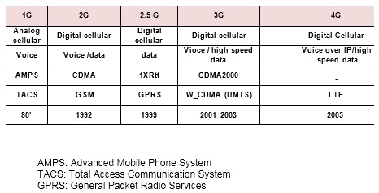

The evolution of Mobile communication can be discussed in terms of different standards starting from 1G to 4G. The evolution can be also discussed in terms of American and European standards. The American standard includes AMPS and CDMA. The European standard include TACS and GSM. The Japan had its own standard called JTACS.

The popular 1G standard includes AMPS and TACS. Both are based on Analog Systems. The type of modulation used during 1G standard was Frequency modulation. Then channel bandwidth was either 25KHz or 30KHz. 1G supports only voice communication. The interfaces were closed in 1G systems.

The most popular 2G standards were GSM and CDMA. The 2G standard was based on digital communication principle. Source coding, Channel coding, Encryption were all part of base band systems. Most of the interfaces were open in 2G such as air interface and A interface. GSM Supports mostly

voice. However SMS and fax text could be transferred in GSM. The initial version of CDMA ( IS95) mainly focused on voice howerver later version supports data rate of 64kbps. The completion from CDMA and the demand of data resulted in evolution of GPRS followed by EDGE. The first evolution of GSM towards data was GPRS( General packed radio service) which is also called 2.5G. The data rate of GPRS was 171kbps. The EDGE ( Evolution in Data only) the advanced version of GPRS. It supports data rate of 384 kbps.

By the time CDMA evolution reached towards CDMA2000, the GSM evolution reached UMTS( also called IMT2000 or WCDMA). The initial version of UMTS supports data rate of 2 Mbps. The advanced version of WCDMA ( HSPA+) supports data rate upto 21 Mbps

  Mobile Communication protocol

https://ilor.itrackglobal.com/ilor/objects/OSSContent:202/datastreams/ibmlogo/content

* **Nano Learning Object**

|  |  |
| --- | --- |
| **Nano Learning Object(NLO)** | **NLO Outcome** |
| First Generation Wireless Networks | Gain knowledge on the First Generation Wireless Networks |

* **NLO Contents**
* First Generation Wireless Networks

In fact , the mobile communication had been appeared in the early 1920’s, But at times the concept about cell and repetition of the frequency had never been appeared ; until the early 1970’s ,the cellular mobile communication had not been aroused ,and at 1980’s it made a rapid development , like the AMPS ,TACS became operational and as a trial ; the 1G cellular mobile communication was established.

But, with the mobile communication development, because the analog cellular system has limitations in terms of capacity, voice quality, supporting less service, it couldn’t meet the people’s requirement.

**Major Radio Standards in North America**

AMPS-1983-824-894 MHz, FDMA, FM, 30 Khz Channel Bandwidth

**Major Mobile Radio Standards in Europe**

ETACS -1985 -900 MHz , FDMA, FM, 25KHZ Channel Bandwidth

NMT-450 1981- 450-470 MHz , FDMA, FM, 25KHZ Channel Bandwidth

**Major Mobile Radio Standards in Japan**

JTACS- 1988 A 860-925 MHz, FDMA, FM, 25 KHz Channel Bandwidth However, the

**analog communication system has the following disadvantages:**

* 1. There is no common interface between the systems;
  2. It cannot quickly evolve to the digital system together with the fixed network, and it is hard to the provision the digital bearer service;
  3. Low frequency utilization rate, so it cannot meet the requirement for large capacity;
  4. Low security; the call can be easily eavesdropped, and the account can be easily embezzled.

**Disadvantages 1G**

* 1. There is no common interface between the systems

Air interface, Abis Interface and A interfaces were closed. That is operator should buy all the network elements from the same vendor. The mobile phone user should buy the mobile phone from the same vendor as the operator.

* 1. It cannot quickly evolve to the digital system together with the fixed network, and it is hard to the provision the digital bearer service.
  2. Low frequency utilization rate, so it cannot meet the requirement for large capacity. There was no frequency reuse concept or frequency planning concept during 1G. Spectrum utilization was minimal because of adoption of analog communication principle
  3. Low security; the call can be easily eavesdropped, and the account can be easily embezzled. Analog communication does not provide the option of encryption

  Mobile Communication protocol

https://ilor.itrackglobal.com/ilor/objects/OSSContent:202/datastreams/ibmlogo/content

* **Nano Learning Object**

|  |  |
| --- | --- |
| **Nano Learning Object(NLO)** | **NLO Outcome** |
| 2G Wireless Cellular Networks | Gain an insight into 2G Wireless Cellular Networks |

* **NLO Contents**
* 2G Wireless Cellular Networks

Because of the disadvantages of analog systems like TACS, the mobile communication which developed on principles of digital communication and time division multiple access ( TDMA) and Interim standard ( IS 95 and IS-95 B) based on CDMA principle were came into existence during 1990.This system is called the second generation mobile communication standard systems also called 2G.

2G is concerned with handling voice and data information. It can also support low speed data serviced and SMS

**Examples :** GSM, DAMPS, IS-95 CDMA, and JDC (Japan).

**TDMA**

The most mature and representative which uses TDMA concepts are GSM , D-AMPS, and Japan Digital Cellular ( JDC).

* 1. The EIA released the technical standard of the D-AMPS. In 1993, the EIA was formally put into commercial operation in 1993. It was based on the AMPS. It supports both digital services and analog services. Its base station and MS are relatively complex.

The D-AMPS which is also referred as TDMA/IS-136 is the Evolution of AMPS. The D-AMPS uses the TDMA technology. Each AMPS channel can be divided into three D-AMPS channels. As with the AMPS, the D-AMPS operates at 800 MHz~900 MHz. The D-AMPS is used in North America.

JDC also called PDC ( Personal Digital Cellular ) was released in 1990. The JDC was put into use in 1993. It is used in Japan only.

* 1. JDC (Japan Digital Cellular System) is a digital cellular mobile communication system presented by China in 1989. Its standards include RCR-STD-27A and RCR-STD-27B. It has two operating bands: 800/900 MHz and 1.5GHz. Its technology is similar to that of the D-AMPS. It is used in Japan only.
  2. The CEPT SMG released phase I standard of the GSM in 1988. Its operating band was about 900MH. It was put into commercial use in 1990. Also in 1990, the specification for the GSM operating at 1800 MHz is released at the request of UK.

**Advantages of 2G**

* 1. Effective spectrum utilization
  2. Support large system capacity.
  3. Variety of services such as voice, data, SMS, etc.
  4. International roaming options.
  5. Improved voice quality and good security features
  6. Interconnection with ISDN and PSTN.

The GSM series include GSM900, DCS1800, and PCS1900. Their major difference lies in the operating band. They have the following features:

* 1. High spectrum efficiency

The highly efficient modulator and technologies such as channel coding, interleaving, balancing, and voice coding bring a high spectrum efficiency to the system.

* 1. High capacity

Because the transmission bandwidth of each channel increases (the transmission bandwidth of the GSM bandwidth is 200 kHz, and that in the analog system is about 25 kHz), the carrier-to-interference ratio of the cofrequency multiplexing is reduced to 9dB. Therefore, the cofrequency multiplexing mode of the GSM system can be 4/12 or 3/9, or even lower (7/21 for the analog system). Besides, the introduction of the half-rate voice coding technology and the traffic allocation make the capacity efficiency (the number of channels of each cell in 1 MHz) 3-5 times the TACS.

* 1. High voice quality

In the GSM, one the transmission quality is higher than the threshold, the voice quality is of the same level and independent of the transmission quality.

* 1. High security

The security is ensured through authentication, encryption, and TMSI.

* 1. Interconnection with ISDN, PSTN, and so on
  2. Roaming based on the SIM card

**The three systems have different advantages:**

* 1. The PDC has a high spectrum utilization rate;
  2. The D-AMPS has a high system capacity;
  3. GSM is developed using the concept OSI and hence standard support open interfaces. This factor leads to large scope for development.

**2G Disadvantage**

* 1. low-rate data services and do not support multi-media services. Ex: Internet speed of GSM is 9.6kbps
  2. Some of the advancement technologies such as E-commerce and M-commerce are getting popular and demand a huge support from mobile communication which was not satisfied by 2G standards.
  3. High demand for higher data through put because of varieties of application used by the subscriber.

**N-CDMA**

N-CDMA mainly involves the IS-95 based N-CDMA researched by the Qualcomm corporation.

The IS 95 CDMA is another digital cellular standard in North America. It operates at 800 MHz and 1900 MHz. It adopts the N-CDMA technology. It is used in North America and South Korea. The N-CDMA matures after the GSM does, so its application is narrower than the application of the GSM. However, compared with the FDMA and TDMA, the CDMA has many unique advantages mentioned below.

**CDMA has the following advantages:**

* 1. High system capacity

Theoretically, the system capacity of the CDMA digital mobile communication network is 20 times larger that of the analog network. Actually, system capacity of the CDMA network is ten (10) times higher than that of the analog communication network and 4 to 5 times higher than GSM counterpart.

* 1. Improved system communication quality

The soft handover technology can overcome the disadvantage of easy call drop of the hard handover. The CDMA system operates at the same frequency and bandwidth, so it can easily implement the soft handover technology compared with the TDMA system, thus improving the communication quality. The CDMA system adopts the adaptive threshold technology to determine the rate of the vocoder, the

powerful soft handover technology with bit error correction, and the multipath diversity receiver. Therefore, the CDMA system can provide a far high communication quality compared with the TDMA system.

* 1. Flexible frequency planning

The subscribers are distinguished by different serial numbers. Different CDMA carriers can be used within adjacent cells. Therefore, the frequency of the CDMA network can be flexibly planned and easily expanded.

* 1. Suitable for multi cast communication system

The CDMA system can easily use multiple CDMA channel modes and multiple CDMA frame modes to transfer multimedia service information with different rates. Compared with the TDMA and TDMA, the processing mode and synthesis mode are more flexible and simple, facilitating the application of the multimedia communication system.

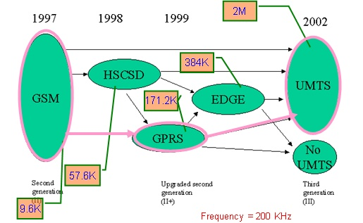

**Fig.1 Evolution of GSM Data Service**

The 2G mobile communication system is a digital system, but it has some disadvantages:

* 1. The band is narrow, therefore not suitable for high data services, TV transmission etc.
  2. Though the GSM is known as "GoTone", it does not really support global roaming; especially, the GSM is not widely used in USA and Japan with a large number of mobile phone subscribers.

**Summary of 2G Technologies**

* 1. Mobile Standards in North America

IS95- 1993 – 824-894 MHz Band , CDMA, QPSK/BPSK supports 1.25 MHz Channel Bandwidth

* 1. Mobile Standards in Europe

GSM – 1990- 890-960 MHz, TDMA, GMSK, 200 KHz Channel Bandwidth

* 1. Mobile Standards in Japan

PDC -1993 – TDMA –Band of operation - 810-1501 MHz – Type of modulation- II/4-DQPSK ,25K Channel Bandwidth

**GSM 2.5G**

GSM 2.5 G also called General Packed Radio Service ( GPRS). It was developed based on adaptive data rate algorithm which yields high data throughput. Theoretically GPRS supports data rate of 171 Kbps. Practically it is around 20Kbps which depend on total users in the cell coverage and the type of application they are interested to download.

**Types of 2.5G data service standards:**

High Speed Circuit Switched Data ( HSCSD). Circuit switching principle is used here.

* 1. General Packet Radio Service generally known as GPRS . It works on the concept of packet switching.

**EDGE (2.75G) Features**

* 1. Enhanced Data Rates for GSM Evolution
  2. It uses 8-PSK modulation techniques ( an advanced modulation technique support high speed).
  3. Theoretical data rate of 384 Kbps.

Mobile Communication protocol

https://ilor.itrackglobal.com/ilor/objects/OSSContent:202/datastreams/ibmlogo/content

* **Nano Learning Object**

|  |  |
| --- | --- |
| **Nano Learning Object(NLO)** | **NLO Outcome** |
| Third Generation Wireless Evolution | Understand the concepts of Third Generation Wireless Evolution |

* **NLO Contents**
* Third Generation Wireless Evolution

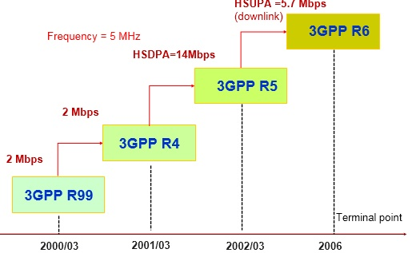

**3G Wireless Networks**

3G research, development, and establishment started in mid 1980’s. 3G was framed by IMT 2000 group (International Mobile Telecommunication) and International telecommunication Union ( ITU).

**IMT-2000 features:**

* + high-speed data services through one or multiple radio channels
  + Compatible with other fixed and mobile networks
  + Utilization of common band across different countries
  + International roaming options
  + Supporting multimedia services such as video streaming and live TV
  + Supported initial data rate of 2Mbps during R4 Phase and reached around 14 Mbps download speed during R5 Phase.

The ITU also calls the 3G mobile communication IMT-2000, and the telecom magnates in Europe call it UMTS. The 3G integrates voice communication and multimedia communication. It can provide value added services such as image, music, Webpage browsing, video conference, and some other information

Services. The 3G means globally suitable standard, new services, wider coverage, more spectrum resources, so it can support more subscribers.

The 3G system is radically different concept compared to 2G system. The 3G standards adopts the CDMA and packet switching technologies, while the 2G system adopts TDMA and circuit switching technologies. In the circuit-switching transmission mode, the line is connected and the bandwidth is occupied whether the call parties are in conversion or not. Compared with the 2G system, the 3G system will support more subscribers at a higher transmission rate.

The radio transmission technology (RTT) of the 3G system has the following requirements:

* + The variable bit rate can be offered according to the bandwidth requirement;144 kbps (during high speed movement), 384 kbps speed (while walking), 2 Mbps (indoor movements)
  + One connection can support services with different QoS requirements at the same time; 3.The delay requirements of different services can be met (including real-time voice service, best-effort data service, and so on).

**Features of the 3G Network:**

* + Including multiple systems;
  + High design consistency around the world;
  + The services in IMT-2000 are compatible with the fixed network;
  + High quality;
  + Small portable terminals are used around the world.
  + Including multiple systems;
  + High design consistency around the world;
  + The services in IMT-2000 are compatible with the fixed network;
  + High quality;
  + Small portable terminals are used around the world.

**Technical features of WCDMA**

The IMT-2000 CDMA DS, normally called as WCDMA, was presented by Europe and Japan. NTT DoCoMo. The 2G mobile telephone system of Japan have not become the international standard, so Japan stuck to international cooperation in the IMT-2000 technical scheme.

The Coherent multirate WCDMA is based on the evolutionary GSM/GPRS network technology, and its air interface adopts Direct Sequence Wideband Code Division Multiple Access (DS WCDMA). Currently, this mode is widely supported by the GSM operators in Europe, North America, and Asia Pacific and most of the operators in Japan and South Korea, so it one of the most competitive 3G mobile communication technologies.

The WCDMA is a DS-CDMA technology. Its information is extended to 3.84 Mchips and it is transferred within a bandwidth of 5 MHz.

It adopts multiple technologies to ensure QoS. Different modes are supported in this technology such as Power control mechanism, diversity techniques, QPSK modulation, Convolution codes used is turbo codes. Power control could be Open loop or closed loop.

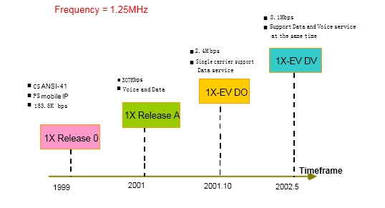

**Technical features of CDMA2000**

The cdma2000, was presented by North America. Its core network (CN) is IS-95 CDMA CN (ANSI-41); it is compatible with IS-95 CDMA. The cdma2000 technology is supported by the IS-95 CDMA operators. It is primarily used in North America. Its single-carrier cdma2000 1X uses the same bandwidth as that of the IS-95, but its capacity is twice that of the IS-95. The cdma2000 supports a service transfer rate of 144 kb/s in phase I and supports 614kb/s in phase II. The 3GPP2 has standardized this part. However, the three-carrier cdma2000 3X is complex, and its standardization and commercial prospect are not clear yet. Currently, the enhanced single-carrier cdma2000 1X EV draws much attention, and its standardization is underway. It has a high commercial potential. The cdma2000 1X EV involves two phases: Data Only (DO) and Data and Voice (DV). In early 2001, cdma2000 1X was commercially deployed in South Korea and USA successfully. Several operators in North America and Japan have announced their choice of 1XEV-DO.

**Technical features of TD-SCDMA**

The IMT-2000 CDMA TD adopts the TDD mode. It includes the UTRAN TDD presented by Europe and the TD-SCDMA presented by China. In the IMT-2000, the TDD has its independent spectrum. It partially adopts the smart antenna and uplink synchronization technologies. It is suitable for high-density low- speed access, small-area coverage, and asymmetrical data transmission.

At present, Europe has given up UTRAN TDD, so TD-SCDMA is the only radio transmission standard based on TDD. In March 2001, R4 was passed by the 3GPP, and TD-SCDMA was accepted as a formal standard. From the technical features and market requirement, as a supplementary to the FDD mode, TD-SCDMA has the development potential. However, only a few manufactures participate in the R&D of the TD-SCDMA, which limits the application prospect of the TD-SCDMA.

The TD-SCDMA integrates FDMA, TDMA, and CDMA. Its channel spacing is extended to 1.6 MHz; Frame structure of TD-SCDMA is very similar to GSM. Besides, the TDD can also be used. The mobile station (MS) will adopt dual-mode mobile phone for compatibility with the network and signaling layers of the GSM. The TD-SCDMA can smoothly evolve to the 3G, so it is supported by many GSM suppliers.

   Mobile Communication protocol

https://ilor.itrackglobal.com/ilor/objects/OSSContent:202/datastreams/ibmlogo/content

* **Nano Learning Object**

|  |  |
| --- | --- |
| **Nano Learning Object(NLO)** | **NLO Outcome** |
| Wireless Local Area Networks | Gain knowledge on the Wireless Local Area Networks |

* **NLO Contents**
* Wireless Local Area Networks

Wireless access point helps in connecting device to the network.

* + Access point (AP)

Single point of contact for connecting devices to the network.

* + WLAN has an interface called wireless network interface card (NIC) which consist of built in antenna

* + **WLAN in the Office application**

- Ideal solution to have low maintenance network.  
- Wireless solution which do not require hubs, switches and cables  
- Anywhere within the coverage area can be fully utilized. Typical example include cafeterias where meetings can be held without additional wired connection.  
- could be used for browsing any internet services.

* + **WLAN in the Home Environment**

- Low cost network infrastructure  
- Convenience of usage ; sitting at any place in home can browse internet services.  
- Muliple uses can get accessed through access point without the need of any additional wired infrastructure.

**IEEE Wireless Networking Specifications**

* + **802.11**

- operated on 2.4 GHz band  
- 1 to Mbps speed  
- the type of modulation used in phase shift keying ( PSK).

* + **802.11a**

- Operated in the 5 - 6 GHz Band  
- data rate range from 6Mbps, 12 Mbps and 24 Mbps  
- If OFDM multiplexing techniques adopted data rate upto 54 Mbps can be reached.

* + **802.11b**

- 2.4 GHz is band of operation  
- Data rate of 11 Mbps  
- Complementary code modulation ( CCK)  
- overcome transmission error due to multipath propagation.

* + **802.11g**

- Operates on 2.4 GHz band  
- data rate upto 54 Mbps within limited coverage  
- used in Robotics application  
- CSMA/CA multiple access techniques  
- Ethernet protocol used for path sharing.  
- Interoperability among different vendors

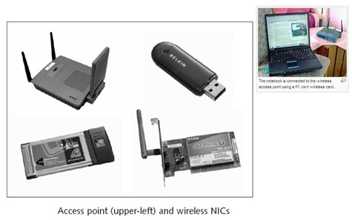

   Mobile Communication protocol

https://ilor.itrackglobal.com/ilor/objects/OSSContent:202/datastreams/ibmlogo/content

* **Nano Learning Object**

|  |  |
| --- | --- |
| **Nano Learning Object(NLO)** | **NLO Outcome** |
| Cellular - WLAN Integration | Gain knowledge on the Cellular -WLAN Integration |

* **NLO Contents**
* Cellular - WLAN Integration

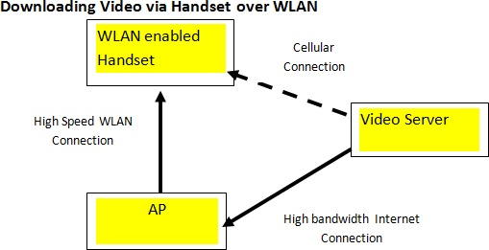

**Cellular - WLAN Integration loosely coupled integration,**

* + Core network gets connected with WLAN network
  + Core network and WLAN are developed by different vendors or same vendors.
  + Core network may be PSTN or Mobile network
  + Feasible options from business point of view.

**WLANs and Voice over IP**

* + since WLAN operates on IP packets, VOIP is always explored in telecom business.
  + Voice over IP is getting popular across the world.

**The Capacities of Handsets**

* + Handset should be designed to support multiple standards.
  + It should be capable of switching between mobile data network with WLAN depending on the priorities set.
  + Normally in the presence of WLAN coverage area, first priority would be selecting the WLAN.
  + Non availability of WLAN coverage area should make device to select mobile data network.
  + AP discovery protocols are used to detect network by handsets.
  + Handset will be capable of receiving compressed video data over Wifi from a server and share it on projector using WLAN connectivity.

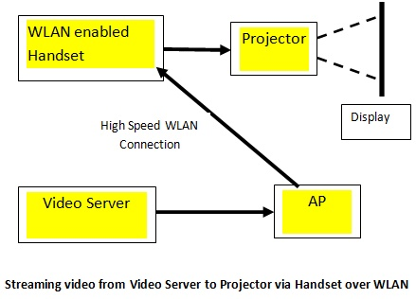

The slide explains the application of WLAN where handset downloads the data from the Access point and transfer to the projector connected via WLAN network.

**Some features of WLAN**

* + Multimedia Messaging Services (MMS), videophone, and video conferencing, via handsets.
  + video-over-IP telephone application. User can able to have a live communication where user live movements will be transferred and could be watch at end points.
  + the advances in mobile standards such as 3G and 4G indirectly or directly popularizing WLAN standards.
  + the interworking of 3G /WLAN and 4G/WLAN getting importance and need to address challenges such as authentication, security and handover.

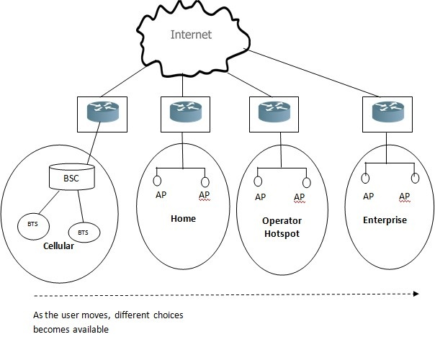

* + It is the basic requirement in any wireless network. Handover is the mechanism which switches channel from one coverage area to another coverage area as per received signal strength, quality and distance.
  + Handover algorithms varies from one standard to another.
  + Handover process has three critical phases : initiation, decision and execution.
  + Handover in Cellular network take place between cell to cell or between base station to base station.
  + Handover in WLAN is between access point to access point or between one WLAN network to another WLAN network.
  + Types : mobile assisted handover , Network controlled handover, and mobile controlled handover.

Network controlled type handover- the handover takes place as per the received signal strength of serving and neighboring access points.

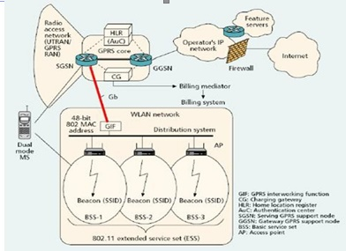

**Integrated WLAN and Cellular Data Networks**

* + In Tight coupling access point is directly gets connected to the Mobile core network. It is usually connected to SGSN.
  + WLAN gets connected to the Packet data network or IP network through Cellular network
  + It is of interest from operators to explore the connectivity between Wifi and cellular network. Cellular network provide low speed or low throughput data service over large coverage area. WLAN also called wifi provides high speed network for small coverage. Integrating these two network is of high interest.
  + Session management is an important evolution where a IP packet flow between two users successfully can take place through WLAN or cellular network.
  + The gadgets comes with the modules which can support cellular as well as WLAN.
  + Depending upon the priority set it can switch over between WLAN and cellular. Normally first priority would be connecting to WLAN for data communication and cellular network for voice communication.
  + Session management algorithms help for smooth switch over between two networks. The term also referred as handover.
  + Types: 1. Mobile assisted handover and 2. mobile-controlled handover.
  + In mobile assisted handover, the Mobile station takes several measurements but the network takes the final decision in handover.
  + Mobile controlled handover- Here Mobile takes the decision of handover in selecting the target access point.

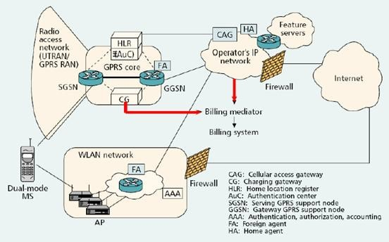

* + The figure shows the connectivity between WLAN and GPRS using loose coupling.
  + Here WLAN network or the access points of the WLAN network gets connected to the external packet data network through direct IP connection and not through cellular network.
  + However Mobile can be connected to the WLAN or cellular data transfer applications.
  + Based on the priority , any of these network will be selected for internet connectivity.
  + Types of handover :soft and the hard handover.
  + Soft handover is between two access points or between two base stations using same frequency channel. Make before break concept.
  + Hard handover is between two entities using different frequency channels. Break before make concept

   Mobile Communication protocol

https://ilor.itrackglobal.com/ilor/objects/OSSContent:202/datastreams/ibmlogo/content

* **Nano Learning Object**

|  |  |
| --- | --- |
| **Nano Learning Object(NLO)** | **NLO Outcome** |
| All-IP and 4G networks | Learn about all-IP and 4G networks |

* **NLO Contents**
* All-IP and 4G networks
  + All IP basically intended to provide IP connectivity between different entities of Mobile network. For example connectivity between BSC and MSC, BSC and SGSN, MSC and HLR etc.
  + All IP also intended to provide data transfer in cellular and WLAN using IP standards.

**Evolution of UMTS ( 3G) R99 to all-IP network**

* + Common core network for all type of access reducing operational cost and investment cost.
  + helps in supporting many IP applications into mobile network.
  + SS7 signaling replaced by IP.
  + PS domain supports all services including multimedia data service through GPRS core network. Session Initiation Protocol will take over such services.
  + UMTS all IP architecture support voice and data applications through PS domain.

**Different options of UMTS all IP network :**

* + It supports Packet switching multimedia and Packet switching data services.
  + First option is extended to accommodate Circuit switching voice services over a SGSN and GGSN

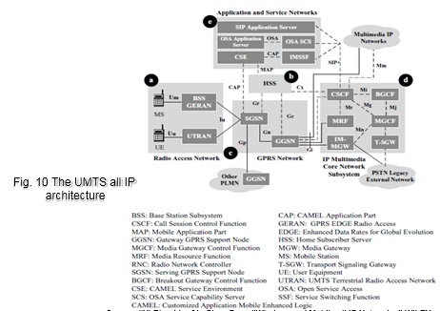

**Radio Access Network**

- It includes UE (User Entity/ Mobile station) connected to Node B. The node B and UE constitute UTRAN (UMTS Radio access network). It is similar to GERAN where node B is connected to RNC. RNC is further connected SGSN network.

**Home Subscriber Server**

- HSS consists of functional modules which performs the functions of HLR, VLR, AUC and EIR. It serves as a master data base. It essentially maintains the subscriber data base such as IMSI, MSISDN, VLR address, Location area details and Cell global identity numbers.

**GPRS Network**

- It consists of GPRS and SGSN Nodes.

The major functions of these nodes are mobility management and session management.

- Capable of interacting with any Radio access network UTRAN or GERAN  
- IP based connectivity exists in between SGSN entity and GGSN entity. Gr and Gc interfaces are sued to connect HSS with SGSN and GGSN respectively.  
- Gn interface is used to connect RNC /BSC to SGSN. Gi interface is used to connect GGSN with external packet data network

**IP Multimedia Subsystem**

- IMS is configured between the GGSN and the external packet or circuit switching network.  
- It is responsible to handle call session initiation and control. It will be exectured at SIP server.  
- Essential functional elements of IMS are : MGW, IP Media GW, Transport Signalling GW  
- These servers are required to handle Voice over IP within the network.

**Application and Service Network**

-These networks are designed using dedicated application servers which handles call control services and connection control services separately.

**“All-IP network “-2nd Option**

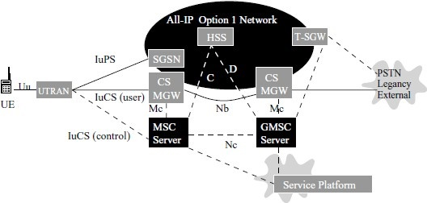

-R99 UMTS Circuit switching domain and PS domains to evolved independently.

- MSC server and GMSC server were introduced. MSC server handles the signalling information.  
- MGW handles the bearer service or data service.  
- HSS and MSC Server are interfaced using MAP signalling  
- The two Circuit switched Media Gate way servers are concerned with voice format conversion between Packet switched and Circuit switched networks.

   Mobile Communication protocol

https://ilor.itrackglobal.com/ilor/objects/OSSContent:202/datastreams/ibmlogo/content

* **Nano Learning Object**

|  |  |
| --- | --- |
| **Nano Learning Object(NLO)** | **NLO Outcome** |
| IT Applications in Telecom Business | Gain knowledge on the IT Applications in Telecom Business |

* **NLO Contents**
* IT Applications in Telecom Business
  1. Smart Meter
  2. Infrastructure Management using IoT
  3. Digital VAS (Value Added Services)
  4. Outage Management Systems
  5. Unified User Profiling
  6. Business Intelligence (BI)

different possible ways where telecom companies can provide digital technologies are

**Smart Meter application**

* 1. These are devices which transmit measurement information through Wifi or cellular networks and used for customer billings.
  2. It is also used for operating electric systems remotely.
  3. Most of the smart meter operates in bi-direction where it can transmit information as well as it can receive commands.
  4. The smart meter infrastructure sometimes called Advanced metering infrastructure.

**Infrastructure Management by Internet of Things**

- IOT is getting geared up due to recent advances in telecommunication. With the evolution of 4G standards and high throughput speed, connecting different neighboring devices and far off devices through wireless media is getting common.  
- Most of the vendors are developing cloud based telecom infrastructure where the functionality of mobile switching center, data base such as AUC, EIR, HLR etc will be hosted through cloud

server. The operator need not investment on these entities for full capacity. The resources from these entities are dynamically allocated based on the traffic or quality required defined by the operators.

**Value Added Services:**

- mobile advertising , mobile TV, online entertainments, gaming etc.  
- operators exploring many value added services ( VAS) for increasing their revenue.

**Outage Management Systems:**

- Continuous monitoring of systems and reporting whenever outage takes place.  
- alarm reporting  
- duration and estimated time of correction or restoration of alarms.  
- Automatic meter reading and interactive voice response software along with GIS make effective outage predictions which helps client to maintain healthy network.

**Unified User Profiling:**

- Support to data analytics which can handle huge data of the customers.  
- Particularly used in customer relationship management, observing customer usage pattern on specific services, managing customer cycle from registration to exit.

**Business Intelligence (BI):**

- required for predictive analysis and forecasting helps in identifying market trends.  
- required in product development and advertisement etc.

   Mobile Communication protocol

https://ilor.itrackglobal.com/ilor/objects/OSSContent:202/datastreams/ibmlogo/content

* **Nano Learning Object**

|  |  |
| --- | --- |
| **Nano Learning Object(NLO)** | **NLO Outcome** |
| Introduction to OSS/BSS | Learn about the introduction to OSS/BSS |

* **NLO Contents**
* Introduction to OSS/BSS
  + Operational Support System (OSS) performs management, engineering, inventory, planning, and repair functions for telecom operators.
  + BSS used in handling customers for managing customer related data, bill processing and for payment options.
  + often abbreviated as OSS/BSS.

**OSS/BSS**

* + OSS is related in handling operating and maintenance of the network
  + BSS used in handling customers for managing customer related data, bill processing and for payment options.
  + OSS functions include 1. Network Management Systems ( NMS), 2. Service Delivery, 3. Service fulfillment ( inventory and activation) 4. Provisioning , 5. Service assurance and 6. Customer care

**Business support systems (BSS)**

* + Used to run its business operations for customer requirement.
  + It support “ Customer management” , “Product management”, “Revenue management and Order management”.

**Product management**

* + Involves in marketing, product development, sales and meeting target

**Customer management**

* + Customer care services such as 24x7 web based service, customer care executives etc.

**Revenue management**

* + Billing for the usage, charging and settlement follow ups.

**Order management**

* + It include Order decomposition, order orchestration, order fallout and order status management.

**Overview of OSS/BSS Applications**

* + OSSs and BSSs are essential for the smooth running of service networks and business operations.
  + OSSs and BSSs are the base on which a telecommunications company builds its business; they facilitate the management of networks operations and customer relations respectively.
  + They are also essential elements of a Service Delivery Environment (SDE), through which service providers deliver enhanced IPTV, WEB, IMS, or a combination of services to large numbers of customers.

Telecommunications companies and service providers, to render services, use equipment as well as software embedded in their networks. OSSs and BSSs are essential for the smooth running of service networks and business operations. OSSs and BSSs are the base on which a telecommunications company builds its business; they facilitate the management of networks operations and customer relations respectively.

They are also essential elements of a Service Delivery Environment (SDE), through which service providers deliver enhanced IPTV, WEB, IMS, or a combination of services to large numbers of customers.

Enhancing the customer experience is the only way through which a telecommunications business can gain and sustain a competitive edge; OSSs and BSSs make this possible. OSSs ensure error-free running of an operator’s network. They are managed by a team of engineers including network planners, architects, service designers, and operations and support team personnel – all of whom operate from a Network Operations Centre (NOC). OSS applications monitor and manage the operational efficiency/performance of the network, server, service fulfilment, service assurance, and provisioning. Additionally, they take care of service quality, resource management, and network management. OSSs form part of operators’ back-office activities.

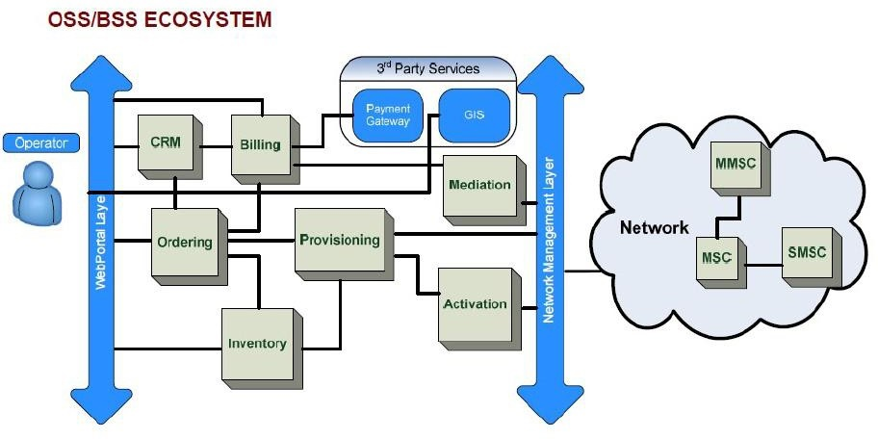

Early OSSs and BSSs had a clear distinction, and BSS/OSS interfaces were simple. For example, for customer order management, the BSS would take the order, put the billing in process, and pass the requirement to the OSS for service fulfilment. More recently, services rendered by operators are much more differentiated, flexible, and complex. As a result, the interfaces between OSSs and BSSs are deeply intertwined.

In a nutshell, these systems are more closely integrated as the telecommunications industry undergoes transformation. A pictorial representation of the interactions between OSSs and BSSs is presented in fig.12.

- OSS related to service is the interface between the BSS and NMS domains. We can flow of data continuously between services. For a given service provide, network and business related solutions are provided.

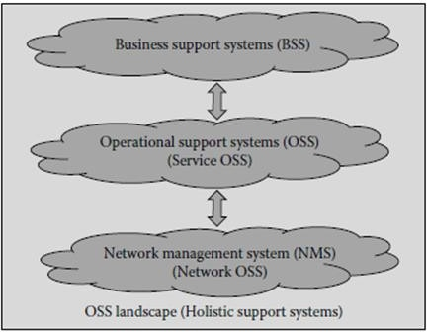

The OSS landscape shown in figure shows the interaction between BSS , OSS and NMS.

The BSS is the highest level which can interact with OSS directly. NMS can interact with OSS whereas OSS can parallely interact with BSS and NMS.

   Mobile Communication protocol

https://ilor.itrackglobal.com/ilor/objects/OSSContent:202/datastreams/ibmlogo/content

* **Nano Learning Object**

|  |  |
| --- | --- |
| **Nano Learning Object(NLO)** | **NLO Outcome** |
| Block diagram of GSM system | Learn about the block diagram of GSM System |

* **NLO Contents**
* Block diagram of GSM system

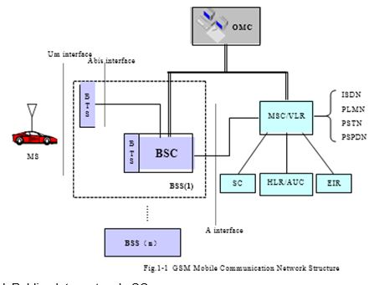

PSPDN—Packet switched Public data network SC- Short message centre

**GSM system consists of:**

Mobile Station, Network Subsystem , Base Station Subsystem and Operation and Maintenance Subsystem

<="" b="" style="box-sizing: border-box;">

NSS is the core element of network switching which interfaces with subscriber services for voice and data.

**NSS Main components are:**

Mobile Switching Centre – switches the voice data between BSS and external circuit switched network

Visitor Location Register –subset of MSC which stores all the information of subscriber under one particular MSC

Home Location Register – master data base which consists of all the subscriber information in the network

Equipment Identification Register – data serves which stores IMEI number

Authentication Centre – stores cryptographic key called Ki used for authentication Short

Message Centre – server to handle short message services.

Home Location Register - HLR stores all the information of subscribers, including the roaming authority, basic services, supplementary services, and current location information. It provides routing information for MSC for call setup. HLR may cover several MSC service areas or even the whole PLMN.

Visitor Location Register - VLR stores all subscriber information in its coverage area and provides call setup conditions for the registered mobile subscribers. As a dynamic database, VLR must exchange large volume of data with HLR to ensure data validity. When an MS leaves the controlling area of a VLR, it registers in another VLR. The original VLR deletes the temporary records of that subscriber. VLR integrated within MSC.

Equipment Identification Register - EIR stores the parameters related to MS. It can identify, monitor, and block the MS. ERI preventing unauthorized MS from accessing the network.

Authentication Centre - AUC is a strictly protected database that stores subscriber authentication information and encryption parameters. AUC integrated with HLR physically.

**Base Station Subsystem**

Base Station Controller (BSC) and Base Transceiver Station (BTS) are the components of BSS.

Base Station Controller - Located between MSC and BTS, it controls and manages more than one BTS. It performs radio channel assignments. BTS and MS transmit power control, and inter-cell handover. BSC is also small a switch that converge and connects local network with the MSC through A interface. Abis interface connects BTS to BSC.

Base Transceiver Station - BTS is wireless transceiving equipment controlled by the BSC in BSS. BTS carries radio transmission. It performs wired-related wireless conversion, radio diversity, radio channel encryption, and hopping. Um interface connects BTS to MS.

Transcoding Unit - Located between BSC and Mobile switching center, TRAU transcodes between 16 kbps RPE-LTP codes and 64 kbps a law PCM codes.

Operation and Maintenance Subsystem OMS is operation & maintenance part of GSM. Functional units in GSM are connected to OMS internal networks. OMS monitors various functional units in GSM network, submits status report, and performs fault diagnosis.

The OMC-S is for NSS maintenance and OMC-R is for for BSS maintenance.

**Mobile Station of GSM**

Mobile station is subscriber equipment in GSM, it can be vehicle installed or hand portable. MS consists of mobile equipment and SIM.

Mobile equipment processes voice signals, receives and transmits radio signals.

SIM stores all information required for identifying a subscriber and security information, preventing unauthorized subscribers. Mobile equipment cannot access GSM network without a SIM card.

GSM service area refers to the total area covered by networks of all GSM operators. Network consists of several MSC service areas, each of which consists of several cells. Logically, several cells form a location area (LA).

MSC Service Area – A PLMN includes multiple MSC service areas. MSC service area refers to the MSC coverage area, that is, the total area covered by BTS under control of BSC connected to MSC. All MSs in the service area table register in local VLR. Therefore, in actual network, MSC is always integrated with VLR as a node.

Mobile Communication protocol

https://ilor.itrackglobal.com/ilor/objects/OSSContent:202/datastreams/ibmlogo/content

* **Nano Learning Object**

|  |  |
| --- | --- |
| **Nano Learning Object(NLO)** | **NLO Outcome** |
| Wireless coverage area structure | Gain knowledge on Wireless Coverage area Structure |

* **NLO Contents**
* Wireless coverage area structure

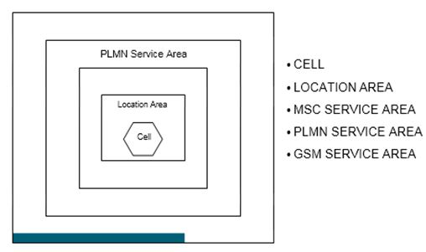

Cell - Area covered by an antenna. Smallest area in GSM. Cell is identified by a unique number called Cell Global Identity (CGI).

Location Area- Area covered by one BSC ( group of cells). Every location area identified by LAI ( location area identiy)

MSC Service Area- It is defined as service supported by one MSC. PLMN Service area- It is defined as service supported in one state. GSM Service area – Entire country or entire world.

**GSM Wireless operating bands**

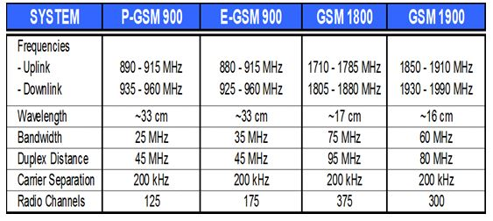

**Working band**

* 1. 900 MHz band   
     Uplink (MS transmitting and BS receiving) frequency range: 890 MHz ~ 915 MHz Downlink (BS transmitting and MS receiving) frequency range: 935 MHz ~ 960MHz
  2. Extended 900 MHz band   
     Uplink (MS transmitting and BS receiving) frequency range: 880 MHz ~ 915 MHz Downlink (BS transmitting and MS receiving) frequency range: 925 MHz ~ 960 MHz
  3. 1,800 MHz band   
     Uplink (MS transmitting and BS receiving) frequency range: 1,710 MHz ~ 1,785 MHz   
     Downlink (BS transmitting and MS receiving) frequency range: 1,805 MHz ~ 1,880 MHz
  4. 1,900 MHz band   
     Uplink (MS transmitting and BS receiving) frequency range: 1,850 MHz ~ 1,910 MHz Downlink (BS transmitting and MS receiving) frequency range: 1,930 MHz ~ 1,990 MHz

**Channel interval**

The interval between two adjacent channels in any band is 200 kHz.

**Channel configuration**

All channels are configured with the same interval.

1      900 MHz frequency band

The channel numbers are in the range of 1 ~ 124. There are 124 frequency bands in all.

2      Extended 900MHz frequency band

The channel numbers are in the range of 0 ~ 124 and 975 ~ 1023. There are 174 frequency bands in all.

The relationship between a channel number and nominal central frequency of a frequency band is illustrated as follows:

Fuplink = 890 + 0.2 n (MHz), 0 n 124

Fuplink = 890 + 0.2 (n-1024) (MHz), 975 n 1023

Fdownlink= Fuplink(n) + 45 (MHz)

The duplex interval is 45 MHz bandwidth

3      1,800 MHz frequency band

The channel numbers are in the range of 512 ~ 885. There are 374 frequency bands in all.

The relationship between a channel number and nominal central frequency of a frequency band is illustrated as follows:

“Fuplink link = 1710.2 + 0.2 (n-512) (MHz)” where n is the frequency “Fdown link = Fu (n) + 95 (MHz)” where n is the frequency

512 n 885

The duplex interval is 95 MHz bandwidth

4      1,900 MHz frequency band

The channel numbers are in the range of 512 ~ 811. There are 300 frequency bands in all.

**GSM frequency bands**

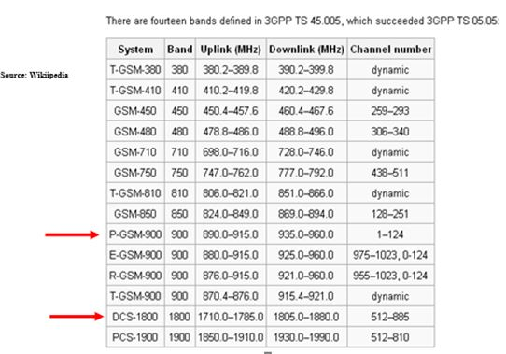

There are different band assigned for GSM as per ITU regulations. GSM 900 MHz and GSM 1800 Mhz band are commonly used in India.

**GSM 900 Mhz Band**

* 1. In India , Airtel, Idea and BSNL uses 900 MHz band

**GSM 1800 Mhz Band**

* 1. In India, Reliance comm, Aircel and vodaphone uses 1800 Mhz band

   Mobile Communication protocol

https://ilor.itrackglobal.com/ilor/objects/OSSContent:202/datastreams/ibmlogo/content

* **Nano Learning Object**

|  |  |
| --- | --- |
| **Nano Learning Object(NLO)** | **NLO Outcome** |
| Cell Global Identity (CGI) | Learn about the Cell Global Identity (CGI) |

* **NLO Contents**
* Cell Global Identity (CGI)

**“Cell Global Identity (CGI)”**

* + It is used for identifying individual cells within an LA

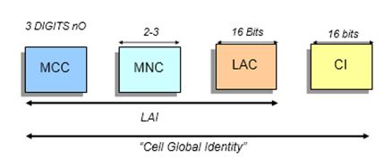

MCC = Mobile country code – It is unique for the country – For India it is 404 MNC= Mobile network code- It is unique for the operator – For Idea it is 44 LAC= Location area code- It has maximum 16 bits – Its range is 0000 to FFFF CI= Cell Identity – 0000 to FFFF

**Identifiers**

**“MSISDN = CC +NDC +SN”**

CC is Country Code ; +91 for Inida

NDC is National Destination Code ; 97 for IDEA SN is Subscriber number

MSISDN number also called Subscriber number

**“IMSI = MCC + MNC + MSIN ( fixed 15 digits )”**

MCC is Mobile Country Code ; For example 404 for India MNC is Mobile Network Code; For example 44 for Idea MSIN is Mobile Subscriber Identification number.

IMSI is also called as SIM Number

**“IMEI = TAC + FAC + SNR + SP.”**

“TAC is Type Approval Code TAC : 6 decimal digits

FAC is Final Assembly Code FAC : 6 decimal digits assigned by manufacturer. SNR is Serial Number is 6 decimal digits assigned by manufacturer

SP is spare bits: 1 decimal place”

**“LAI = MCC + MNC + LAC”**

“MCC is Mobile Country Code is country specific”

“MNC is Mobile Network Code which is operator specifc”

“LAC is Location Area Code normally assigned to one BSC area”

“International Mobile Station Equipment Identity (IMEI Number)”

-IMEI is a serial number which is unique to hardware.

* + Allocated by equipment manufacturer
  + once MS is registered, the information is stored in Equipment Identification Register ( EIR)
  + “This is allocated by the equipment manufacturer and registered by the network operator, who stores it in the Entrepreneurs-in Residence”

**“International Mobile Subscriber Identity (IMSI Number)”**

* + Unique to SIM also called as SIM number
  + all IMSI number will be on SIM and will be stored in Home location register.
  + During registration process, IMSI number is used for authentication along with authentication key

**“Temporary Mobile Subscriber Identity TMSI”**

* + It is ALLOCATED by VLR during location update or registration process
  + it is used as indicator of present location of subscirber.
  + it is stored in SIM and VLR . It can go up ot 32 bits.

**Cell Identifier CI**

* + It may have maximum of 16 bits
  + It is unique to the cells assigned by the operator during the planning phase.
  + It is a part of Cell global identity

**Channel Types**

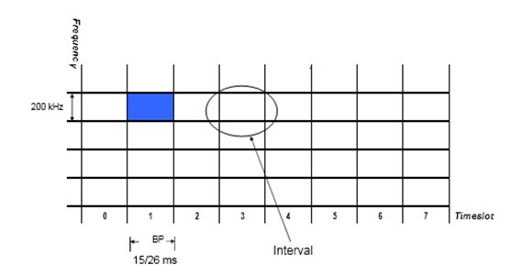

**Physical channel and Logical Channels.**

One frequency in GSM supports 8 time slots. ( TDMA Principle). Each timeslot in GSM is called Physical channel. Based on the information type on physical channel, different Logical channels are defined.

   Mobile Communication protocol

https://ilor.itrackglobal.com/ilor/objects/OSSContent:202/datastreams/ibmlogo/content

* **Nano Learning Object**

|  |  |
| --- | --- |
| **Nano Learning Object(NLO)** | **NLO Outcome** |
| Voice Transform Process | Gain knowledge on the Voice Transform Process |

* **NLO Contents**
* Voice Transform Process

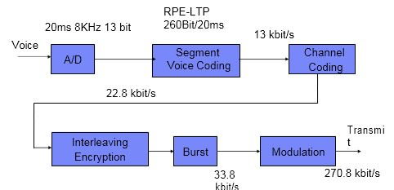

* + The continuous voice signal is segmented into a frame of 20 msec and each segment is sampled at the rate of 8KHz. Every sample is further represented by 13 bits.
  + The output of the analog to digital converter is 104 kbps
  + The out of A/D is given to voice coding which uses RPELTP algorithm to produce a output of 13 kbps. Voice coding is used to compress the data
  + The channel coding module accept 13kbps data and produces a output of 22.8 Kbps. Convolution coding is used as voice coder in GSM.
  + The channel coder is used to correct error detection and corrections. It is used for short sequence error.
  + The output of channel coder is given to Interleaving module which produces the output of 22.8 kbps. The out of Interleaver is given to Burst module where burst is formed with 156.25 bits.
  + Finally the modulation module takes these baseband burst to produce an output of 270.8 kbps.
  + GMSK modulation used in GSM for analog voice signals, first make A/D conversion before doing voice coding to output 13Kbit/s digital voice signals. To control errors in the process of transmission, channel coding and interlacing processing shall be conducted on digital voice signals, which are then encrypted according to the input/output bit stream of 1:1. These bits are grouped into 8 1/2 burst pulse sequences (corresponding to voice signals/20ms segment) before they are transmitted at about 270Kbit/s in the appropriate timeslots.

The process of receiving voice signals is as follows: for the wireless signals sent by BTS, first do demodulation before decomposing and decrypting burst pulses. After every 8 1/2 burst pulse sequences are received, they are subjected to interlacing processing and re-assembled into 456 bit information.

After that, do channel decoding and error detection and corrections that occur in the middle of transmission before finally conducting voice decoding of the bit stream generated by the decoder and converting it analog voices.

Mobile Communication protocol

https://ilor.itrackglobal.com/ilor/objects/OSSContent:202/datastreams/ibmlogo/content

* **Nano Learning Object**

|  |  |
| --- | --- |
| **Nano Learning Object(NLO)** | **NLO Outcome** |
| Voice Transform Process | Gain knowledge on the Voice Transform Process |

* **NLO Contents**
* Voice Transform Process



* + The continuous voice signal is segmented into a frame of 20 msec and each segment is sampled at the rate of 8KHz. Every sample is further represented by 13 bits.
  + The output of the analog to digital converter is 104 kbps
  + The out of A/D is given to voice coding which uses RPELTP algorithm to produce a output of 13 kbps. Voice coding is used to compress the data
  + The channel coding module accept 13kbps data and produces a output of 22.8 Kbps. Convolution coding is used as voice coder in GSM.
  + The channel coder is used to correct error detection and corrections. It is used for short sequence error.
  + The output of channel coder is given to Interleaving module which produces the output of 22.8 kbps. The out of Interleaver is given to Burst module where burst is formed with 156.25 bits.
  + Finally the modulation module takes these baseband burst to produce an output of 270.8 kbps.
  + GMSK modulation used in GSM for analog voice signals, first make A/D conversion before doing voice coding to output 13Kbit/s digital voice signals. To control errors in the process of transmission, channel coding and interlacing processing shall be conducted on digital voice signals, which are then encrypted according to the input/output bit stream of 1:1. These bits are grouped into 8 1/2 burst pulse sequences (corresponding to voice signals/20ms segment) before they are transmitted at about 270Kbit/s in the appropriate timeslots.

The process of receiving voice signals is as follows: for the wireless signals sent by BTS, first do demodulation before decomposing and decrypting burst pulses. After every 8 1/2 burst pulse sequences are received, they are subjected to interlacing processing and re-assembled into 456 bit information.

After that, do channel decoding and error detection and corrections that occur in the middle of transmission before finally conducting voice decoding of the bit stream generated by the decoder and converting it analog voices.

Mobile Communication protocol

https://ilor.itrackglobal.com/ilor/objects/OSSContent:202/datastreams/ibmlogo/content

* **Nano Learning Object**

|  |  |
| --- | --- |
| **Nano Learning Object(NLO)** | **NLO Outcome** |
| Channel Coding | Learn about the Channel Coding |

* **NLO Contents**
* Channel Coding

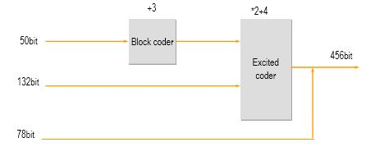

Total bits = 456

50 very critical bits, 132 critical bits and 78 normal bits

**Convolutional code:**

It has k information bits into n bits. Both k and n are very small so that they are used for transmission in a serial port manner. Besides they also show very little delay. The coded n code elements are not only related to k information code elements of this packet, but also to information code elements in the preceding (N-1), where N is called constraint length. The convolutional code is generally represented as (n, k, N). The error tolerance of the convolutional codes increases as N increases while its error rate decreases as N increases. The convolutional code is mainly designed for error correction. When the demodulator uses the maximum likelihood estimation method, it can generate very effective error correction results. Convolution code can be expressed as (n, k, N). The error-correction capability in convolution encoding grows stronger with the rise of N, while the error probability decreases exponentially as N rises. The convolution code is used to correct errors, and it is effective when the decoder works in the maximum likelihood estimate mode.

Packet code: This is a kind of shortened loop code, which gets the redundancy bits by increasing the exclusive-or algorithm of information bits and maps k input information bits to no output binary code elements (n>k) through exclusive-or algorithm. The packet code is designed mainly to detect and correct error codes in groups and it is used in a mixed way with the convolutional code. The packet code is used for detecting and correcting errors in groups. It is generally used along with the convolution code.

**An example of interleaving**

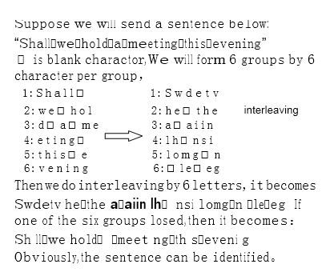

**Interlacing Technology**

The occurrence of burst error codes in wireless communication is usually caused by fading that lasts a long time. It is not enough to detect and correct errors in the above-mentioned channel coding scheme.

To better address the issue of error codes, the interlacing technology is introduced to the system. The interleaving technology is adopted in channels to better solve the error problems.

**Channel Interleaving**

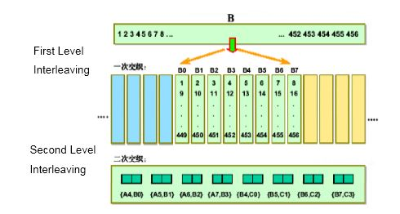

**GSM - Encryption**

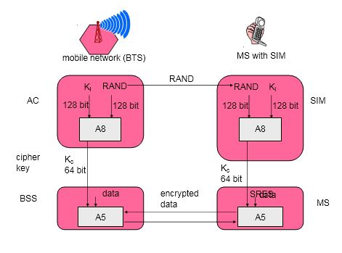

**Encryption Process:**

- 128 bit pseudo Random number is forwarded to the mobile station from the network.   
- The Cryptograpic key Ki and 128 bit random number enables an algorithm called A8 results in 64 bit Ciphering Key Kc  
- The cipher key along with the data enables an algorithm called A5 results in an encrypted data.  
- The encrypted data is sent to the modulator , later transmitted at the transmitter end.  
  
- Reverse process takes place at the receiver end ( network end)

Mobile Communication protocol

https://ilor.itrackglobal.com/ilor/objects/OSSContent:202/datastreams/ibmlogo/content

* **Nano Learning Object**

|  |  |
| --- | --- |
| **Nano Learning Object(NLO)** | **NLO Outcome** |
| Modulation | Gain knowledge on the concept of Modulation |

* **NLO Contents**
* Modulation

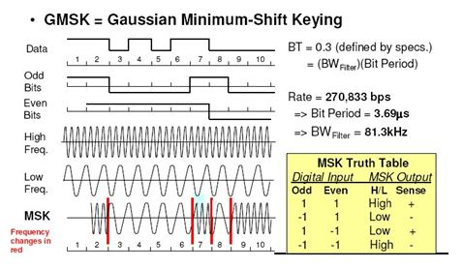

* + Modulation type used in GSM is GMSK ( Gausian Minimum Shift keying. The modulation rate is 270.833 kilobits per sec
  + Demodulation takes place using Viterbi algorithm. Gaussian demodulation filter is used to reduce the modulation spectrum.
  + The waveform is shown in the diagram. It is a special type of Frequency shift modulation.
  + The center frequency of the carrier serves as constant phase reference, the signal 67.708 KHz will cause steady increment of phase.
  + The phase rotates complete cycle of 360 degrees and takes 67,708 times per second. For a bit duration of 1/270.833 KHz, the phase angle moves ¼ of a circle in I/G diagram which comes around 90 degrees. The data symbol one can be looked as 90 degree plus the phase angle. Two 1s result in a phase increment of 180 degree which makes an increment of 270 degrees and so on. The data 0 indicates same phase angle change in the reverse direction.

**Traffic**

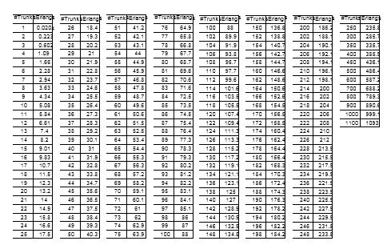

* + “Traffic is defined as numbers of subscribers the network can support”

For example. 5 different subsriber made calls in peak hour as follows… 20min, 5min, 4 min.. 50 sec ,,20 sec… Find traffic.. Ans: A=0.5

Q) How many subsriber can a traffic of 9.83 Erlang dcan support?

Q) For 1000 subsriber what is trafic..

Q) For 34 channesl what is configuration ?

Q) How many subsriber can S3/3/1 can handle

Q) Sector1=1100 subscriber, Sectro2=600 subsriber, sector 3= 1900 subsriber. In ZTE S12/12/12 can support???

**GOS “Grade of Service（GOS）”**

* + Parameter used to define network congestion. Grade of Service is defined as the degree of Telephone network‟s congestion. Also termed as call loss rate.
  + 2% GOS means out of 100 calls, 98 times subscriber can able to connect to the call while 2 times he fails to connect.
  + 2-5% of GoS is taken into consideration during planning phase by any network operators.

**Traffic Table P.02 (GOS)**

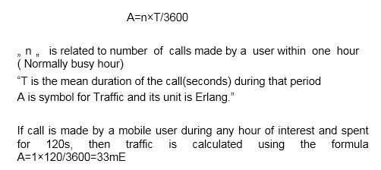

Mobile Communication protocol

https://ilor.itrackglobal.com/ilor/objects/OSSContent:202/datastreams/ibmlogo/content

* **Nano Learning Object**

|  |  |
| --- | --- |
| **Nano Learning Object(NLO)** | **NLO Outcome** |
| Suggested Channel Configuration | Understand about the Suggested Channel Configuration |

* **NLO Contents**
* Suggested Channel Configuration

**Based on 2% GoS, operators adopts followed traffic model.**

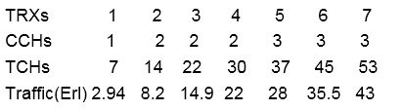

This the channel configuration normally used at Operator. Normally 2% GOS is used.

* + For one Transceiver module, 7 TCH and 1 CCH is configured. ( Assuming zero GPRS channel)
  + For two Transceiver module, 14 TCH and 2 CCH is configured. Similarly for other cases.

**GSM - authentication**

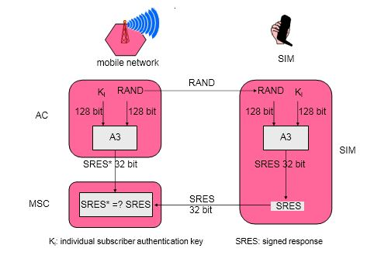

* + Every SIM comes with Ki which is called as Cryptographic identification Key.
  + During registration phase, network sends 128 bit random number to Mobile Station and same number is used at AUC
  + The 128 bit random number and Ki ( 128 bit ) together used to enable an algorithm A3 which produces signed 32 bit result. Similar thing happens at network.
  + The signed result produced from Mobile is sent back to the network where it is compared with result produced at network. If both are same authentication is successful.

**Multiple Access Technologies**

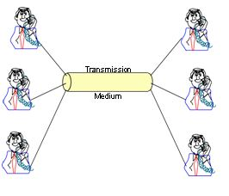

Multiplexing（Multiplex Access Technology）：Transmit two or more voice signals through one pair of cables without mutual interference at the same time.

Multiplexing technology: used to transmit voice and data of many users on a single channel. Mobile radio Transmission types:

Simplex- Only transmission or reception is possible. Only one frequency channel between tx and rx – FM receiver

Half Duplex – Transmit or receive but one at a time. Only one frequency channel between tx and rx- Ex. Police hand set

Full Duplex- Simultaneous transmission or receiption is possible. Two frequencies are used between two transceivers. Mobile hand set operates on Full duplex.

**Multiple access technology types:**

**FDMA,TDMA and CDMA**

FDMA- Assigns individual channels to an individual subscriber

Types: FDMA/FDD ---The subscribers are pair of frequencies ;uplink and downlink frequencies. Limitation: ineffective channel utilization or spectrum utilization

TDMA/FDD ------ GSM( 1 carrier -8 subscriber) and TDMA/TDD, CDMA/FDD -----IS95

FDMA ; N= Bt-2Bguard/Bc;

N---total channels,

Bt—total spect..allocated…….Bc---channel bw

TDMA---- Entire “radio spectrum” is divided into multiple time slots and in each slot only one subscriber is permitted.

In TDMA/FDD, two frequencies are used. One frequency for uplink and other for downlink.

CDMA---More users can be fit into one frequency. Practically 33 subscribers are used for one IS 95 frequency.

For the communication, it is similar to the road , how to let the more people communicate in the channel is imortant , like the road ,the number of holding the people is limited by the time and breadth, it is very alike , In communication , it is limited by the time , frequency and power ; so, the access tenique is generated;

About the multiple access , it is similar to the road , in fact ; many people walked in the same road; SO , how to hold more people is important in the road ; according to the breadth of the road ,people can go one by one according to the time ,or people can go at the same time if only the road is broad enough ;

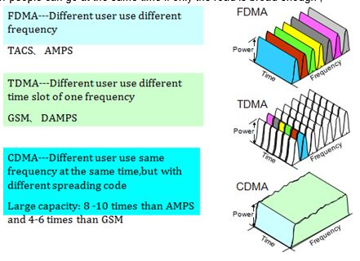

* + In face , Large capacity is related to Eb/I。,C/I
  + Because the frequence reuse , voice activation , cellor division,can provide large capacity;
  + Cellor division is equle to reduce the coefficient of frequence reuse , which makes the co-channel interference reduced ,So can add capacity;
  + Voice activation is that the user transmits signal when it communicated with others, which makes background interference reduced, So can add capacity;

Mobile Communication protocol

https://ilor.itrackglobal.com/ilor/objects/OSSContent:202/datastreams/ibmlogo/content

* **Nano Learning Object**

|  |  |
| --- | --- |
| **Nano Learning Object(NLO)** | **NLO Outcome** |
| Frequency Reuse | Learn how to reuse the Frequency |

* **NLO Contents**
* Frequency Reuse

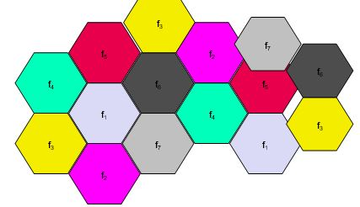

large-capacity mobile telephone network usually needs dozens of or even hundreds of BTSs to cover its entire service area, and they must meet the requirement for high traffic density (that is, the BTS capacity should be large enough). On the other hand, the GSM network has only limited resources available.

After dozens of years of experiment and practice, for the PLMN, the analog communication system with the cellular technology has developed to be fairly mature. The effectiveness of this structure has been recognized by engineering and planning personnel.

To describe the cellular network structure in a simpler way, let us suppose the ideal conditions: The BTS is deployed on a plain, there is not any obstacle on the ground and omni antennas are used. Under these conditions, the BTS covers a round area. If seven circles somewhat overlap one another, then the connection border (or handover border in the case of cellular network) of the circle at the center forms a regular hexagon. The corresponding co-frequency interference will be distributed regularly along the sides of the hexagon, as shown in fig.

Therefore, in a service area (taken as an omni-directional area), the normal handover borders of adjacent cells form multiple adjacent regular hexagons like a beehive, which is called the cellular structure. However, in order to use the cellular structure to meet the needs of co-frequency reuse and the increase in the coverage area in the radio planning and design, it is necessary to divide cells into a reuse area cluster, which connects another reuse area cluster to expand the coverage area and implement frequency reuse.

A reuse area cluster is a group composed of several adjacent BTS cells. In a reuse area cluster, all the available channels are evenly allocated to each BTS cell or sector cell, as shown in Fig. 1.1-2. Two same radio area clusters are adjacent to each other. Two BTS cells in the appropriate locations in the cluster are co-frequency reuse areas, while the adjacent radio area clusters are co-frequency reuse area clusters. In addition, the cellular splitting technology can be used to continuously make smaller BTS coverage areas for more times of frequency reuse to meet the needs of the increasing subscriber density. This technology divides an omni BTS into several sector cell BTSs or divide one sector cell BTS into multiple sector cell BTSs with an even smaller coverage radius

**Reuse factor =12**

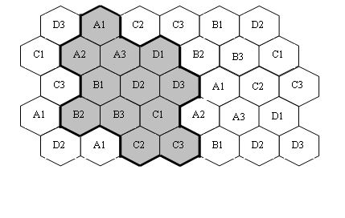

**Frequency Reuse Factor**

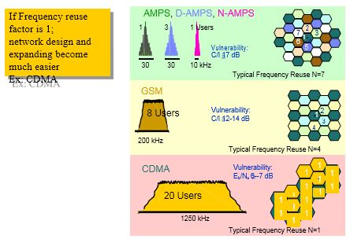

This only want to show the cdma , Frequency reuse is 1 , because of the 1 , it lead to the C/I . Here , some questions will be put to , like “soft capability” and “frequency reuse “;

   Mobile Communication protocol

https://ilor.itrackglobal.com/ilor/objects/OSSContent:202/datastreams/ibmlogo/content

* **Nano Learning Object**

|  |  |
| --- | --- |
| **Nano Learning Object(NLO)** | **NLO Outcome** |
| Location Update / Registration Procedures | Gain knowledge on the concept of Location Update / Registration Procedures |

* **NLO Contents**
* Location Update / Registration Procedures

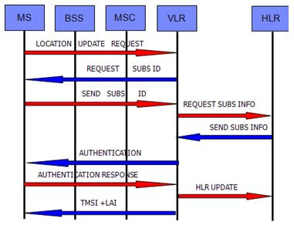

Let us go through the mobility functions of GSM..... Basic Location update.....

Though basically similar, the call process of mobile subscribers and that of ordinary fixed subscribers are different in the following aspects:

Before a mobile subscriber originates a call, he should first input the number, ensure that no modification is needed, and then send the call.

Before the number is sent out and the call is connected, there is some additional information that should be transferred between mobile stations (MS) and the network. Such operations are automatically performed by the equipment, with no need for user interference, but it results in a certain delay.

**Initialization**

“Initialization is a random access process. It starts from MS which sends a “channel request” message on RACH”.

“After receiving this message, BTS notifies BSC, and attaches BTS’s estimation of the transmission delay (TA) from this MS to BTS and the cause for the current access”.

BSC will select an idle and dedicated channel SDCCH to notify BTS to activate it according to the access cause and the current information.

Access causes mainly include: location updating; response to a paging call; and subscriber service application, such as a call, sending one short message.

After BTS completes the activiation of the designated channel, BSC sends the “immediate allocation” message on AGCH via BTS, including the description of the SDCCH channel assigned by BSC to MS, TA, the maximum initialization transmission power and the access random reference value.

When MS correctly receives its initialized allocation, it will, according to channel description, adjust itself to this channel, set up a signaling transmission link, and send the first initialized message on the dedicated channel, including subscriber’s identification number (such as IMSI), cause for the current access, registration, and authentication. If BSC has no idle channels to allocate, BSC will send to MS the “immediate allocation rejected” message.

**Location update**

(1) MS moves from one area (belonging to the coverage of MSC-B) to another area (belonging to the coverage of MSC-A).   
(2) By detecting the broadcasting information sent persistently by the base station BS, MS finds out that the newly received LAI is different from the current LAI.   
(3) MS sends the location updating request with the message of “I’m here” via this base station to MSC-A.   
(4) MSC-A sends the location updating message that contains the MSC-A identifier and MS identification number to HLR (the authentication or encryption calculation process will start from here, though not shown in the diagram).   
(5) HLR sends back the response message, including all the related subscriber data.   
(6) Subscriber data registration in the visited VLR.   
(7) Sending related location updating response message via the base station to MS (if TMSI is re- assigned, it is sent together to MS).   
(8) Notifying the original VLR to delete subscriber data related to this MS

**Call Establishment (PSTNO-MT)**

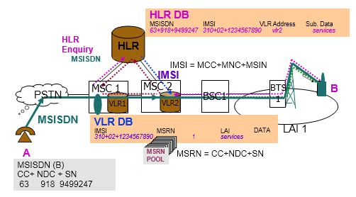

**Incoming Call Flow from PSTN to MS**

(1) Through the No.7 signaling user part ISUP/TUP to enter MSC(GMSC) and receive a call from the fixed network (ISDN/PSTN).   
(2) GMSC requests HLR for the MSC address (i.e., MSRN) visited by the related called mobile subscriber.   
(3) HLR requests the visited VLR to assign MSRN which is assigned and notified by VLR to HLR in each call.   
(4) After GMSC obtains MSRN from HLR, it can re-search for routes to set up connection to the visited MSC.   
(5) The visited MSC obtains related subscriber data from VLR.   
(6) MSC sends paging messages to the mobile station through all base stations( BS) in the location area. (7) The mobile station of the called mobile subscriber sends back the paging response messages, then carries out the same steps of (1), (2), (3), (4) as shown in the above outgoing call flow till the mobile station rings,   
then sends back the call connection acknowledgment signal (omitted in the diagram) to the calling subscriber.   
(8) The mobile subscriber offhooks to answer, thus the response (connection) message is sent back to the fixed network to signal calling and called parties enter final call session.

**Call Establishment (MO-PSTNT)**

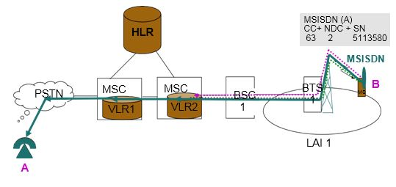

**Outgoing call flow from MS to PSTN**

(1) Within the service cell, once the mobile subscriber dials, the ms will request the base station for RACH channel.   
(2) The setup process to set up signaling connection between MS and the MSC.   
(3) Authentication of mobile station’s identification number; if encryption is needed, then it sets the encryption mode and enter the call setup starting phase.   
(4) Service channel allocation   
(5) Adopting the No.7 signaling user part ISUP/TUP to set up a channel from the fixed network (ISDN/PSTN) to the called subscriber, send ringing to the called subscriber, and send back the call connection acknowledgment signal to the mobile station.   
(6) The called subscriber offhooks to reply, in which case a response (connection) message is sent to the mobile station, thus entering the ultimate call session phase.

**Call Establishment (MO-MT)**

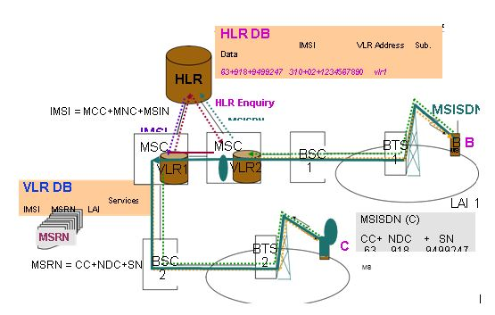

**Between Two Mobile Subscribers**

**Call Flow**

MS1 is served by MSC1/VLR1, and MS2 is served by MSC2/VLR2 and belongs to HLR/AUC.

1. MS1 dials the phone number of MS2. BSS informs MSC1 of the call.   
2. MSC2 analyzes the phone number of MS2, finds out the home HLR of MSC2 and sends the route application to HLR.   
3. HLR queries the current location information of MS2 and obtains the MSC2/VLR2 that serves the MS2. HLR requests the route information from the MSC2/VLR2.   
4. MSC2/VLR2 allocates the route information, that is, MSRN and submits the MSRN to the HLR.   
5. HLR transmits the MSRN to MSC1.   
6. MSC2 sets up the call with MSC2 according to the MSRN.   
7. MSC2/VLR2 sends the paging message to MS2.   
8. MSC2/VLR2 receives the message, indicating the access of MS2 is allowed.  
9. The call between MSC2 and MSC1 is set up.   
10. MSC1 sends the successful connection signal to MS1. MS1 and MS2 can talk over the phone.

Mobile Communication protocol

https://ilor.itrackglobal.com/ilor/objects/OSSContent:202/datastreams/ibmlogo/content

* **Nano Learning Object**

|  |  |
| --- | --- |
| **Nano Learning Object(NLO)** | **NLO Outcome** |
| Handover Mechanism in GSM | Gain knowledge on the Handover Mechanism in GSM |

* **NLO Contents**
* Handover Mechanism in GSM

The process where ongoing call during busy state change its frequency between two cell coverage. It could be based on received signal strength or quality.

* + Reasons for Handover:

– due to received signal strength or quality  
– due to increase in traffic

* + Types:

1. Intra cell Handover ( within single BSC)  
2. Inter cell Handover ( within single BSC)  
3. Inter cell -Inter BSC Handover ( within two BSCs)  
4. Inter MSC Handover ( between two MSCs)

Handover is a very important function of the cellular mobile system.

In GSM cellular system, the multiplexing technology for radio frequency resource is fully adopted to realize the coverage by several cells. Thus the concept of cross-cell handover is introduced.

Handover enables a user to keep continuous conversation during the process of passing through different cells. Handover also adjusts the traffic of cells. Moreover, handover is implemented without being noticed by users, and does not require users’ involvement.

The following are some of the handover causes: Signal strength is too weak

Signal quality is too poor Signal interference is too large Large distance

Uplink level degrades suddenly

**Macro-micro handover**

**There is a more appropriate cell**

**Handover Types Intra-cell handover**

The handover is completed by the BSC to which the cell belongs.

**Intra-BSC inter-cell handover**

The two cells before and after handover are different cells under the same BSC.The handover does not require MSC and is completed by BSC.

**Intra-MSC inter-BSC handover**

The two cells before and after handover are under different BSCs, and the two BSCs are controlled by one MSC. The handover is completed by MSC and the two BSCs.

**Inter-MSC handover**

The two cells before and after handover are under different MSCs.

**Handover (1)**

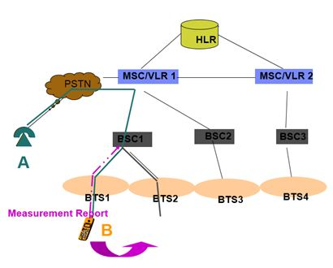

**Handover (2)**

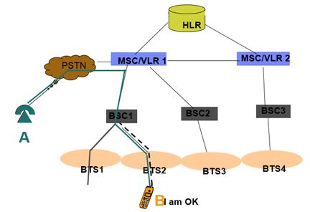

**Handover (3)**

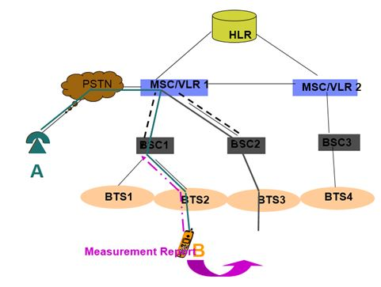

**Handover (4)**

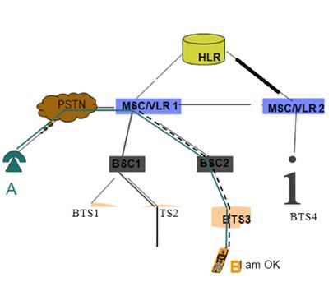

**Handover (5)**

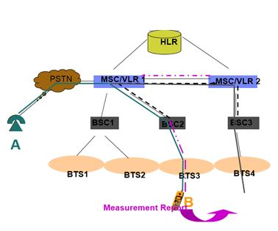

**Handover (6)**

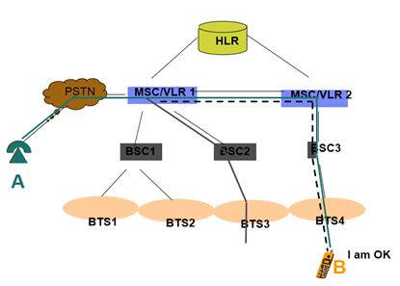

**Handover (7)**

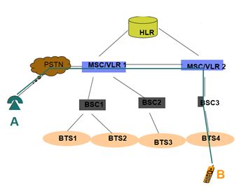

**Handover reasons**

* + Following are the Handover reasons：
  + Weak signal
  + Bad quality
  + Severe interference
  + Large TA
  + Macro-micro handover
  + Better cell handover

   Mobile Communication protocol

https://ilor.itrackglobal.com/ilor/objects/OSSContent:202/datastreams/ibmlogo/content

* **Nano Learning Object**

|  |  |
| --- | --- |
| **Nano Learning Object(NLO)** | **NLO Outcome** |
| Handover Process – NW overview | Learn about the Handover Process – NW overview |

* **NLO Contents**
* Handover Process – NW overview

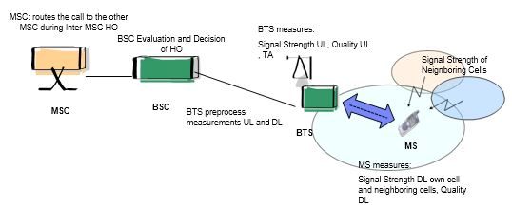

**Inter-cell handover signaling process**

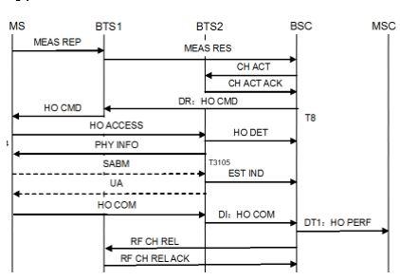

**Capacity Expansion methods**

* + Carrier Expansion and Cell Splitting
  + Frequency Reuse Pattern
  + Concentric Cell Technology
  + Micro cells
  + Half Rate
  + Dual Band Network for Capacity Expansion

**Channel Assignment Scenarios**

1. “Fixed Channel Assignment”   
2. “Dynamic Channel assignment”

   Mobile Communication protocol

https://ilor.itrackglobal.com/ilor/objects/OSSContent:202/datastreams/ibmlogo/content

* **Nano Learning Object**

|  |  |
| --- | --- |
| **Nano Learning Object(NLO)** | **NLO Outcome** |
| What is Spread Spectrum | Learn about the Spread spectrum |

* **NLO Contents**
* What is Spread Spectrum

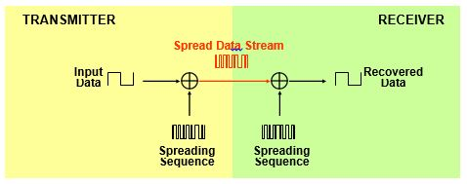

* + Transmitter combines data with spreading code and transmits spreaded data stream
  + Receiver decodes using same spreading sequence and extract original data

Spread Spectrum or CMDA is a type of information transmission technique where the resultant signal band-width is much more than the information bandwidth.

This is achieved through pseudo random coding and modulation

Advantages: Reduces interference , difficult to hack and reduce multipath effects

The diagram shows the overall concept of spread spectrum. The input data is multiplied with pseudorandom spreading sequence. The resulting signal is transmitted through the channel. If spread signal is used in mobile communication, then the resultant spreaded sequence will be modulated using FSK or QPSK. The modulated signal will be transmitted through the channel.

At the receiver, after demodulation, the original information will be recovered if receiver has the same pseudorandom sequence as that of the transmitter. No other receiver can recover the information with this code. Therefore spread spectrum is called secure communication.

Types spread spectrum techniques:

* + Direct Sequence spread spread spectrum
  + Frequency hopping spread spectrum.

**Spread Spectrum Principles SHANON Formula**

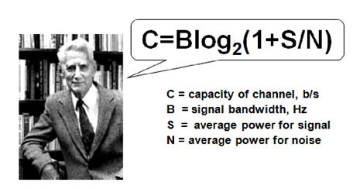

Formula describes a fact that under the condition that C is fixed , when your add the B , noise can be added , that ‘s to say , if only B was enough , even if the voice is submerged by the noise , it has no effect on the communication;

* + The shannon equation gives the relation between channel capacity, Bandwidth and Signal to interference ratio.
  + In CDMA Technology, Signal is travelled as Noise . Therefore S/N=1. Log2 (2) results in 1. Hence C=B
  + Channel capacity is equal to bandwidth. Idea we can accommodate infinite subscriber per frequency. However practically the total number of users per channel is limited to 35 for CDMA and around 300 in case of WCDMA techniques.

**Spectrum Variation of Spread**

   Mobile Communication protocol

https://ilor.itrackglobal.com/ilor/objects/OSSContent:202/datastreams/ibmlogo/content

* **Nano Learning Object**

|  |  |
| --- | --- |
| **Nano Learning Object(NLO)** | **NLO Outcome** |
| IS-95 CDMA Channels | Gain knowledge on the IS-95 CDMA Channels |

* **NLO Contents**
* IS-95 CDMA Channels

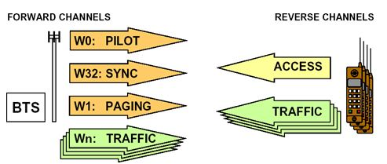

**CDMA Forward Traffic Channels**

* + If total walsh code is 64, then number of traffic channel = 64-1 pilot –one SCH-1 to 7 PCH
    - Therefore one CDMA frequency frequency supports around 55 Traffic Channel.

**PILOT Channel : WALSH CODE 0**

* + - Works like “structural beacon” It is used for system acquisition by providing timing resource and e during handoffs

**SYNC Channel: WALSH CODE 32**

* + - Brings system identification and system parameter information for the mobile system during system acquisition

PAGING Channel: WALSH CODES 1 to 7 ( commonly one paging channel used. However it can be extended to upto 7)

* + - It carries incomming call or sms related information.

TRAFFIC Channel: remaining WALSH codes

* + - Assigned to subscriber to carry traffic ( voice or data ). Depending upon the traffic requirement, walsh codes are utilized.
    - carries a traffic signal up to 55 forward code channels.

**Reverse Channel**

**ACCESS Channel :**

* + Acknowledges the paging channel. Also used to initiate call or SMS. It is used by the MS during registration as well.

**Rev. TRAFFIC Channel:**

* + Carries traffic in uplink or reverse link

**“Codes used in CDMA”**

* + **“Walsh codes”;**
    - “Used to differentiate channels in the forward link”
  + Short PN Code:
    - Used to differentiate sectors of different base stations. It helps MS to distinguish different sectors.
    - 512 short PN codes to distinguish different sectors
  + Long Sequence Code
    - used to distinguish different mobile station in the uplink
    - trillions of codes to identify trillions of mobile station.

   Mobile Communication protocol

https://ilor.itrackglobal.com/ilor/objects/OSSContent:202/datastreams/ibmlogo/content

* **Nano Learning Object**

|  |  |
| --- | --- |
| **Nano Learning Object(NLO)** | **NLO Outcome** |
| CDMA Architecture | Understand the CDMA Architecture |

* **NLO Contents**
* CDMA Architecture

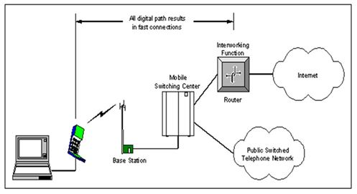

* + It is essentially consists of MS, BTS , MSC and HLR/VLR data base, AUC and EIR databases.
  + The MS consists of hardware and SIM. Hardware is a transceiver module and identified by unique number. SIM is a memory device used to store data. The data stored in information may be static or dynamic.
  + BTS is used for radio channel allocation. The managing of BTSs are done through BSC. Handover and power control algorithm are managed in BSC.
  + MSC is used to switch the traffic between BSC and external network such as PLMN or PSTN network
  + CMDA initially came with IS95 A followed by IS 95B architecture. Though major elements remain same in these version. The data throughput changes. The IS 95 B offers data rate of 64 Kbps.
  + CDMA 2000 supports a data rate of 2 Mbps ( downlink ) whereas CDMA EVDO ( latest version of CDMA) supports data rate of 3.1 Mbps.
  + Al the CMDA version uses bandwidth which is of 1.25 MHz and 800 MHz band

**Walsh Code Channel Generation**

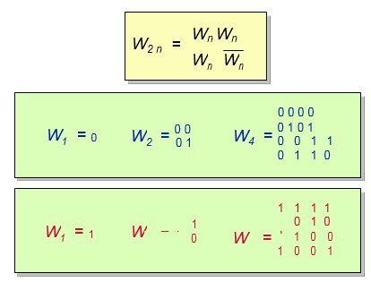

**PN Code Generator**

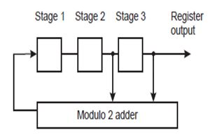

**CDMA uses three PN code sequences: two “short” and one “long”**

1. The two short PN codes (called “I” and “Q”) are used for quadrature spreading to differentiate between CDMA partitions (sectors/cells) in the forward direction   
2. The two short codes are generated by 15-bit PN code generators. The generated strings are 215 -1 bits long plus one zero inserted following the longest string of generated zeroes (32,768); and their cycle period is 26.666... milliseconds (or 75 times every 2 seconds).   
3. The long PN code is used to differentiate among mobile stations in the reverse direction. It is generated using 42-bit random code generator. The generated code range is is 242 -1 bits long;

Mobile Communication protocol

https://ilor.itrackglobal.com/ilor/objects/OSSContent:202/datastreams/ibmlogo/content

* **Nano Learning Object**

|  |  |
| --- | --- |
| **Nano Learning Object(NLO)** | **NLO Outcome** |
| CDMA Radio Frequency Spectrum | Learn about the CDMA Radio Frequency Spectrum |

* **NLO Contents**
* CDMA Radio Frequency Spectrum

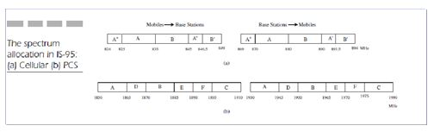

**CDMA Spectrum:**

* 1. The spectrum is divided into two parts. Uplink frequency band and down link frequency band. Both Uplink and downlink band further divided into A”, A , B” and B. The figure shows spectrum allocation of IS-95 in US.
  2. Figure a is for Cellular CMDA and figure b is for PCS.
  3. In a CDMA cellular system Channel bandwidth is 30 kHz and in PCS system channel spacing is 50 kHz.
  4. In PCS system, there are 1,200 FDD channels.
  5. The channel bandwidth of a CDMA system is 1.25 MHz.

**Radio Resources Management**

A CDMA system has to maintain a narrow range of received power levels. Strong received signals interfere excessively with weaker signals.

**“Power control methods:**

* 1. “Open loop Power control”
  2. “Closed loop power control”

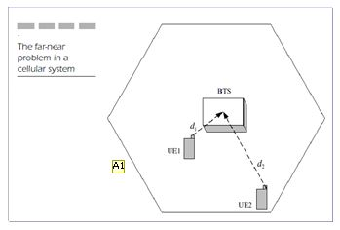

**Types of Power control:**

1. “Forward link “Power Control” and Reverse link “Power Control””

Forward link power control is done by Base stations. Reverse link power control is done by Mobile Stations. Later it is further divided into open loop and closed loop operations.

2. ”Open loop power control”   
In Open loop power control, no feedback mechanism is available.   
1. “Closed loop power control”

In closed loop power control BSC will be involved in decision making of handover.

* 1. “MS measures the downlink signal strength of received pilot signal”.
     + Strong signal indicates MS close to base station therefore MS is instructed to transmit at lower power.
     + Weak signal indicates MS is far from base station and therefore instructed to transmit at high power.
     + The power level of all received signals at the base station should be equal.
  2. Popen(dBm) = -Preceive(dBm) + Ptarget(dB)
  3. Ptarget(dB) = -73 dB + Pcontrol(dB) Closed-loop power control:
  4. Ptransmit (dBm) = Popen (dBm) + Pclosed (dB)
  5. Pclosed (dB) = Pclosed (dB) + 1 dB, 0 received*
  6. Pclosed (dB) = Pclosed (dB) - 1 dB, 1 received*
  7. Base station transmits either 0 or 1 in power control sub channel, based on received power level at base station.00 b/s by puncturing code symbols on a traffic channel once every 1.25
  8. Mobile Communication protocol

https://ilor.itrackglobal.com/ilor/objects/OSSContent:202/datastreams/ibmlogo/content

* **Nano Learning Object**

|  |  |
| --- | --- |
| **Nano Learning Object(NLO)** | **NLO Outcome** |
| Soft Handoff | Gain knowledge on the Soft Handoff |

* **NLO Contents**
* Soft Handoff

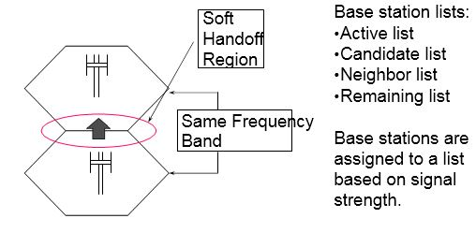

**Handoff**

When the MS is moving from serving BTS coverage area to another BTS area, the process of switching radio channel from weaker radio channel to a stronger “radio channel” is called a handoff.

**Types of Handoff**

* 1. Hard handoff   
     Changing of radio channels form one base station to another where radio channel frequency numbers are different is called hard handoff. GSM uses Hard handoff.
  2. Soft handoff   
     Changing of “Channel frequencies” from one base station to another where radio channel frequency number remain same however they are different by pseudo random offset. In other words two BSs uses same frequency but sectors are differentiated by short sequence codes. This type of handover is called handoff used in CMDA. Here make before break concept is involved.

**Handoffs Supported in CDMA ( IS-95)**

* 1. Soft and softer handoff - mobile station operate at the same frequency.
  2. Hard handoff - MS switches between two different CDMA carrier frequency channels.

**Soft Handoff Procedure**

* 1. The pilot channel transmits a continuous signal.
  2. MS measures and decodes the the pilots and also measures relative signal strength of neighbouring base stations and consider it as a basis for handoff.
  3. MS searches for sufficiently strong pilot signal . Once it is found, measurement report is forwarded to the network to take suitable decision towards handoff. It is called Mobile initiated handoff.
  4. Base station is also measures signal strengths of MSs and analyses to take proper handover decision.
  5. “As MS “moves from one cell” coverage area to another coverage area of cell, it communicates with both cells.( make before make concept)”
  6. Handoffs are mobile initiated and switch controlled.

**Mobility Management**

The mobile sends registration messages to the system.

Registration messages help the system to locate the mobile when a call is directed to the mobile.

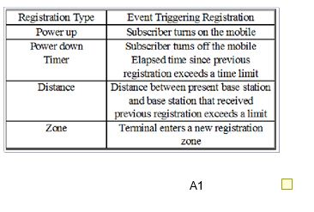

**WiCoRe, UT-**

To help manage calls in a system more efficiently, mobile send registration messages through reverse access channel of the network. When the system receives a call directed to a specific mobile, the registration message helps to locate that mobile.

There are five “different types” of registration messages, each based on the event that causes the mobile to transmit a registration message. ’Power Up’ registration happens when mobile is switched ON.

‘Power OFF’ registration occurs when the mobile is turned off. ‘Timer’ registration occurs when the previous registration’s elapsed time has exceeded a certain limit.

‘Distance’ registration happens when location update timer exceeds the specified time. And ‘Location’ registration occurs “when the MS enters into a new location area”.

  Mobile Communication protocol

https://ilor.itrackglobal.com/ilor/objects/OSSContent:202/datastreams/ibmlogo/content

* **Nano Learning Object**

|  |  |
| --- | --- |
| **Nano Learning Object(NLO)** | **NLO Outcome** |
| 3G Spectrum | Gain an insight into the 3G Spectrum |

* **NLO Contents**
* 3G Spectrum

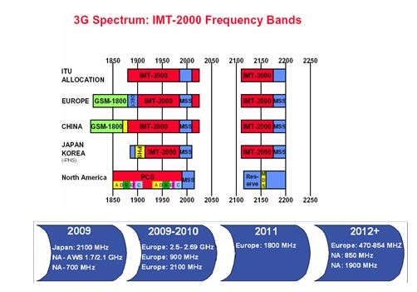

The third generation mobile communications —— IMT2000 (UMTS)

* 1. Feature: Code division multiple access (CDMA) digital signal broadband
  2. Meaning of ‘2000’: Frequency spectrum around 2000MHz data rate up to 2000kbps putting into business about 2000
  3. Main mode: WCDMA CDMA2000 TD-SCDMA

**3GPP Versions Difference**

a. R99：

i. Creation of the Universal Terrestrial Radio Access(UTRA)，no fundamental changes in core network

b. R4：

i. Enable bearer independent CS network architecture (MSC split to 'Media gateway' and 'MSC server')  
ii. Low Chip Rate TDD (TD-SCDMA)

c. R5：

i. IMS- IP based Multimedia Services  
ii. IP transport in UTRAN  
iii. HSDPA

* 1. Enable bearer independent CS network architecture (MSC split to 'Media gateway' and 'MSC server')
  2. “HSDPA- High Speed Downlink Packet Access :to support existing and future Internet based services: Web Browsing, Downloading, etc”
  3. New technique introduced. AMC: adaptive modulation and Coding/FCS: Fast cell selection
  4. HARQ: Hybrid automatic retransmission requested/MIMO: multi input multi output.

**Architectural Requirements -Release 99**

* 1. “Evolved 2G MSC and an evolved SGSN with Gs interface”
  2. Separated or combined MSC/VLR and SGSN connections
  3. Separate control and user plane nodes.
  4. “Circuit switch domain to the Packet switch domain evolution in road map”
  5. Provision on backward compatibility.

Mobile Communication protocol

https://ilor.itrackglobal.com/ilor/objects/OSSContent:202/datastreams/ibmlogo/content

* **Nano Learning Object**

|  |  |
| --- | --- |
| **Nano Learning Object(NLO)** | **NLO Outcome** |
| Rel. 99 Reference Architecture | Understand about the Rel. 99 Reference Architecture |

* **NLO Contents**
* Rel. 99 Reference Architecture

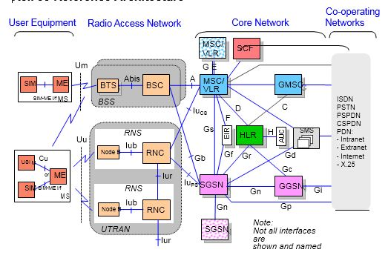

“CS network: It provides circuit switched connections, such as the existing telephone services. Both ISDN and PSTN are CS networks”.

PS network: It provides packet switched connections. The Internet is an example of the PS network.

The MSC processes circuit switched services, while the VLR stores a copy of the service feature description of the roaming subscribers, and more accurate information of the location of the UE in the service system.

1. voice and video will use Circuit switch paths via MSC.   
2. Non real-time services, or internet data will use GPRS network utilizing SGSN and GGSN nodes.   
3. The new element Radio network controller (RNC) is similar to BSC of GSM.   
4. The Value Added Services (VAS)  
5. The 3G MSC is the key element of the R99 architecture as it is in GSM architecture.  
6. 3G MSC has VLR and SCF ( Service control function) to control GSM BSS and 3G network.

**The 3G HLR**

1. 3GHLR derived from 2GHLR through Software modifications.. The same HLR supports both 2G and 3G subscribers.The HLR maintains the portfolios of 2G and 3G subscribers.   
2. The 3G HRL stores subscriber information of 2G and 3G service and information such as mobility management, authentication and equipment identity.

**3G SGSN**

1. “Acts as a link between the 3G RAB and packet core”.   
2. New interfaces Iu, Gn, and Gp.   
3. Iu interface is realized using “STM-1” optical interface   
4. Gn and Gp interfaces realised using Ethernet technology.   
5. communication towards the “HLR (Gr), EIR (Gf) and the SMSC (Gd) using SS7 signalling”.   
6. SMSC is connected via IP.   
7. “E1- PCM connections for SS7 interfaces for Gf, Gr and Gd”

**UTRAN Architecture**

1. The UTRAN contains RNSs communicating with the Core Network (CN) through the Iu interface.   
2. “RNS contains RNC and one or more Node Bs”.   
3. Node B connects to the RNC through the Iub interface, and it can support either a FDD or TDD or combined dual mode operation.   
4. “handover decisions are forwarded at RNC.

   Mobile Communication protocol

https://ilor.itrackglobal.com/ilor/objects/OSSContent:202/datastreams/ibmlogo/content

* **Nano Learning Object**

|  |  |
| --- | --- |
| **Nano Learning Object(NLO)** | **NLO Outcome** |
| Rel. 4 & 5 Reference Architecture | Understand about Rel. 4 & 5 Reference Architecture |

* **NLO Contents**
* Rel. 4 & 5 Reference Architecture

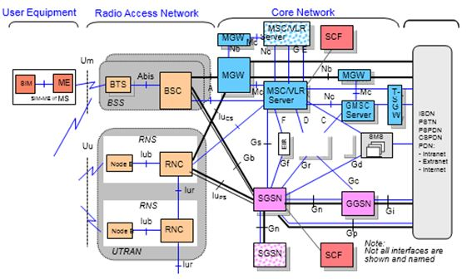

The bearer and the control part is separated.

MSC for the signaling process,and the MGW for the usr data process

We can use IP,ATM,PCM to carrier the information, and the signaling have no relationship with the bearer way.

**Rel. 5 Reference Architecture**

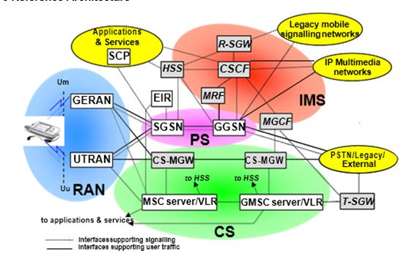

   Mobile Communication protocol

https://ilor.itrackglobal.com/ilor/objects/OSSContent:202/datastreams/ibmlogo/content

* **Nano Learning Object**

|  |  |
| --- | --- |
| **Nano Learning Object(NLO)** | **NLO Outcome** |
| Channel Type | Learn about the types of Channel |

* **NLO Contents**
* Channel Type

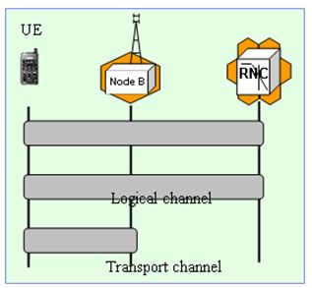

**Channel types in UTRAN**

* + Physical channel: form the physical existence of the Uu interface between the UE domain and access domain.
  + RNC deals with transport channels: carry different information flows over the Uu interface and the physical elements.
  + Logical channels: different tasks the network and the terminal should perform in different moments of time.

“Logical channels”: carries information to be transmitted in certain format.

“Transport channels”: packets from logical channels are forwarded through Transport channels

**“Physical channels”:**

The final information is transmitted to the physical medium through this channel.

**Logical Transport**

* + Characterize how data is transmitted
  + Provide services to the upper layer
  + Mapped to physical channels
  + Common transport channel
  + Dedicated transport channels

**Physical**

* + Carry one or more transport channels
  + Responsible for transporting data over the air
  + Identified by carrier frequency, orthogonal code, relative phase
  + One radio frame is:
  + 10 milliseconds in duration
  + Divided into 15 time slots
  + “Each slot has a duration of 0.625 milliseconds”

**Concept of channel**

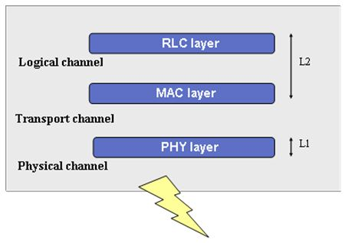

The transmission channel is defined how data characteristics such as transmission interval, size and number of transmission blocks in every interval.（format）

The logic channel service can be summarized as what type of data is to be transmitted. Types: Control channels and Traffic channels.

**Physical layer functions:**

* + providing data transmission to MAC through the transmission channel
  + diversity combination
  + transmission channel error indication
  + match of the transmission channel rate to the physical channel after coding
  + mapping from CCTrCHs to the physical channel
  + spread spectrum and modulation/despread and demodulation
  + frequency synchronization, time synchronization
  + radio characteristic measurement (SIR and power interference),
  + closed loop power control, and RF processing

The specific functions of the MAC (Media Access Control) protocol are:

mapping between the logic and transmission channels

selection of an adequate transmission format for every transmission channel priority processing between UE data streams

multiplex of higher-layer PDU to transmission blocks transmitted to the “physical layer” through the transmission channel

“multiple of transmission blocks from the physical layer to higher-layer PDU through the transmission channel”

The specific functions of the RLC (Radio Link Control) protocol are:

segmentation and reassembly padding, user data transfer sequence-based transmission of higher-layer PDU in error detection, copy check flow control serial number check of the unauthenticated data transfer mode protocol error check and recovery, ciphering on the control plane, it provides the RRC sublayer with signaling radio bearer services, on the user plane, it provides service radio bearer services together with the PDCP sublayer

The specific functions of PDCP (Packet Data Convergence Protocol) are:

* + “compression of header and decompression of IP data streams in the transmitting and receiving entities respectively”
  + transmission of user data
  + forwarding of PDCP-SDU sent from a non-access layer to the RLC layer
  + multiplex of multiple different RBs to one RLC

The specific functions of the RRC protocol are:

* + Setting up of , “maintenance and releasing” of RRC connection between UE and UTRAN
  + Setup, reconfiguration of resource and release of radio bearer
  + “mobility function management”
  + routing of PDU at higher layer
  + request for QoS control
  + UE measurement report and report control
  + “outer loop power control”
  + ciphering control, paging
  + “Cell selection and reselection”
  + Mobile Communication protocol

https://ilor.itrackglobal.com/ilor/objects/OSSContent:202/datastreams/ibmlogo/content

* **Nano Learning Object**

|  |  |
| --- | --- |
| **Nano Learning Object(NLO)** | **NLO Outcome** |
| Logical Channels | Gain knowledge on the Logical Channels |

* **NLO Contents**
* Logical Channels

Logical Channel lies between MAC Layer and RLC Layer.

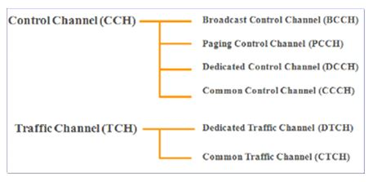

**“Control Channels”**

* + “Broadcast Control Channel (BCCH)”
    - This channel operates in downlink. It is used to broadcast system information. It may include CGI, Timer information, Location area information, cell selection parameters.
  + “Paging Control Channel (PCCH)”
    - This channel operates in downlink. This channel basically used to transfer incomming call or sms information.
  + “Common Control Channel (CCCH)”
    - “It is a Bi-directional channel for transferring control information between BS and Ues. These channel are used to take appropriate decision during handover”.
  + “Dedicated Control Channel (DCCH)”
    - bidirectional channel used along with traffic channel for transmitting signaling information.

**Traffic Channels**

**“Dedicated Traffic Channel (DTCH)”**

* + “It operates in both uplink and downlink”. It is used to carry traffic information.

**“CommonTraffic Channel (CTCH)”**

* + “It is necessary to transfer point-to-multipoint unidirectional channel for transmitting group information.”

**Transport Channel**

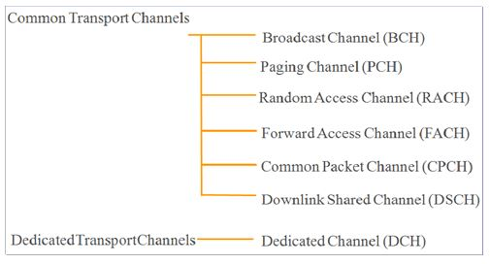

**“Transport channels” Types: dedicated channels and common channels.**

* + “Dedicated channel are reserved for a single subscriber only”.
  + “handles fast power control and soft handover”.
  + “Common channel channels are used by any number of subsrciber at any time”.
  + do not handle soft handover but some handles fast power control.
  + Physical channel maps to transport channel also there exist physical channels for signaling.

**The transport channel:**

The transport channel primarily defines how data are transported and in what characteristic they are transported, for example, interval of transport and the number and size of blocks transported during each interval.

**Types of transport channels:**

**“Random Access Channel (RACH)”:**

* + As an uplink common channel, it is used to transport packets small in size, for example, initial access information, non-real-time control information and user information.

**Common Packet Channel (CPCH):**

* + Also an uplink common channel, it is used to transport some burst packets.

**Forward Access Channel (FACH):**

* + As a downlink common channel, it is used to transport some packets small in size.

**Downlink Shared Channel (DSCH):**

* + It is used to bear dedicated control or user information.

**Broadcast Channel (BCH):**

* + As a downlink channel, it is used to broadcast information throughout a cell.

**Paging Channel (PCH):**

* + It is used to transport paging and notification information in the downlink direction.

**Dedicated Channel (DCH):**

* + As a bi-directional channel, it is private for each user, and is used to transport user data and high-layer control information.

**“Types of common transport channels: BCH, FACH, PCH, RACH, CPCH and DSCH”.**

   Mobile Communication protocol

https://ilor.itrackglobal.com/ilor/objects/OSSContent:202/datastreams/ibmlogo/content

* **Nano Learning Object**

|  |  |
| --- | --- |
| **Nano Learning Object(NLO)** | **NLO Outcome** |
| Physical Channel | Gain an insight into the Physical Channel |

* **NLO Contents**
* Physical Channel

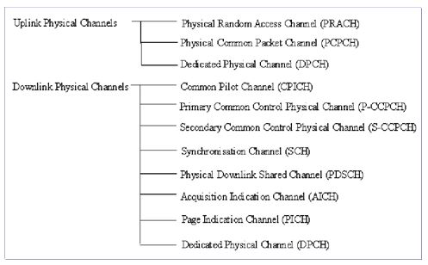

In every 10 ms, data is transmitted from MAC layer to physical layer.

* + “Transport Format Indicator (TFI) gives the format for transport block for transport channel which is used in the layer to layer communication”.
  + “physical layer” multiplexes different transport channels to for a single “composite transport channel” ( CCTrCH)
  + **Uplink dedicated physical channels**

-carries DCH transport channel information.   
-uplink Dedicated Physical Control Channel (uplink DPCCH).

Carries control information or signaling information. Power control commands and feedback information are transferred using this channel.

”Physical Random Access Channel (PRACH)”

It works in uplink and utilizes a Slotted ALOHA algorithm to access the radio network.

* + - 15 access slots per two frames and are spaced 5120 chips apart.
    - The random-access transmission consists of one or several preambles of length 4096 chips and a message of length 10 ms or 20 ms.

**“Physical Common Packet Channel” carries CPCH information.**

* + Downlink Common Physical Channel
    - “Common Pilot Channel (CPICH) “
    - ‘Downlink channel provides reference signal to Use“ .
    - The CPICH is a fixed rate (30 kbps, SF=256) carries a pre-defined bit sequence.

Types: the Primary and Secondary CPICH.

* + **“Synchronous Channel (SCH)”**

used for cell search operates in downlink.

the Primary SCH and Secondary SCH are subchannels.

The 10 ms radio frames of the Primary and Secondary SCH are divided into 15 slots, each of length 2560 chips.

1. Physical Downlink Shared Channel (PDSCH)

-carries Downlink Shared Channel (DSCH).

2. Acqusition Indication Channel(AICH)

-carries Acquisition Indicators (AI).

3. Paging Indication Channel (PICH)

-carries the paging indicators.

**Physical Channel**

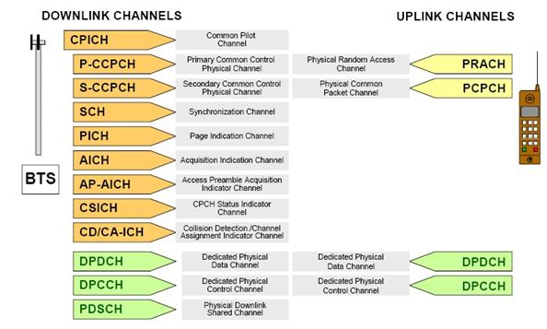

**“WCDMA Downlink Physical Channels”**

**“Common Downlink Physical Channels”**

1. “P-CCPCH Common Control Physical Channel (Primary)” Broadcasts cell site information

Broadcasts cell SFN; Timing reference for all DL 32kps SF 256 continues transmission

2. “SCH Synchronization Channel”

Fast Synch. P frame, S slot, time-multiplexed with P-CCPCH

3. “S-CCPCH Common Control Physical Channel (Secondary)” Transmits idle-mode signaling and control information to UE’ s Variable rate, with DTX

4. “P-CPICH” Common Pilot Channel

5. “S-CPICH” Secondary Common Pilot Channel (for sectored cells)

PDSCH - “Physical Downlink Shared Channel” Transmits high-speed data to multiple users

6. “Dedicated Downlink Physical Channels”

DPDCH Dedicated Downlink Physical Data Channel DPCCH Dedicated Downlink Physical Control Channel Transmits connection-mode signaling and control to UE’ s Downlink Indicator Channel

**AICH (Acquisition Indicator Channel)**

Acknowledges that BS has acquired a UE Random Access attempt (Echoes the UE’ s Random Access signature)

**PICH (Page Indicator Channel)**

Informs a UE to monitor the next paging frame AP-AICH (Access Preamble Indicator Channel)

Acknowledges that BS has acquired a UE Packet Access attempt

（Echoes the UE’ S Packet Access signature) CD/CA-ICH

Confirms that there is no ambiguity between UE in a Packet Access attempt (Echoes the UE’ s Packet Access Collision Detection signature)

Optionally provides available Packet channel assignments CSICH

Broadcasts status information regarding packet channel availability

**WCDMA UPLINK PHYSICAL CHANNEL**

**“Common Uplink Physical Channels”**

PRACH: Physical Random Access Channel Used by UE to initiate access to BS

PCPCH: Physical Common Packet Channel Used by UE to send connectionless packet data “Dedicated Uplink Physical Channels”

DPDCH: “Dedicated Uplink Physical Data Channel”

DPCCH: “Dedicated Uplink Physical Control Channel” Transmits connection-mode signaling and control to BS Synchronization Channel (1) used for cell search, operates in downlink Types: P-SCH, S-SCH

**CPICH**

-Provides a known reference signal to aid channel estimation. Types: Primary and secondary

  Mobile Communication protocol

https://ilor.itrackglobal.com/ilor/objects/OSSContent:202/datastreams/ibmlogo/content

* **Nano Learning Object**

|  |  |
| --- | --- |
| **Nano Learning Object(NLO)** | **NLO Outcome** |
| Power Control | Gain an insight into the Power Control |

* **NLO Contents**
* Power Control

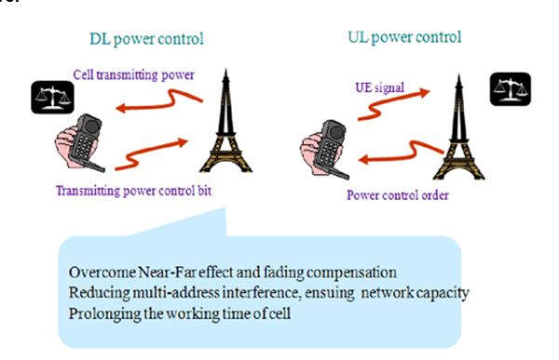

Power control Involved node B and UE. Both in UL and DL. Bidirectional—two way

CDMA subscribers uses the same frequency with in the cell. Codes used to discriminate the subscribers. Nearby subscribers contributes towards interference.

**CDMA**

* + Power control is an import part in the WCDMA system.
  + Assuming all the UE node transmits signal with the same transmitting power, the transmitted signals reaching node B from all the UE nodes closer to the Node B are stronger signal. The signals traveling from far UE Nodes are attenuated comparably before reaching node B and are weak.
  + This will lead to “overpower the weak signals by stronger signals”. The effect is called “near-far effect”.
  + Since “WCDMA is a self-interference system” because all UEs uses the same frequency within the cell because of which the “ near far effect “ is more influential.
  + For the “WCDMA” system, the Node B is power is fixed in downlink.
  + For better quality of signal for the case of less TX power, power control by adjusting the transmitting power of Node B and UE is essential.

**Three methods of power control**

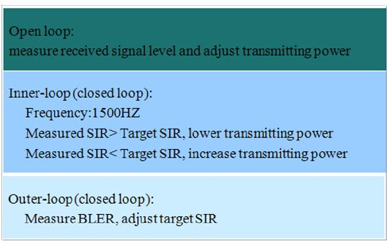

**“Inner Loop Power control UL/DL (fast)”**

* + “For a fixed SIR ratio, target per service (RAB), UE or Node-B will utilizes Signaling channel, and TCP Continuously at the rate of 1500 times/s and relatively changes either uplink or downlink power to meet the SIR targeted value”.

**“Outer loop Power control (Slow)”-**

* + “If the BER measured signal either in Uplink or downlink is above or below the set target, UE node or RNC increases or reduces to meet SIR target value. Later utilizes new target value for the inner loop PC. “

**Requirement of “DL power control”:**

Saving power resource of base station, reducing “interference” to other station.

**Requirement of of “UL power control”:**

Solving “Near-Far effect”, received signal level from all UEs is the same.

"In a situation where MS1 which is at the edge of the cell has a pathloss more than 60 dB than the MS2 which is “nearer to the base station”. During unavailability of “power control “ mechanism, MS2 “over shout “ MS1 and block large part of a cell resulting in Near – Far problem.”

The power control strategy basically design to “equalise the received power per bit” of all mobile node Bs at all times.

In “open loop power control “mechanisms, MS attempt to make a “rough estimate of path loss” using downlink broadcast transmitted signal and control its power accordingly. This method is not too accurate because uncorrelation between uplink and downlink due to fast fading and due to the large frequency separation of the “downlink and uplink” bands

**Power control**

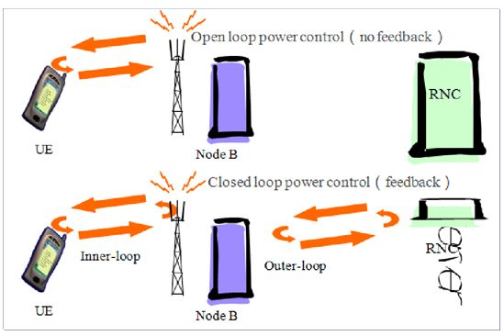

Open loop power control is a process where the mobile measures the power received from the BTS in the Pilot channel and calculate HIS power to be transmitted when it will access the network. It is to minimize it's power to a minimum level.

During the call, both the mobile and the BTS are sending real-time power control commands to each other 1500 times per second. This is again to minimize the power transmitted to the right level.

**Closed loop Power control**

Here the BS performs frequent estimates of the received SIR and compares it to a target SIR.

“If the measured SIR greater than the target SIR, the BS will send power control command to the MS to decrease the power”.

If power is too low, BS commands the MS to increase the power.

The overall cycle which consist of measurement, command and react is executed at a rate of 1500 times per second. Hence any significant change due to path loss or fast rayleigh fading could be nullified by power control mechanism.

“Closed loop power control” also used on the downlink to provide a marginal amount of additional power to mobile stations at the cell edge to overcome the interference from neighbouring cells”.

  Mobile Communication protocol

https://ilor.itrackglobal.com/ilor/objects/OSSContent:202/datastreams/ibmlogo/content

* **Nano Learning Object**

|  |  |
| --- | --- |
| **Nano Learning Object(NLO)** | **NLO Outcome** |
| Hard & Soft Handover | Gain an insight into the Power Control |

* **NLO Contents**
* Hard & Soft Handover

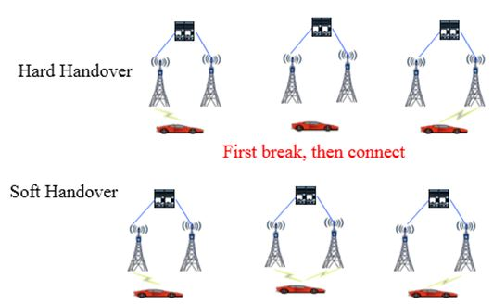

Lighten the burden of CN. Break means disconnect----if time longer than 5 seconds, will lead to drop call.

Softer handover,

The interaction between MS and BS take place two “channels”, one for each sector separately.

Two “separate codes” are required in the “downlink direction” for mobile station to distinguish the signals.

Similar process happens in uplink.

5–20 % of overall connections results in Softer handover.

**Soft handover**

A mobile station is in the overlapping cell coverage area of two cells belonging to different base stations. The interaction between “mobile station” and “base station “take place simultaneously through two air “interface channels” from each base station separately.

**Types of “handover”**

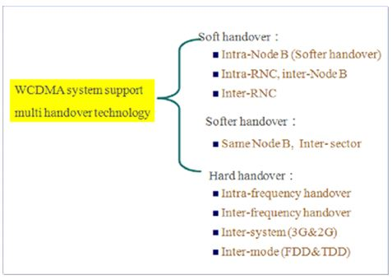

   Mobile Communication protocol

https://ilor.itrackglobal.com/ilor/objects/OSSContent:202/datastreams/ibmlogo/content

* **Nano Learning Object**

|  |  |
| --- | --- |
| **Nano Learning Object(NLO)** | **NLO Outcome** |
| LTE/SAE System Architecture Evolution | Learn about the LTE/SAE System Architecture Evolution |

* **NLO Contents**
* LTE/SAE System Architecture Evolution



* + “RNC functions and Node B functions are merged into a functions of EnodeB”.
  + EPC – Evolved packed cored has evolved from the principles of packet switching network.
  + MME takes care of control plane functions
  + Serving gate takes care of User plane functions

The evolved RAN part is also called E-UTRAN. E-UTRAN contains a sole node - eNB, proving the function of user plane RLC/ MAC/ PHP (Physical-layer Protocol) and the function of control plane RRC protocol.

**Features:**

* + OFDM-based air interface technology.
    - “flat network architecture” here E-UTRAN consists of eNodeBs only. No RNC concept here.
  + -x2 interface for eNodeB to enodbeB connection.
  + S1 interface for evolved packet core
  + -The user plane of S1 interface will have two end points one towards enodeB and one towards Serving Gate way. “The control plane of S1 interface terminates towards Mobile Management Entity”.

**eNodeB**

* + Handles RNC functionality such as RRC connection establishment, radio access control, Scheduling, and mobility. The additional functions include Radio resource management,compression of IP headers and encryption.

**MME:**

* + handles bearer control, access control,, paging, and handover.
  + NAS signaling, NAS signaling security, “Tracking area list” monitoring, “P-GW or S-GW selection”

**S-GW”**

* + ”S-GW implements data transfer function between the eNodeB and the external packet data network. It is concerned with billing functions”.
  + Packet routing and forwarding

**PDN gateway (P-GW)**

* + lawful interception , forwarding packets, billing, Quality of service control and interconnection with non-3GPP networks.
  + service level charging in uplink and downlink and enforcement of rate
  + ”S1” interface and “X2” interface replaces earlier interfaces in new LTE architecture

**E-UTRAN Structure**



Flat network architecture reduce the system time latency.

The number of NE reduce make the network easy deployment and maintenance.

The centralized control RNC is cancelled, avoid the single point of failure, and improve the network stability.

The enodeb, MME and SGW functionalities are similar to functions described earlier.

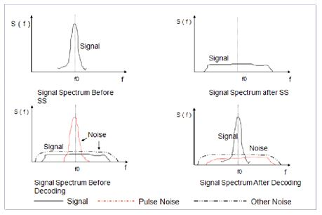

### Mobile Communication protocol

https://ilor.itrackglobal.com/ilor/objects/OSSContent:202/datastreams/ibmlogo/content

* **Nano Learning Object**

|  |  |
| --- | --- |
| **Nano Learning Object(NLO)** | **NLO Outcome** |
| Network Architecture for LTE | Gain an insight into the Network Architecture for LTE |

* **NLO Contents**
* Network Architecture for LTE
  + Since RNC deployment is not there, operation and maintenance cost is reduced considerably in LTE Network. This is a big advantage for the operators.
  + Latency is improved in the absence of RNC.
  + In earlier networks like GSM or CDMA or UMTS, if BSC or RNC is down, the entire BSC coverage area would lost the connection. However in LTE such things wont happen. Therefore it has better reliability.

**LTE Characteristics**

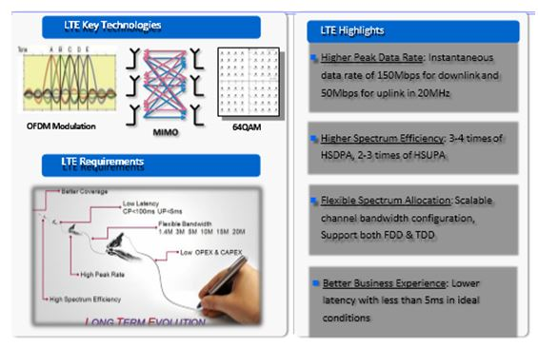

**“Peak Data Rate”**

* + -”downlink peak data rate of 100 Mbit/s at 20 MHz channel bandwidth”
  + “uplink peak data rate of 50 Mbit/s at 20 MHz channel bandwidth”
  + “Presence of MIMO Antenns and higher modulation technologies to increasing peak data rates”.

**“Control Plane Delay”**

* + -”transmission delay time of the control plane is <100 ms”
  + from the “CELL_PCH state” to “CELL_DCH state”, the transmission delay time <50 ms
  + -support 200 active user for 5 MHz spectrum and 400 active users for 20 Mhz spectrum.

**User Plane Delay**

* + Not more than 5 ms

**User Throughput**

* + higher than of R6 HSDPA.( both for uplinkd and downlik)

**Spectrum Efficiency**

* + three times more efficient than R6 HSUPA.

**Spectrum Flexibility**

* + “Operating at different bands : 1.4 MHz, 3 MHz, 5 MHz, 10 MHz, 15 MHz, and 20 MHz”.
  + “paired and unpaired spectrums”.
  + “On the other hand, the spectrum flexibility allows consolidation of spectrum bands”.

**LTE Spectrum**

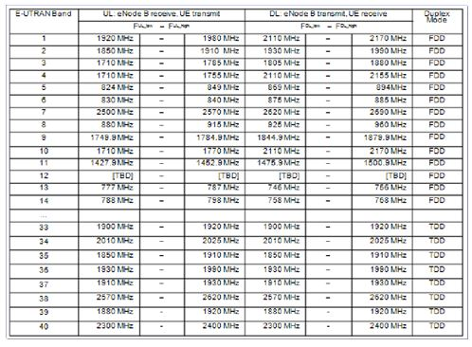

Mobile Communication protocol

https://ilor.itrackglobal.com/ilor/objects/OSSContent:202/datastreams/ibmlogo/content

* **Nano Learning Object**

|  |  |
| --- | --- |
| **Nano Learning Object(NLO)** | **NLO Outcome** |
| Radio Channel’s Problems to Solve | Learn about the Radio Channel’s Problems to Solve |

* **NLO Contents**
* Radio Channel’s Problems to Solve

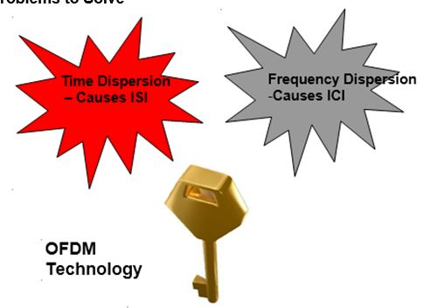

Using OFDM technology can solve this two kinds of radio transmission fading effectively.

* + The channel characteristics causes time dispersion which results in “Inter symbol interference”
  + ISI causes overlapping of symbols .
  + One way of solving ISI is to leave sufficient space between the symbols to be transmitted.
  + However leaving additional space would limit the throughput
  + Another method of solving this is to have an equalizer. This works like a “ anit channel”, avoiding time dispersion.
  + Today’s technology allows to handles block of symbols in frequency domain.

“The objective of pulse shaping at transmitter end is to “limit the out-of-band radiation”.

“However, pulse shaping within the limits of the “transmitted symbol (or block) itself will Corrupt the symbols”

“To avoid this, the symbol (or block) is extended in time and the shaping is performed on this extension”

**What is OFDM ?**

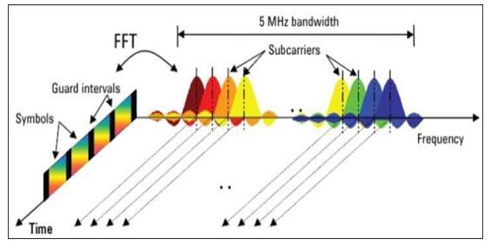

In frequency domain, OFDM divides channel into some sub-channels overlapped between adjacent sub- channels. These sub-channels are orthogonal.

Implement of CP can undermine ISI caused by Delay Spread.

“The total signal bandwidth, is be divided into “N non-overlapping frequency” subchannels”.

“ Every “subchannel” is modulated with a “separate symbol” and the N subchannels are frequency domain multiplexed.

“ The common method of avoiding spectral overlappin of subchannels used to be applied to eliminate ICI”. It results in inefficient bandwidth utilization.

* + This resulted in “ OFDM evolution” ( “ ORTHOGONAL FREQUENCY DIVISION MULTIPLEXING”
  + The figure indicates the principle of OFDM Technolgoy. It uses the concept of FFT and IIFT principles.
  + It results in efficient utilization of bandwidth.

**OFDM Benefits**

* + Dividing large bandwidth into small subcarriers, can be effectively against frequency-selective fading
  + It can be effectively against ISI, so it is suitable for “high-speed data transmission” in multi-path environment.
  + Spectrum efficiency is maximized. Because of the orthogonality between subcarriers, adjancent subchannels overlap.
  + Modulation/demodulation can be achived by IFFT/FFT. Calculation is efficient and simple.
  + It can achieve the different UL and DL transmission data rate by using different number of subchannels.
  + It can take full advantage of high SNR subchannels to increase system throughput by dynamic subchannel allocation.

**Why using OFDM ?**

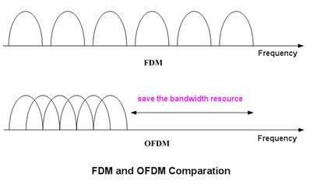

* + Bandwidth utilization rate is higher than FDM
  + Frequency selective fading is small
  + Time selective fading is small

Mobile Communication protocol

https://ilor.itrackglobal.com/ilor/objects/OSSContent:202/datastreams/ibmlogo/content

* **Nano Learning Object**

|  |  |
| --- | --- |
| **Nano Learning Object(NLO)** | **NLO Outcome** |
| OFDM Principle Diagram | Understand the concept of OFDM Principle Diagram |

* **NLO Contents**
* OFDM Principle Diagram

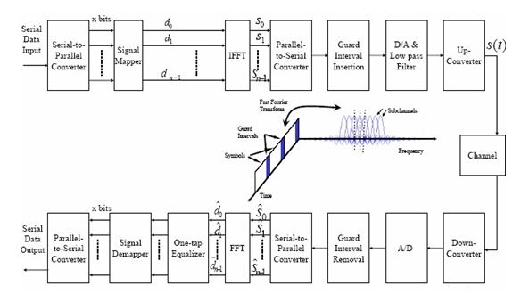

OFDM modulation and demodulation processes are as follows:

* 1. The transmitter converts “high datarate serial data” into low-rate parallel data for data transmission by using multiple orthogonal subcarriers.
  2. Each subcarrier adopts an independent modulator and a demodulator.
  3. These subcarriers are completely orthogonal to each other and synchronous in transmission and reception.
  4. The transmitter and the receiver must be accurately co-channel and synchronous, and sample bits precisely.
  5. The receiver performs bit sampling at the backend of the demodulator to acquire and convert data into high-rate serial data.

As a key role in the evolution to B3G/4G, the OFDM can maximize system performance by integrating diversity, spatiotemporal coding, interference, inter-channel interference suppression, and intelligent antenna technologies.

The beginning of OFDM can be dated to 1950s, but it is practically impossible to implement orthogonal subcarriers with traditional analog techniques due to constraints in steps 2 and 3 above. With advancement of digital signal processing technologies, S.B.Weinstein and P.M.Ebert put forward a   
method for implementing orthogonal carrier modulation by using FFT, which laid a solid foundation for wide use of the OFDM. To overcome the ISI caused by multipath effect and timing error, A.Peled and A.Ruizt raised an idea for adding a cyclic prefix.

**Advantages and Disadvantages of OFDM**

The OFDM system wins increasingly wide attention because of its following advantages:

* 1. The OFDM system converts high-rate serial data into low-rate parallel data to extend the symbol duration on each subcarrier, which effectively reduces the ISI caused by time dispersion on wireless
  2. channels and simplifies the receiver balance. Sometimes the ISI impact may be eliminated by “adding a cyclic prefix” instead of using any balancer.
  3. Subcarriers are orthogonal and subchannels can be overlapping one another. Therefore, the OFDM system can make full use of spectral resources in contrast with classical FDM systems.
  4. Orthogonal modulation and demodulation on subchannels can be implemented through FFT and IFFT.
  5. Generally wireless data services such as webpage browsing and FTP downloading are asymmetric, that is, the data volume in downlink is much larger than that in uplink. The MS power is usually less than 1W and the transfer rate in macro cellular environments is less than 10 kbit/s–100 kbit/s. The BS transmit power can be great and may provide over 1 Mbit/s of transfer rate. Therefore, the physical layer is expected to support asymmetric high-rate data transfer so as to meet the user data service demands and the mobile communications system requirements. The OFDM system can easily implement different transfer rates in uplink and downlink by using different amounts of subchannels.
  6. Wireless channels have frequency selectivity and all subcarriers are less likely to be concurrently in deep fading. Subchannels with a higher SNR can be fully utilized through dynamic bit allocation and dynamic subchannel allocation, thus improving system performance.
  7. The OFDM system can be easily combined with other access methods including “Multi-Carrier Code Division Multiple Access (MC-CDMA),” “ Frequency Hopping OFDM (FH-OFDM)”, and OFDM- TDMA and to comprise an OFDMA system to enable multiple users to simultaneously transfer information by use of OFDM technologies.
  8. There are multiple orthogonal subcarriers in the OFDM system, but the output signals are generated by overlap of several subchannels. Compared with “Single Carrier FDMA (SC-FDMA) systems”, the OFDM system has following disadvantages:
  9. Easy to be affected by frequency deviation: Spectral overlap of subchannels raises a rigorous requirement for orthogonality between subcarriers.
  10. Due to the “time varying nature of wireless channels”, frequency deviation, for example, Doppler shift, may occur to radio signals during signal transmission or between the “transmitter’s carrier frequency” and the receiver’s local oscillator, which will impair the orthogonality between subcarriers and lead to mutual interference between subchannels. Pool sensitivity to frequency deviation is a prominent “defect of the OFDM system”.

**“High Peak-to-Average Power Ratio (PAPR)”:**

* 1. The output of the “multi-carrier modulation system” is overlap of several subchannel signals.
  2. When many signals have the same phase, “the instantaneous power of overlapping signals is much greater than the average signal power”, resulting in a high PAPR. This lays an extremely high requirement for linearity of the amplifier on the transmitter. If the dynamic range of the amplifier cannot adapt to signal changes, it will lead to signal distortion and spectral change of the overlapped signals, thus impairing the orthogonality between subchannel signals and causing mutual interference and system performance deterioration.

   Mobile Communication protocol

https://ilor.itrackglobal.com/ilor/objects/OSSContent:202/datastreams/ibmlogo/content

* **Nano Learning Object**

|  |  |
| --- | --- |
| **Nano Learning Object(NLO)** | **NLO Outcome** |
| Multi-Path Effect | Gain an insight into the Multi-Path Effect |

* **NLO Contents**
* Multi-Path Effect

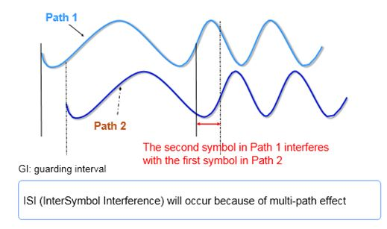

**If GI is Inserted**

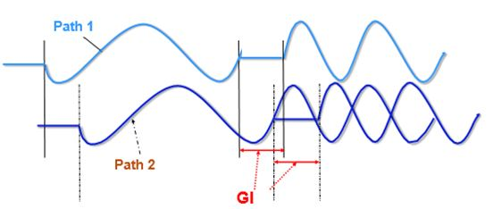

GI is inserted in order to eliminate ISI

When GI is longer than max “delay spread” of channel, the “multi-path component” of a symbol doesn’t interfere with next symbol

OFDM is robust to multipath delay spread. It extends each symbol duration that is used for subcarrier modulation to be N times larger than the original symbol duration through serial-to-parallel data conversion and modulation on N parallel subchannels. Likewise, the ratio of delay spread to symbol duration decreases by N.

To eliminate “ISI”, a “guard interval” is inserted between OFDM symbols. Guard interval “length Tg “is usually larger than the “maximum delay spread of the wireless channel” to prevent the multipath components of a symbol interfering the next symbol. If no signal is interpolated within this guard interval, this interval is deemed an “idle transmission period”. In this case, however, multipath propagation produces the ICI which impairs the orthogonality between subcarriers, as shown in the figure

Every OFDM symbol contains all non-zero subcarrier signals and delay signals. The figure above shows the delay signals of the first and the second subcarriers. In the FFT calculation period, the difference of number of periods between the first subcarrier and the second subcarrier with a delay is no longer an integer. Therefore, the second subcarrier will cause interference when the receiver attempts to modulate the first subcarrier. Similarly, the first subcarrier may cause interference when the receiver attempts to modulate the second subcarrier.

**ICI Brought by GI**

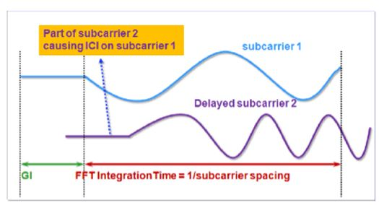

“FFT integral time length” can’t contain the entire waves because GIs are included. The orthogonality between subcarriers is destroyed.

**If CP is Inserted**

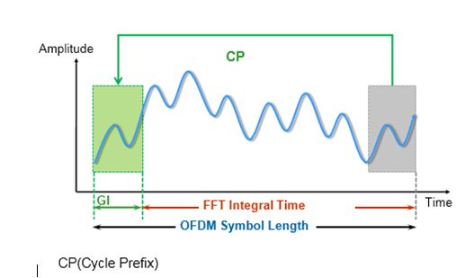

CP refers to the prefixing of a symbol with a repetition of the end, in order that the orthogonality between subcarriers is not undermined due to GI.

FFT integral time length can contain integer number of waveforms of subcarriers in multi-path, as long as time delay of every path is less than GI.

To avoid the ICI caused by multipath delay effect, an OFDM symbol needs to be added with a cyclic prefix within its guard interval, as shown in the figure below. This can ensure that the delayed copies of an OFDM symbol contain an integral number of waveform periods in an FFT period and no ICI is caused during demodulation of the delay signals with delays less than the guard interval Tg

Generally, when the guard interval accounts for 20%, the power loss is not more than 1 dB while the data rate loss reaches up to 20%. In traditional SC-FDMA systems, there are also data rate (bandwidth) losses. Guard interval insertion can eliminate the ISI and the ICI caused by multipath delay effect, so such losses are worthwhile. shows a block diagram of the IDFT(IFFT)-based OFDM system with a guard interval inserted.

The figure above shows the process of OFDM modulation and cyclic prefix insertion: The transmitter converts serial data signals into parallel output which are the data symbols to be modulated on corresponding subcarriers and can be deemed as a group of data in the frequency domain. After the IFFT, the parallel data is transformed into the data located at dispersed time points. In this way, IFFT implements conversion from frequency domain to time domain.

  Mobile Communication protocol

https://ilor.itrackglobal.com/ilor/objects/OSSContent:202/datastreams/ibmlogo/content

* **Nano Learning Object**

|  |  |
| --- | --- |
| **Nano Learning Object(NLO)** | **NLO Outcome** |
| OFDM Time-Frequency Structure | Learn about the OFDM Time-Frequency Structure |

* **NLO Contents**
* OFDM Time-Frequency Structure

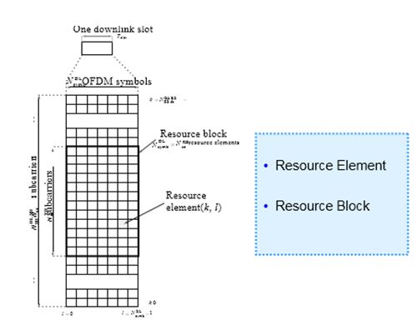

**Resource Element**

The smallest resource unit Resource Block

Contains 12 subcarriers in frequency domain

Contains 7 OFDM symbols in time domain(6 OFDM symbols when Extended CP is used) 1 RB :

* + 180kHz (i.e. 12 x 15KHz )in frequency domain
  + 0.5 ms (i.e. one slot)in time domain

1. The OFDM symbols in LTE are grouped into resource blocks.   
2. The resource blocks have a total size of 180kHz in the frequency domain representation and 0.5ms in the time domain representation   
3. Each 1ms Transmission Time Interval (TTI) consists of two slots (Tslot)   
4. Each user is allocated a number of resource blocks in the time -frequency grid.

  Mobile Communication protocol

https://ilor.itrackglobal.com/ilor/objects/OSSContent:202/datastreams/ibmlogo/content

* **Nano Learning Object**

|  |  |
| --- | --- |
| **Nano Learning Object(NLO)** | **NLO Outcome** |
| What is MIMO? | Understand about the MIMO |

* **NLO Contents**
* What is MIMO?

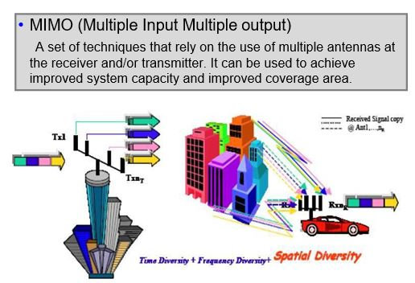

Multiple-antenna technology is a significant breakthrough in wireless transmission technology in the mobile communications industry. Generally, multipath effect is regarded as a harmful factor as it causes fading. Multiple-antenna technology, however, utilizes multipath as a favorable factor.

Multiple Input Multiple Output (MIMO) technology is the use of multiple antennas at both the transmitter and receiver by utilizing multiple spatial paths. MIMO enables diversity gain or multiplexing gain by adopting space-time processing technology, makes full use of spatial resources, and enhances spectrum utilization.

Objectives of MIMO technology are to provide:

* + Higher space diversity gain: Combine the space diversity gains of the receive diversity and transmit diversity to provide higher space diversity gain, ensure smoother equivalent radio channels, reduce bit error rates, and enhance system capacity.
  + Larger system capacity: When the Signal Noise Ratio (SNR) is high enough and Rank > 1 on channels, MIMO:
  + Decomposes the user data into multiple parallel data flows.
  + Transmits the data flows simultaneously on each antenna at the same frequency while maintaining total transmit power.
  + Identifies the data flows by multi-element receive antenna arrays in light of the space characteristics of each parallel data flow at the receiver; restores the original data flows by utilizing the multi-user demodulation technology.

**Inputs and Outputs**

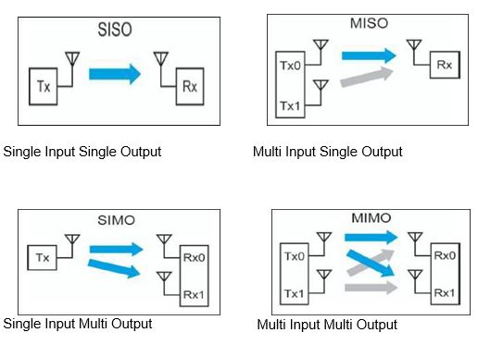

Single Input Single Output Multi Input Single Output

Single Input Multi Output Multi Input Multi Output

In the specifications, the terms “input” and “output” apply to the medium between the transmitters and receivers, including the RF components of both– known as the “channel”.

In wireless communications, the following transmission models are adopted: Single Input Single Output (SISO) model, Multiple Input Single Output (MISO) model, Single Input Multiple Output (SIMO) model, and MIMO model. Figure 1.2-1shows these transmission models.

In a wireless communication system, antennas are the first section to process signals at the front end. Enhancing antenna performance and efficiency will bring high gains to the system. The traditional antenna system has developed from SISO to MISO and SIMO. To withstand the impact on signal transmission caused by time-varying multipath fading, people keep looking for new technologies. Time diversity (time interleaving) and frequency diversity (spectrum extension) are effective means to resist multipath fading in a traditional SISO system. Space diversity (multiple antennas) is an effective means to further resist fading in MISO, SIMO, and MIMO systems. The frequently-used MIMO models in the LTE system includes downlink Single-user MIMO (SU-MIMO) models and uplink Multi-user MIMO (MU- MIMO) models.

SU-MIMO: A UE exclusively occupies all space resources in one time-frequency unit. The SU-MIMO precoding takes into account the performance of a single transmitting and receiving link. Figure shows the SU-MIMO transmission model.

**LTE MIMO Mode**

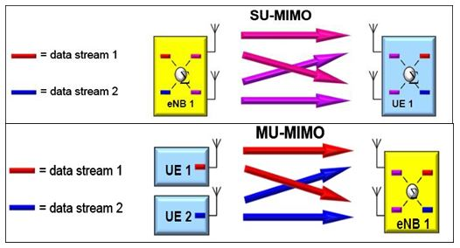

**Multi-antenna Technology**

LTE adopts MIMO as multi-antenna technology

LTE basic antenna configuration is DL 2*2 (Double Transmitters Double Receivers) and UL 1*2 (Single Transmitter Double Receivers). LTE maximum antenna configuration is 4*4 (Quadruplex Transmitters Quadruplex Receivers).

**SU-MIMO**

* + it is an example of downlink 2×2 single user MIMO with precoding
  + Two data streams are mixed to best match the channel conditions
  + The receiver reconstructs the original streams resulting in increased single user data rate and corresponding increase in cell capacity

2×2 SU-MIMO is mandatory for the downlink and optional for uplink

**MU-MIMO**

- it is an Example of uplink 2×2 multiple user MIMO   
- In multiple user MIMO the data streams come from different UE   
- There on possibility to do the precoding since the UE are not connected but the winder Tx antenna - spacing gives better de-correlation in the channel   
- Cell capacity increases but not the single user data rate   
- The key advantage of MU-MIMO over SU-MIMO is that cell capacity increase can be had without the increased cost and battery drain of two UE transmitters   
- MU-MIMO is more complicated to schedule than SU-MIMO

MU-MIMO: indicates that multiple UEs transmit signals using the same time-frequency Resource Block (RB). Each antenna uses one antenna. The system receiver performs joint test to the uplink mixed multi- user received signals and restores the original transmitted signals of each UE respectively. The uplink MU-MIMO technology is an important means to enhance uplink spectrum efficiency in the LTE system, but it cannot increase the uplink single-user peak throughput.

**Why select MIMO ?**

MIMO increase spatial dimensions freedom for radio resources

Through space-time processing technology, make full use of space resource, to ascend the capacity of the communication system without increasing the spectrum resources and power, improving the reliability and Spectrum efficiency.

Through space-time processing technology, make full use of space resource, to ascend the capacity of the communication system without increasing the spectrum resources and power, improving the reliability and Spectrum efficiency.

**MIMO System Model**

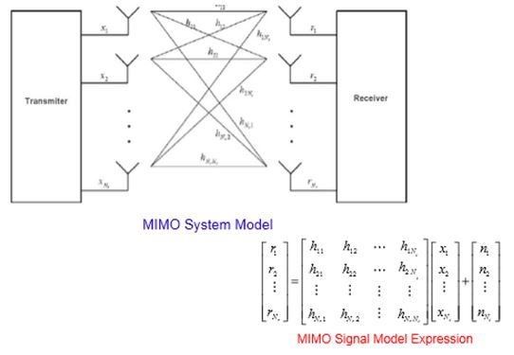

MIMO system uses multiple antennas and multiple paths at both the transmitter end and the receiver end. MIMO aims at multi-path radio channels. Figure shows the functional block diagram of the MIMO system.

The transmitter is configured with Nt transmit antennas and the receiver is configured with Nr receive antennas.

* + xj (j = 1, 2……Nt): indicates signals transmitted by No.j transmit antenna
  + ri (I = 1, 2……Nr): indicates signals received by No.i receive antenna
  + hij: indicates channel fading factor from No.j transmit antenna to No.i receive antenna

On the receiver, the noise signal (ni) is an independent complex zero-mean Gaussian variable. Every ni is separated from transmitted signals or ni at different time. Every receive antenna receives the ni with the same power, that is, σ2. Assume the channels are quasi-static Rayleigh flat fading channels.

The signal model of the MIMO system can be expressed in the following figure. Matrix: r = Hx + n

The MIMO system optimizes the multi-path wireless channels, transmitters, and receivers as a whole to achieve large communication capacity and high spectrum utilization. This is a best space-time diversities and interference cancellation.

   Mobile Communication protocol

https://ilor.itrackglobal.com/ilor/objects/OSSContent:202/datastreams/ibmlogo/content

* **Nano Learning Object**

|  |  |
| --- | --- |
| **Nano Learning Object(NLO)** | **NLO Outcome** |
| ISO 7-Layer OSI Model | Gain knowledge on the ISO 7-Layer OSI Model |

* **NLO Contents**
* ISO 7-Layer OSI Model

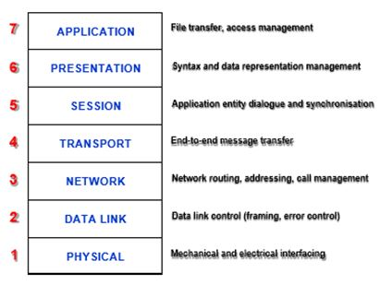

A protocol is a set of rules, agreed by both sides, to allow meaningful communication to take place Protocols are needed whenever systems need to pass information from one to another

* 1. **Physical Layer (Layer 1) :**
     + -It is the lowest layer of the OSI reference model.
       - Realizes physical connection between the two devices.
       - In this layer information would be transmitted in the form of bits. The received data in the form of 1s and 0s would be sent to data link layer for the formation of frame.

**Important functions:**

Bit synchronization, rate control, topologies types and transmission mode

* 1. **Data Link Layer :**
     + error detection and correction functionalities
       - Transmit data to the host using MAC address
       - data link layer is divided into Logical link control and Media access control
       - Functions of Data link layer are, framing, physical addressing, error control, flow control, and access control
  2. **Network Layer :**
     + Concerned with transmission of from one node to another in different networks.
     + packet routing, IP address assignment of sender and receiver.
  3. **Transport Layer :**
     + Formation of segment of data and end to end delivery of packets.
     + acknowledgement for every successful data transmission and helps in retransmission of data whenever error is found.
     + Connection oriented and connection less services
  4. **Session Layer :**
     + Establishment of data connection, session management and authentication
     + security functions
  5. **Presentation Layer :**
     + also termed as presentation layer.
     + application layer data is extracted and manipulated as per the format required over the network.
     + functions: translation, Encryption, Decryption, Compression,
  6. Application Layer :
     + implemented by network application
     + any applications results in data which needs to be transmitted over the network.
     + Example, Google chrome, Skype messenger etc.
     + Network virtual terminal, mail services, file transfer access and managment.

   Mobile Communication protocol

https://ilor.itrackglobal.com/ilor/objects/OSSContent:202/datastreams/ibmlogo/content

* **Nano Learning Object**

|  |  |
| --- | --- |
| **Nano Learning Object(NLO)** | **NLO Outcome** |
| GSM interfaces | Learn about the GSM interfaces |

* **NLO Contents**
* GSM interfaces

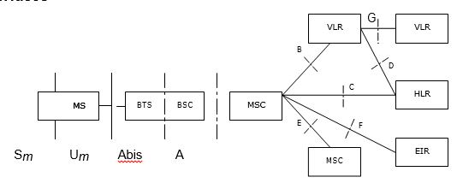

**Sm Interface:** Man-machine interface implemented in MS. It is an interface between subscribers and PLMN. MS consists of keyboard, LCD, and SIM card.

**Um Interface:**Radio interface between MS and BTS. It is an important interface in PLMN. Digital mobile communication network has different radio interface as compared to analogue mobile communication network.

**A Interface:** It is an interface between BSC and MSC. Base station management information, call processing interface, mobility management information, and specific communication information are transferred through A interface.

**Abis Interface:**It is an interface between BSC and BTS. Supports all services provided to subscribers. Also supports the control of BTS radio equipment and management of radio resources assigned.

**B Interface:** It is an interface between MSC and VLR. VLR is a database locating and managing MS when MS roams in the related MSC control area. MSC can query the current location of MS from VLR and update MS location. When subscriber uses a special supplementary service or changes a relevant service, MSC notifies the VLR. Sometime VLR also updates information in HLR.

**C Interface:**It is an interface between MSC and HLR. C interface transfers management and route selection information. When a call finishes, MSC sends the billing information to HLR. When PSTN cannot get location information of a mobile subscriber, the related GMSC queries HLR of the subscriber to obtain the roaming number of the called MS, and then transfers it to the PSTN.

**D Interface:** It is an interface between HLR and VLR. Exchanges MS location information and subscriber management information. To enable a mobile subscriber to originate or receive calls in the whole service area, data must be exchanged between HLR and VLR. VLR notifies HLR about the current location of MS belonging to HLR, and then provides MS roaming number. HLR transmits VLR data required to help the services of the MS. When an MS roams to the service area of another VLR, HLR notifies the previous VLR to delete the relevant MS information. When MS uses supplementary services, or some parameters are changed, D interface is also used to exchange the related information.

**E Interface:** It is an Interface between MSCs. It exchanges the handover information between two MSCs. When MS in a conversation moves from one MSC service area to another MSC service area, inter-cell handover occurs to maintain the conversation. At that time, related MSCs exchange the handover information through E interface.

**F Interface:** It is an interface between MSC and EIR. It exchanges the MS management information, such as IMEI, between EIR and MSC.

**G Interface:**It is an interface between two VLRs. When MS uses a Temporary Mobile Subscriber Identity (TMSI) to register with a new VLR, the relevant information is exchanged between VLRs through G interface. This interface also searches IMSI of the subscriber from VLR that registers TMSI.

   Mobile Communication protocol

https://ilor.itrackglobal.com/ilor/objects/OSSContent:202/datastreams/ibmlogo/content

* **Nano Learning Object**

|  |  |
| --- | --- |
| **Nano Learning Object(NLO)** | **NLO Outcome** |
| GSM protocol structure | Gain an insight into the GSM Protocol Structure |

* **NLO Contents**
* GSM protocol structure

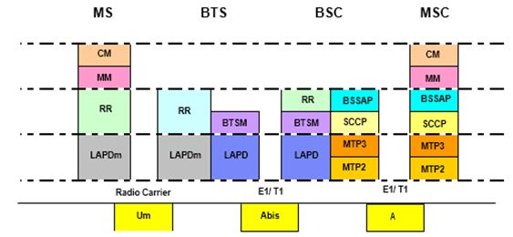

Abis Interface Protocols

Physical layer

2 Mbps PCM link is often used

**Data link layer**

LAPD is a data link protocol for signaling transmission between BTS and BSC, used to implement message transmission between the L3 entities in the D channel.

LapD is a point-to-multipoint communication protocol which employs frame structure. LapD implements the following functions:

1. Providing one or multiple data connections in the D channel.   
2. The data link connections are identified by the data link connection identifiers (DLCI) contained in the respective frames. DLCI consists of terminal equipment identifier (TEI) and service access point identifier (SAPI), indicating the terminal entity and target service access point.   
3. Delimitation, location and transparency of the frame   
4. Sequence control, ensuring sequential transmission of the frames   
5. Error detection   
6. Error recovering   
7. Notifying the management entity of the unrecoverable error   
8. Flow control

Functions 1, 2 and 4 hereof are completed automatically by the hardware, while functions 3, 5, 6 and 7 are implemented via the software.

LapD is implemented in the LapD module of RSL. Fig 1.2-5 shows the position of the LapD module in RSL.

The LapD module communicates with the physical layer and L3. The L3 protocol is processed in FURRM.

OAMM configures the parameters such as TEI and values of the timer necessary for LapD module running.

The LapD module provides two types of information transmission modes for the FURRM: I-frame multi- frame operation and UI frame operation.

**Um Interface Protocols**

**Physical layer**

This layer provides transmission channel for wireless links to transmit data through the radio carrier. It also provides different functional channels for higher layers including service and logic channels. <

**Data link layer**

This layer provides reliable data links between MS and BTS. It uses the LAPDm protocol, a derivative of the LAPD and dedicated for GSM.

In GSM, LapDm is a data link protocol for signaling transmission between MS and BTS, used to implement message transmission in the Dm channel to the L3 entities via the radio interface. LapDm is based on LapD with some simplification and modification.

LapDm implements the following functions:

1. data link connection in Dm channel. Support multiple services for the upper layer. The data link connections are identified by the DLCIs in the respective frames. The DLCI in the LapDm protocol only contains SAPI, indicating the target service access point.   
2. Supporting to identify diversified frame types.   
3. Supporting the transparent transmission of L3 messages between L3 entities.   
4. Sequence control, to maintain the sequence of respective frames connected via data link.   
5. Checking the format and operation errors in the data link layer.   
6. Notifying the L3 entities to process the unrecoverable errors.   
7. Flow control   
8. Supporting access of the burst solution mode after the RACH channel access is instantly assigned.

**LapDm is implemented in the LapDm module of RSL.**

Fig shows the position of the LapDm module in RSL.

The LapDm module communicates with the physical layer and L3. The L3 protocol is processed in FURRM. OAMM configures the value of the timer necessary for LapDm module running.

LapDm module provides two types of message transmission modes for FURRM: I-frame multi-frame operation and UI frame operation In terms of frame structure, LapDm eliminates the frame delimiter flag (FLAG) and the frame check sequence (FCS). In LapDm, frame delimitation information is transmitted by means of synchronization scheme of the radio interface without the beginning frame and end frame flags. FCS is not available in the LapDm because the transmission scheme in the physical layer of the Um interface has the error check function.

Mobile Communication protocol

https://ilor.itrackglobal.com/ilor/objects/OSSContent:202/datastreams/ibmlogo/content

* **Nano Learning Object**

|  |  |
| --- | --- |
| **Nano Learning Object(NLO)** | **NLO Outcome** |
| What’s GPRS? | Understand the concept of GPRS |

* **NLO Contents**
* What’s GPRS?

**General Packet Radio Service**

* + mobile data services across end to end connection relied on packet switching concept.
  + Suitable low traffic burst data and long latency application
  + GPRS can be called as Mobile＋IP
  + Providing general packet radio service with least modification and least cost

GPRS can effectively utilize the radio resources and network terrestrial resources and is suitable for long-time small-volume burst data services

**GPRS Features**

* + Continuous undisrupted connection with IP network

Internet Protocol (IP) technology is adopted in GPRS core network, and many transmission technologies are employed in GPRS bottom layer. Thus, it is easy to implement the seamless connection with the highly developed IP network.

* + High rate

With help of multi-slot binding and high-speed coding scheme, GPRS phase I adopts CS1 and CS2 coding schemes, and provides the access rate up to 115 kbps. GPRS phase II adopts CS3 and CS4 coding schemes, and provides rate up to 171 kbps.

* + Always online and flow charging

GPRS provides the ‘availability for connection and always online performance’, offering new means for mobile subscribers to access Internet and Intranet rapidly. Once GPRS terminal is powered on and connected with GPRS network, it can maintain the online status all the way. Subscriber can receive and send information at any time without dial-up process required in circuit switching. As long as GPRS terminal does not transmit data, it will not occupy network and radio resources. Thus, the mobile subscribers can benefit from flow charging. That is, mobile subscribers can stay online as long as possible without bothering the prohibitive bill.

**Mature technology**

GPRS provides solutions to implement data services in GSM technologies and current networks. GPRS provides subscribers the end-to-end mobile data services based on packet switching and transmission technology. GPRS can effectively utilize the radio resources and network terrestrial resources and is suitable for long-time small-volume burst data services

**GPRS Services**

According to ETSI assumption, GPRS must implement:

* + PTP service
  + PTP TCP/IP subscriber interworking
  + X.28 protocol from MS to GGSN and X.25 protocol from GGSN to external PDN
  + Gn, Gb, Gr, Gp, Gs, and Gi interfaces
  + PTP and roaming security guarantee
  + Charging
  + Operator-determined Call barring and call termination, and operator call filtering
  + PTM radio interface preparation
  + Anonymous access
  + SMS-MO and SMS-MT support through GPRS

GPRS MSs are divided into three categories:

* + Type-A GPRS MS   
    Type-A GPRS MS can be used in both GSM and GPRS environments. Type-A GPRS enables the subscribers to receive speech calls and communicate with called party without interrupting data transmission.
  + Type-B GPRS MS   
    Type-B GPRS MS can be connected with GSM and GPRS system at the same time, and provide GPRS and GSM circuit-switched services. However, it cannot provide both GPRS and GSM services at a time.   
    When a circuit-switched call is originated to the type-B MS in GPRS, the MSC/VLR transmits a message to disconnect current packet from the SGSN. Then GPRS connection gets disconnected from SGSN temporarily. After the circuit-switched call is complemented, the MSC/VLR sends a Restore message to the SGSN. The SGSN resumes the GPRS connection after receiving the message. Thus, the MS need not to establish GPRS connection repeatedly. Most of the GPRS MS types in current market are type-B MS.
  + Type-C GPRS MS   
      
    Type-C MS enables subscribers to use GSM services and GPRS alternatively. Manual service changeover is required.

**GPRS Network**

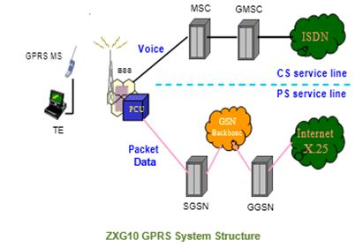

**GGSN**

* + Gateway GPRS support node
  + it is gateway between GSM and external data network
  + routes incoming data packets to the SGSN
  + Gi interface is interface between GGSN and PDN

**SGSN**

* + Monitors location information
  + security functions

Using SGSN and GGSN, operators can construct a GPRS backbone network on the basis of current transmission network. By reconstructing the current GSM network, operators can easily provide both circuit and packet services, and fully utilize radio resources and network terrestrial resources.

GPRS MSs are divided into three categories:

* + Type-A GPRS MS   
    Type-A GPRS MS can be used in both GSM and GPRS environments. Type-A GPRS enables the subscribers to receive speech calls and communicate with called party without interrupting data transmission.
  + Type-B GPRS MS   
    Type-B GPRS MS can be connected with GSM and GPRS system at the same time, and provide GPRS and GSM circuit-switched services. However, it cannot provide both GPRS and GSM services at a time.
  + Type-C GPRS MS   
    Type-C MS enables subscribers to use GSM services and GPRS alternatively. Manual service changeover is required.

Mobile Communication protocol

https://ilor.itrackglobal.com/ilor/objects/OSSContent:202/datastreams/ibmlogo/content

* **Nano Learning Object**

|  |  |
| --- | --- |
| **Nano Learning Object(NLO)** | **NLO Outcome** |
| Radio block structure | Learn about the RADIO Block Structure |

* **NLO Contents**
* Radio block structure

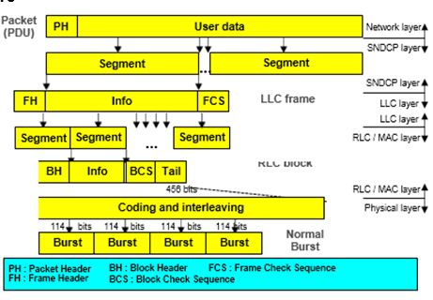

**Relay：**

Normal Burst

To relay LLC PDU between Um and Gb interfaces in BSS and relay PDP PDU between Gb and Gn in SGSN.

**BSSGP（BSS GPRS Protocol):**

Routing and Quality of service information

**NS (Network Service):**

This layer transfers BSSGP PDU.

L1bis、L1、L2:

Not regulated in GPRS regulations.

GTP（GPRS Tunnel Protocol):This protocol supports data and signaling transmission among nodes of GPRS backbone network. All PTP PDU PDP are packed with GTP.

**UDP/TCP：**

TCP carries GTP PDU that needs reliable data link, X.25 for example, in GPRS backbone.UDP carries GTP PDU that does not need reliable data link, IP for example, in GPRS backbone. TCP provides traffic control and protects GTP PDU from losing and damaging.UDP protects GTP PDU from damaging.

**IP：**

* + routing data packets and control information.
  + Currently based on IPv4, finally IPv6.
  + Assignment IP address

**RADIO BLOCKS**

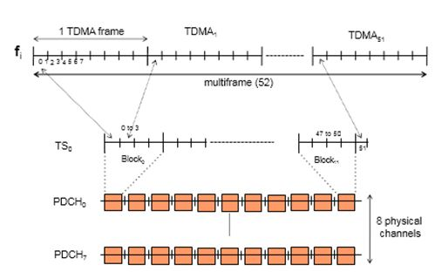

Division into blocks: One block = four consecutive TSs. This is the radio resource allocation unit. One block = four TS of 156.25 bits = 625 bits.

Bit rate on a PDCH The standard allows, for each channel, four "coding schemes": CS-1: bit rate = 9.05 kbit/s (poor radio conditions, redundant bcp).

CS-2: bit rate = 13.4 kbit/s (better conditions) CS-3: bit rate = 15.6 kbit/s

CS-4: bit rate = 21.4 kbit/s (best conditions)

In each cell, CS Adaptation algorithms are tuned as part of the QoS.

The theoretical maximum of 160 kbit/s is given for one MS which would have eight PDCHs of 21.4 kbit/s each. There is still no mobile capable of managing eight channels.

Reminder: A physical channel on a frequency fi in practice includes two frequencies: fi DL and fi UL.

**PACKET LOGICAL CHANNELS**

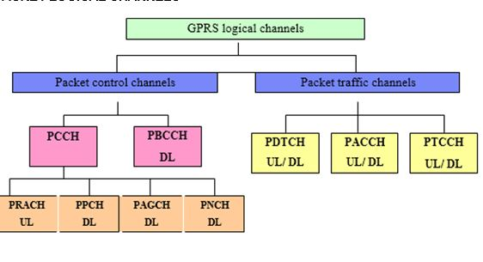

Frequency band refers to TDMA under FDMA, and Wireless transmission refers to basic transmission unit on radio path, which is the burst pulse lasting for 15/26 ms (equivalent to about 156.25 modulation bits).

GPRS system divides a carrier into eight timeslots as in GSM, which constitute eight basic time division channels. Therefore, a physical channel can be uniquely determined by a TDMA frame sequence, a timeslot No. (module 8), and a definite hopping sequence. Because GPRS is designed to coexist with GSM voice transmission, some physical channels in a GSM cell supporting GPRS may transfer voice, and other physical channels may transfer GPRS packet data. In addition, some GPRS signaling flows, such as packet system message broadcasting, packet access and resource allocation, are conducted on CS channels.

PRACH: It delivers packet access burst pulse and extended access burst pulse. MS sends data or paging response to BSS through PRACH.

* + PPCH: It sends paging messages for CS services and GPRS services. CS paging services is applicable to type-A and type-B MSs. PPCH also uses paging group and can support DRX
  + PAGCH: Before MS sends packets, PAGCH allocates one or several PDTCHs to MS for packet transmission. If MS is transmitting packets, the resources allocated can be transferred in PACCH.
  + PNCH: It notifies MS of PTM-M call. DRX mode must be configured to monitor PNCH.

**Packet Broadcast Control Channel (PBCCH):**

PBCCH broadcasts packet data system messages. Parameters carried in these messages determine channels mapping on multiframes. If no PBCCH is allocated, BCCH can transfer these messages. BCCH will give definite indication, showing whether the cell supports packet data service. If cell supports packet data service, and PBCCH is assigned, the PBCCH combination configuration information is sent.

**Packet dedicated control channel:**

* + PACCH: It transmits signaling information, such as acknowledge message and power control message. In addition, it also carries resources allocation and re-allocation information, which is used for allocating PDTCH capacity or adding PACCH in future. MS transmitting packets are able to enter circuit switching mode through PACCH paging. ACCH is dynamically allocated to physical channel with PDTCH. It is a bi-directional channel.
  + PTCCH/U: It transmits random access burst and estimates time advance of MS in packet transmission mode.
  + PTCCH/D: It amends the time advance of several MSs. A PTCCH/D corresponds to several PTCCH/Us.

  Mobile Communication protocol

https://ilor.itrackglobal.com/ilor/objects/OSSContent:202/datastreams/ibmlogo/content

* **Nano Learning Object**

|  |  |
| --- | --- |
| **Nano Learning Object(NLO)** | **NLO Outcome** |
| GPRS MULTIFRAME | Gain knowledge on the GPRS MULTIFRAME |

* **NLO Contents**
* GPRS MULTIFRAME

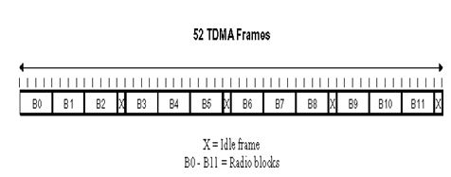

Each of the combination are mapped to a single physical channel using a 52-frame multiframe

GPRS introduces 52 TDMA multiframe structure. Logical channels on packet data channels (PDCHs) mapping is based on 52 TDMA multiframe structure.

Fig shows 52 TDMA multiframe structure.

PDCH multiframe contains 12 blocks (each block is consists of 4 consecutive TDMA frames), 2 idle frames, and 2 TDMA frames used for Packet Timing advanced Control Channel (PTCCH). There are 52 TDMA frames all together.

In GPRS, except packet random access channel (PRACH) and PTCCH/U, basic unit of other packet logical channels is a block.

In a 52-multiframe, sequence of 12 blocks is B0, B6, B3, B9, B1, B7, B4, B10, B2, B8, B5, B11.

**MAPPING OF PITCCH/U**

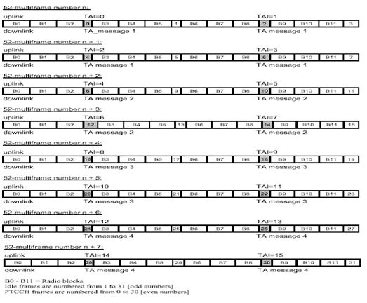

**PDTCH/U and PACCH/U mapping:**

For each PDCH allocated to MS, MS will be allocated with an Uplink State Flag (USF). Network uses USF to control the different MSs radio block multiplexing in uplink PDCH. US control’s the timeslot usage. Three-bit USF is located in header of each downlink radio block, and can form eight states for uplink transmission multiplexing. In PCCCH, one USF value marks the PRACH (USF = idle), and other values are reserved for seven different MSs (USF = R1/R2 … R7). When an MS without USF is using the uplink, a USF value can prevent conflict of uplink channels. USF is directed to the next uplink radio block.

When an MS finds its own USF in header of a BX (Bx = B0 ! B11) downlink block of a PDCH, MS can use BX+1 (X = 11) or B0 (when X=11) uplink blocks on this PDCH. If the network permits, MS can also use three consecutive blocks (four blocks in total).

* + PTCCH/U mapping:   
    When an MS is allocated a PDTCH from a PDCH, PTCCH/U must also be allocated from that PDCH. The cycle of PTCCH/U is eight 52-multiframes, including 16 PTCCH/Us (0 to 15). PTCCH/U sub-channel No. of each MS is determined by the time advance index (TAI) obtained by the MS in resource allocation.
  + GPRS has 52 frame multi frame structure. Logical channels on packet data channel mapping is based on 52 TDMA multiframe structure.

**UTRAN INTERFACES**

General Protocol Model for UTRAN Interfaces

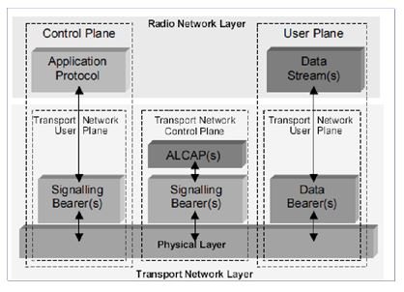

**Layers Types :**

1. Radio network Layer   
2. Transport network layer

**Vertical Plane Types:**

* + Control Plane

- It consists of application protocol, for example RANAP/ RNSAP.   
- It also consist of signaling bearer

The main function of control plane is to handle signaling information required to establish connectivity and maintain link.

* + User Plane

- It handles data streams and data bearers   
- the data bearers are defined as per specific protocols

The User plane is responsible to carry user data across various nodes in the architecture ALCAP protocol are used to set up data bearers in transport layer. It includes bearers required for signalling.

**Transport network control plane**

1. Exist between the control plane and the user plane.   
2. The presence helps higher level protocol to be completely independent of technology evolution.

**Setting up of transport bearers**

1. At control plane signalling establishment by application level protocol   
2. Data bearer setup by ALCAP protocol

Mobile Communication protocol

https://ilor.itrackglobal.com/ilor/objects/OSSContent:202/datastreams/ibmlogo/content

* **Nano Learning Object**

|  |  |
| --- | --- |
| **Nano Learning Object(NLO)** | **NLO Outcome** |
| Radio interface protocol architecture | Gain an insight into the Radio Interface Protocol architecture |

* **NLO Contents**
* Radio interface protocol architecture

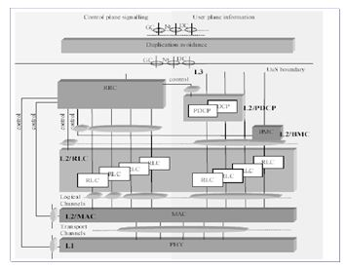

* 1. Physical Layer

- Carries data packets in air interface.   
- radio link adaptation , cell search for initial setting up , power control, handover and other measurements

* 1. Medica access control layer

- Mapping between transport channels and logical channels

* + - Multiplexing MAC SDUs onto transport channels
    - Error correction and Scheduling functions
  1. Radio Link Control

- Three modes of operation:   
- Transparent Mode, Unacknowledged Mode, Acknowledged Mode.   
- Transmitts upper layer Packet data units and takes care of error correction

* 1. Radio Resource Control

- System Information is brodcasted related to the non-access stratum, access stratum   
- Establishment of Paging signal   
- RRC connection Establishment   
- security

* 1. Packet Data Convergence Control

- IP Header compression / decompression   
- user plane / control plane data transfer function   
- PDCP Sequence maintenance   
- sequence delivery of upper layer packets.   
- Ciphering and deciphering

* 1. Non Access Stratum (NAS) Protocols

- forms the highest stratum between the user equipment and MME.   
- deals with mobility of the MS   
- establishes and maintains session management   
- IP connectivity between mobile and network gate way

   Mobile Communication protocol

https://ilor.itrackglobal.com/ilor/objects/OSSContent:202/datastreams/ibmlogo/content

* **Nano Learning Object**

|  |  |
| --- | --- |
| **Nano Learning Object(NLO)** | **NLO Outcome** |
| UTRAN control plane protocol stack | Understand the UTRAN Control Plane Protocol Stack |

* **NLO Contents**
* UTRAN control plane protocol stack

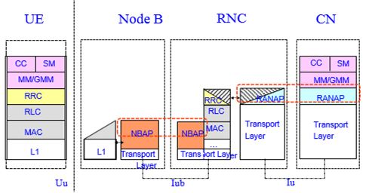

The UTRAN protocol structure may be divided into two parts:

* + UTRAN Control Plane Protocol
  + UTRAN user plane Protocol

**Control Plane Protocol**

1. The protocol structure can be explained in terms of Uu , Iub , Iu   
2. Under UE, the protocol layer consists of L1, MAC, RLC, RRC, MM, CC, SM

**Functions of Idle Mode:**

1. The MS connects to any cell selection or reselection.   
2. link quality, access technology details are received through broadcast channels..   
3. monitors paging information to detect incoming calls and text messages. System information messages such as CGI, Radio parameter information, Type of codes used and timer information, modulation types are received.

**Connected Mode Functions :**

1. The mobile station transmits neighbour cell info and channel quality information to the network which select the best cell for the mobile station during call establishment or call retain phase.   
2. Here RRC protocol will be utilized.

**UTRAN User Plane Protocol Stack**

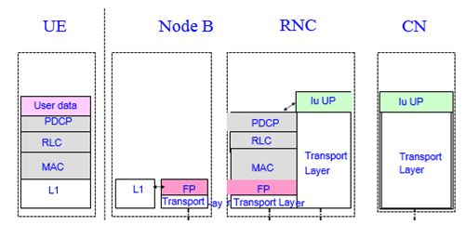

Packet Data Convergence Protocol

Collects the higher layer packets and adds necessary header bits required to segment the data so that it can fit into the radio channels.

**RLC (radio Link Control)**

Basically works for error detection and correction at layer 3. The quality of service related information is also incorporated at this layer.

**Medium Access Control (MAC)**

This layer concerned with error detection and correction at layer2. The information related to type of link used , modulation techniques used will be added at this layer.

**Layer-1**

The type of channel used, frequency related information , radio link quality etc will be considered.

**Functions of other layer**

* + packets at EPC are encapsulated using particular EPC protocol and tunnelled between eNodeB and PGW
  + Various tunneling protocols are used depending on the type of physical interface used. (PCM or Ethernet or ATM or IP).
  + S1 interface uses GTP protocol between the eNodeB and S-GW also between between the S-GW and P- GW.

   Mobile Communication protocol

https://ilor.itrackglobal.com/ilor/objects/OSSContent:202/datastreams/ibmlogo/content

* **Nano Learning Object**

|  |  |
| --- | --- |
| **Nano Learning Object(NLO)** | **NLO Outcome** |
| E-U TRAN network interfaces | Gain knowledge on the E-U TRAN Network Interfaces |

* **NLO Contents**
* E-U TRAN network interfaces

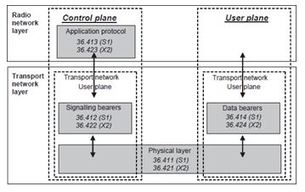

**E-UTRAN model**

1. radio network layer –   
It consists of higher level protocol . Define the rules of S1 and X2 interfaces   
2. Transport network layer   
It defines the rules for radio network layer to transport the data at these layer. 

o The split allows liberty in between these two layers.   
o At every interface, there is a split between a User plane and a Control plane.   
o Different data packets are given to the transport layer before transmission without the requirement of preprocessing. Hence the radio network box in the User plane is empty.

The layer common to both User and Control planes is physical layer.

o Most of the E-UTRAN interfaces are open interface so that any interconnectivity between different vendors are permitted   
o S1 interface defines the protocols for S1 and X2 

1. S1 User Plane Interface

* + - * user data packet are transported between the eNodeB and the SGW. Protocol used GTP over UDP/IP.
      * data encapsulation is provided by this data stack.

2. S1 Control Plane Interface

* + - * It is a signalling interface defines rules for connection between the eNodeB and the MME.
      * Bearer-level procedures, . Handover procedures, NAS signalling transport MMEsignalling etc

**LTE Protocol Structure**

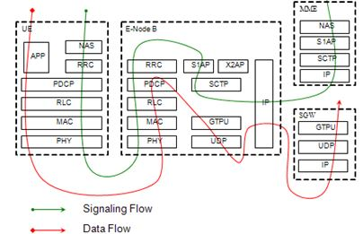

The radio protocol architecture for LTE

1. control plane architecture   
- The control plane architecture takes care of flow of data packets associated with signalling information. These data packets are processed using the protocols such as TCP, UDP and IP. All the signalling information required before the establishment of bearer channel are processed here.   
2. user plane architecture 

o concerned with handling user packet data.   
o Sub layers of user plane:

1. PDCP   
2. RLC   
3. MAC

**Physical Layer (Layer 1)**

1. functions include cell search during initial synchronization, handover decision, measurements for power control   
2. link adaptation

**Medium Access Layer (MAC)**

1. Error detection and control. It involves in Mapping of logical channels to transport channels   
2. MAC SDUs gets multiplexed onto transport blocks (TB) to be delivered   
3. Scheduling functions   
4. Bits are converted into frames

**Radio Link Control (RLC)**

* + Transparent Mode (TM), Unacknowledged Mode (UM), and Acknowledged Mode (AM).
  + Error detection and control in Layer 3

**Functions of RLC**

1. Transfers upper layer PDUs and error correction through ARQ   
2. protocol error detection

**Radio Resource Control (RRC)**

1. broadcast of System Information   
2. Paging information   
3. maintenance and release of an RRC connection between the UE and E-UTRAN,   
4. Security functions

**Packet Data Convergence Control (PDCP)**

1. Header compression IP packet data   
2. user plane /control plane transfer of data

**Non Access Stratum (NAS) Protocols**

1. Support the mobility of the UE. Establishes and maintains IP connections between connectivity between the mobile and a PDN GW.   
2. Conveys non-radio signalling UE and MME .

**Control-Plane Protocol Structure**

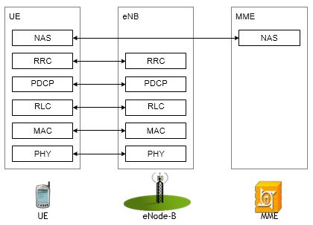

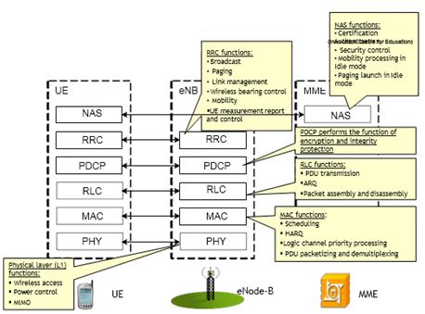

**User-Plane Protocol Structure**

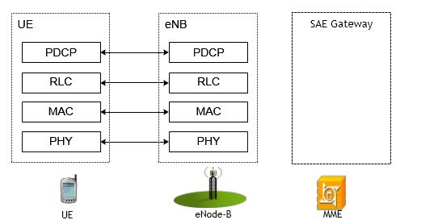

**User-Plane Protocol Structure**

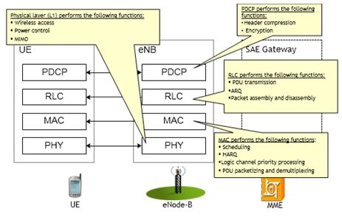

**EPS Bearer Service Structure**

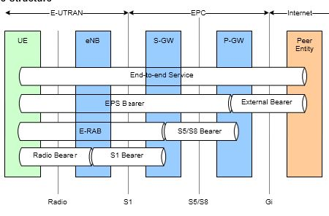

   Mobile Communication protocol

https://ilor.itrackglobal.com/ilor/objects/OSSContent:202/datastreams/ibmlogo/content

* **Nano Learning Object**

|  |  |
| --- | --- |
| **Nano Learning Object(NLO)** | **NLO Outcome** |
| Frame structure | Learn about the Frame Structure |

* **NLO Contents**
* Frame structure

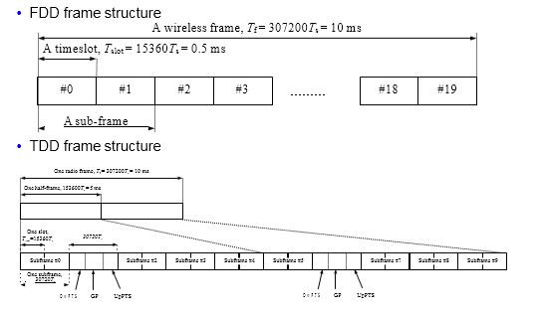

radio frame of10 ms, which is further subdivided into 10 1 ms subframes. Each subframe is split into two 0.5 ms slots.

* + Each slot comprises seven OFDM symbols for normal cyclic prefix length.
  + Each slot comprises six if the extended cyclic prefix is configured in the cell.
  + In the frequency domain, resources are grouped in units of 12 subcarriers each subcarries of 15 KHz.
  + subcarriers for a one slot duration is termed a Resource Block (RB).1

The smallest unit of resource is the Resource Element (RE), which consists of one subcarrier for a duration of one OFDM symbol.

Out of all resource blocks, certain resource elements are reserved for sychronization and referece signals, controls signalling and broadcast information.

The balance resource elements are used for data transmission allocated in pairs. domain).

**Types of frames:**

Type 1 - used in Frequency Division Duplexing (FDD)

* + frame duration =10 msec
  + Time slot = 1 subframe = 1 msec
  + Total there are 10 subframes

Type 2 -used in Time Division Duplexing (TDD).

* + frame =10 msec
  + subframe = 1 msec
  + subframe: 0 and 5 = should be always used for downloading.It carries synchronization and broadcast information
  + Subframe 2 – used for uploading
  + subrame 1- special subframe, serves as a switching point between DL and UL
  + Subframe 6 – left to enB for DL or special
  + Subframe 3, 4, 7,8, 9 – Uplink or downlink

Physical Resource Block

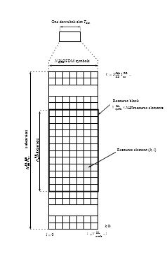

Resource block is main unit to get data service

* + Resource block is provided by eNB
  + In one sector we can expect 50 Ues with 2 RB/ User
  + If you reduce RB<2, speed is less
  + enodeB decide any of 50 sets ( to service) it need not be q set for UE1 and so on.
  + for signalling 1 RB sufficient
  + It is not compulsory that 2 successive RB should be allocate to one UE
  + RE=Resource element occupies in 1 subcarrier ( 15 KHz) in frequency domain and one symbol duration in time domain - 1200x7=8400 resource elements
  + 1 Resource block= 12 subcarrier x7 symbols in one time slot = 12 SC in frequency domain and 7 symbol duration in time domain.
  + 1RB= 7x12 =84 resource element = Res
  + Total RBs in one time slot = 8400 RE/ 84 RE = 100 RBs

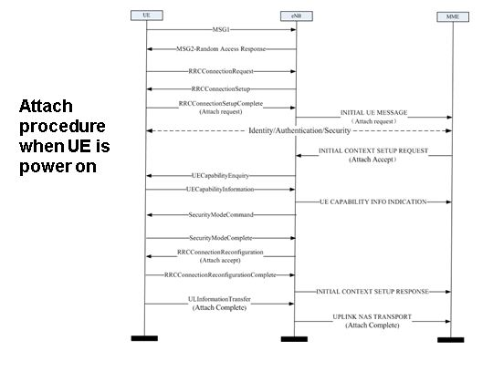

   Mobile Communication protocol

https://ilor.itrackglobal.com/ilor/objects/OSSContent:202/datastreams/ibmlogo/content

* **Nano Learning Object**

|  |  |
| --- | --- |
| **Nano Learning Object(NLO)** | **NLO Outcome** |
| Establishment of the NAS signaling connection | Learn about the Establishment of the NAS signaling connection |

* **NLO Contents**
* Establishment of the NAS signaling connection

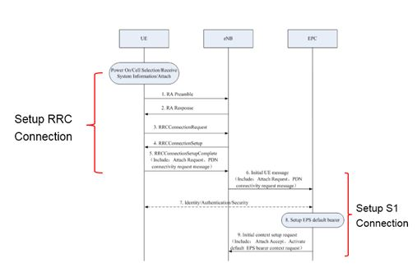

**Detach Procedure: RRC_IDLE（1）**

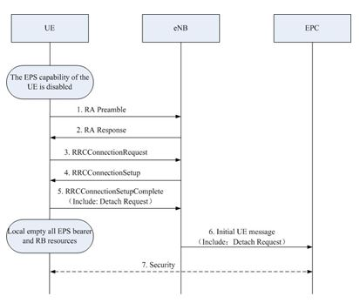

**Detach Procedure: RRC_IDLE（2）**

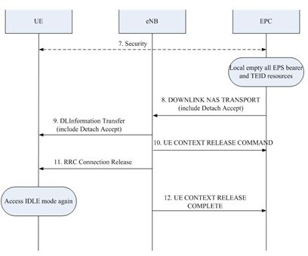

**Detach Procedure: RRC_CONNECTED**

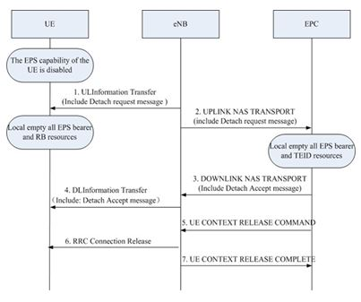

**S1-Interface**

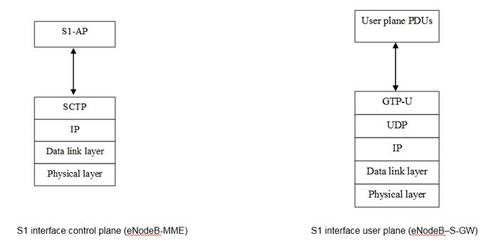

**X2-Interface**

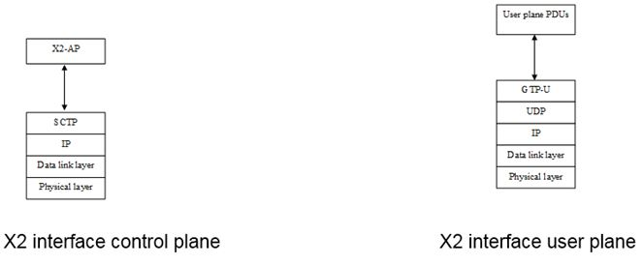

Mobile Communication protocol

https://ilor.itrackglobal.com/ilor/objects/OSSContent:202/datastreams/ibmlogo/content

* **Nano Learning Object**

|  |  |
| --- | --- |
| **Nano Learning Object(NLO)** | **NLO Outcome** |
| Concept of mobile IP | Understand the Concept of Mobile IP |

* **NLO Contents**
* Concept of mobile IP
  + Wireless LANs and cellular networks
    - provides Wireless connectivity
    - provides Mobility at the data link layer

Dynamic Host Configuration Protocol (DHCP)

* + It provides local IP addresses for mobile unit
    - not secure
    - do not maintain network connectivity when moving around

Limitations:

* + - Do not provide Transparent connectivity at the network layer
    - Do not provide Mobility with local access

* + Mobile IP developed by Internet Engineering Task Force (IETF)
  + It is a protocol which maintains user’s own IP addresses while moving from one network to the other. This helps to maintain higher level link connections during movement..
  + This protocol present IP concept in both wireless and wired network.

1. Present Internet technology is based on TCP /IP. This was designed as per the requirement of fixed access points   
2. The wide popularity of mobile communication for voice transmission and provision to support Internet call by hand held devices initiates the need of utilizing existing IP protocols and its issues.   
3. Here mobile equipment uses 2 IP address viz fixed home address and care of address that changes during every new point of attachment.   
4. The objective of Mobile IP is to solve mobility issues at the IP player   
5. Basic working Principle:

* + - Target packets to mobile nodes are first routed to home network where home agent intercepts these packets and tunnels towards care of address locations. Here inner packets are decapsulated and packets are delivered to the mobile unit.
    - In the opposite direction, packets intended to get delivered from Mobile unit are routed through IP routing.

**Mobile IP features:**

1. An authenticated registration procedure   
Here Mobile unit informs its home agent about its present location through care of address   
2. Internet control message Protocol Router Discovery   
- The extension of this protocol makes mobile to discover its home agents and foreign agents.

**Basic entities for MIPv4**

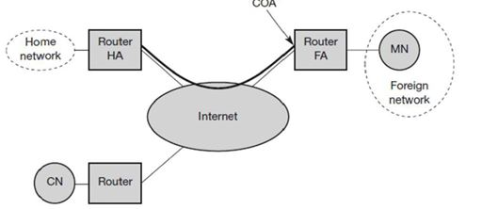

**MN :**

- MN stands for Mobile Node which can change the point of attachment in the network without changing its primary IP address.

HA:

- HA stands of Home agent. It is typically a router which registers the location of the MN, tunnels IP packets to the care of address.

FA:

- FA stands for Foreign Agent. It is typically router in foreign network. It forwards the tunnelled IP packets to the Mobile unit. It can have care of address list. It also takes care of security functions.

**Care of Address**

- It is commonly termed as COA. It is the end point address of the current tunnelled packets. It can be chosen via DHCP

- Two approaches of care of address: FA as COA and Co-located COA

- In case of FA as COA, the care of address is an IP address of the FA. It will be the tunnel end point which forwards packets from home network towards Mobile unit. Many mobile units under FA can share this care of address as common address.

- In case of colocated COA, Mobile unit temporarily acquires an additional address which serves as care of address. Here tunnel end point is mobile unit. Colocated address can be acquired using DCHP protocol. Only limitation of this method is mobile always requires an additional IP address.

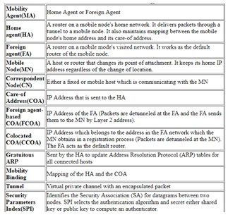

* + network layer mobility is supported in Mobile IP
  + seamless roaming opportunities across the network.
  + home network gets Extended across the entire Internet

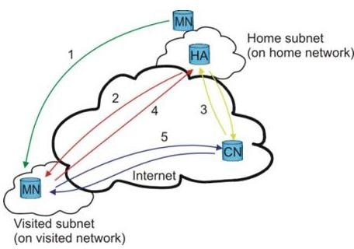

1. When MN travels to a new location area called foreign network , its gets a new care-of-address.   
2. At new location, Mobile unit initialises binding update ( similar to the location update in case of cellular network ) to its home agent.   
3. During this phase, care of address gets updated at HA. HA acknowledges Mobile node after update.   
4. When CN wants to transmit IP packets to Mobile, HA intercepts packets intended to reach Mobile unit. The Home agent encapsulate data packets using Mobile unit’s new care of address and tunneling protocol. The tunnelled packets are transmitted to the FA where it is detunnelled and routes the original payload to the mobile unit.   
5. When the mobile unit transmits to the corresponding node, it can communicate with corresponding node directly (“route optimization”).

   Mobile Communication protocol

https://ilor.itrackglobal.com/ilor/objects/OSSContent:202/datastreams/ibmlogo/content

* **Nano Learning Object**

|  |  |
| --- | --- |
| **Nano Learning Object(NLO)** | **NLO Outcome** |
| Mobile IP requirement | Learn about the Mobile IP requirement |

* **NLO Contents**
* Mobile IP requirement
  + To support mobility and flexibility of environment such as on road, home, office etc.
  + To overcome the issues due to change in IP address in applications such as Remote access VPN, Microsoft office and windows, Data base applications, VOIP.
  + In all these applications, with out mobile IP, the user entity has to restart the session again whenever the change in locations or change in network / subnet are identified.

**Advantages**

* + low cost access remote access to corporate network
  + Supports variety of applications under Internet
  + Equipment can be connected permanently to the internet and charged based on the data usage.
  + seamless roaming
  + identifies local IP router and gets connected to it automatically.
  + higher layer protocols are not affected

**Disadvantage**

- Routing mechanisms are not efficient because of Triangle routing

**Mobile IP Operation**

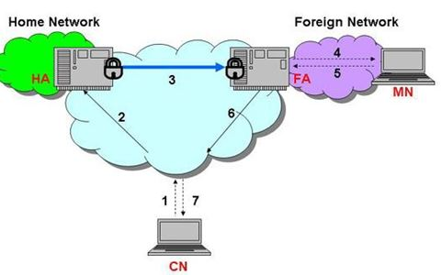

* + Communication node wants to communicate with MN
  + CN transmits IP data packets intended for Mobile. It wast ill be forwarded to the Home network using normal routing.
  + since during last binding update, HA knows the present location of mobile, it intercepts the incomming data packets using ARP protocol.
  + ARP table indicates the layer 2 of HA is layer 2 address of MN, so IP data packets are directly sent to HA.
  + HA encapsulates the original data packets into a new IP packets with destination IP address as COA and source IP address as HA address
  + At FA, the outer header are removed, and forwards data packets to the mobile unit using link layer address.
  + IF it is colocated COA, the HA sends data packets directly to the mobile unit where the packets are deencapsulated and retrieve the orginal payload.
  + If mobile wants to send a data packets to CN, it takes the route directly to CN as shown in figure.

Mobile Communication protocol

https://ilor.itrackglobal.com/ilor/objects/OSSContent:202/datastreams/ibmlogo/content

* **Nano Learning Object**

|  |  |
| --- | --- |
| **Nano Learning Object(NLO)** | **NLO Outcome** |
| Internet protocol version 4 vs version 6 | Gain knowledge on the Internet Protocol Version 4 Vs Version 6 |

* **NLO Contents**
* Internet protocol version 4 vs version 6

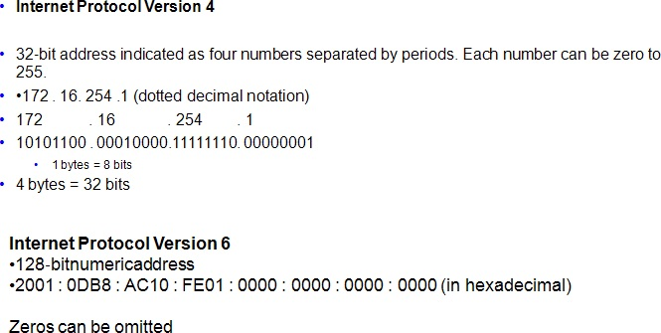

**Working principle of Protocol**

* + Agent advertisements messages are advertised by Mobile agent to indicate their presence
  + Agent solicitation messages are sent by Mobile Hosts
  + based on MA advertisements, mobile host determines that it is in “home network “or in the “foreign network”.
  + when mobile returns form a “foreign network”, it must update this information through deregistration “request” signal and “reply” signal.
  + “when mobile moves to a new network, “COA” is obtained through FA”
  + Once it receives COA, mobile registers with HA using Registration request and acknowledge.
  + “Packets sent by Mobile on FN need not take the path of “HA”, but could be sent directly to the corresponding node”

The overall procedure can be explained interms of Agent discovery, Registration and Tunnelling.

**Mobile IP Type-MIPV4 and MIPv6**

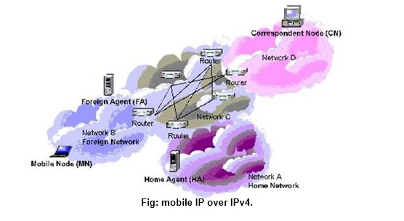

1. Mobile IP v6 Overview :

* + - Whether Mobile is currently attached to Hone link or at Foreign network, it should be addressable at home address

o IP address assigned to Mobile unit at home network is called as home address   
o “IP routing mechanisms” are used to route packets when mobile unit is within Home network   
o when mobile unit is at foreign network, it is identified using “one or more Care of addresses” ( COA)   
o Mobile unit acquires “care of address” using traditional IP V6 mechanisms.   
o Binding update process is similar to IP V5, where HA acknowledges using binding acknowledgement messages.   
o Modes of communication are 1) Bidirectional tunnelling and 2) route optimiaztoin.

2. Comparison with Mobile IP for IPv4:

1. ”no need to keep routers as "foreign agents", as in Mobile IPv4.”   
2. High level of security   
3. reduction in overheads and reduces overall throughput 4. Robustness: “IPv6 Neighbor Discovery” instead using “ARP” for discovery. 5. ”dynamic home agent address discovery”

- “Mobile IPv6 returns a single reply to the mobile node instead of separate replies from each home agent”.

**Comparison**

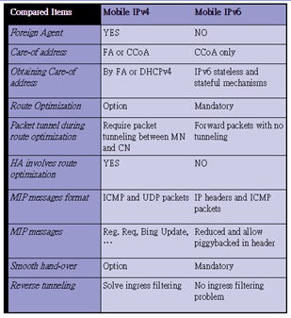

   Mobile Communication protocol

https://ilor.itrackglobal.com/ilor/objects/OSSContent:202/datastreams/ibmlogo/content

* **Nano Learning Object**

|  |  |
| --- | --- |
| **Nano Learning Object(NLO)** | **NLO Outcome** |
| Mobile IP functionality | Learn about the Mobile IP Functionality |

* **NLO Contents**
* Mobile IP functionality
  + Location Discovery
  + Move Detection
  + Tunneling

1. Location Discovery

* + “Mobile unit needs to know whether it is in its home location or foreign network. The location discovery helps in identifying it”.
  + The process is initiated using Agent Advertisment or agent solicitation
  + Foreign agent periodically broadcasts the IRDP messages through which any visited mobile units can able to recognize its foreign location. There is a provision even mobile unit can initiate the service by sending solicitation message to Foreign agent . If it doesnt receive acknowledgement, after “certain period”, it uses DHCP in order to acquire new IP address.
  + Registration request message is sent by Mobile unit after discovery phase, with its care of address related information to Home agent. An acknowledgment is received to confirm the registration. The COA is updated at HA.

2. Move Detection

* + “Whenever Mobile unit changes its location within home network or entered into a foreign network, the movement information need to be updated and is called move detection phase”.
  + Registration based on life time field value inside the ICMP header where Mobile tries to register to new network if it fails to receive any advertisement messages within time.
  + “In second method, Mobile node uses a network prefix feature of the agent advertisement protocol. Using this, mobile unit can determine whether it has moved to different location and hands off with other network. To avoid packet loss, handoff takes place before re registration process”.

3. Tunneling

To deliver packets from Mobile node to the Home Agent, either FA or Mobile unit has to tunnel its packet to over come route propagation.

**“Agent Advertisement/Discovery”:**

* + “It consists of broadcast messages used by mobiles to detect that they have moved and are required to register with a new FA”.
  + “FAs send agent advertisements”
  + “MNs can solicit for agents if they have not heard an agent advertisement in awhile or use some other mechanism to obtain a COA or temp. IP address” (e.g. DHCP).

MNs know they are home when they recognize their HA. Registration: used by a MN to inform the FA that it is visiting. The new care of address of the MN is sent to the HA. Registration expires, duration is negotiated during registration Mobile must re-register before it expires

**All registrations are authenticated**

The MN sends a regristration request in to the FA which passes it along to the home agent. The “HA responds to the FA which then informs the MN that all is in order and registration is complete”.

**“Routing/Encapsulation/Tunneling”:**

* + “consists of the delivery of the packets to the mobile node at its current care of address”.
  + “Sender does not need to know that the destination is a MN”.
  + ”HA intercepts all packets for the MN and passes them along to MN using a tunnel”. MN communicates directly with the CN.

**Referred to as Triangle Routing**

**Agent advertisement**

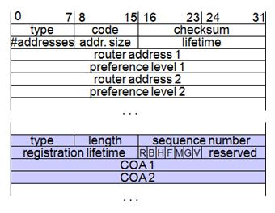

**Registration**

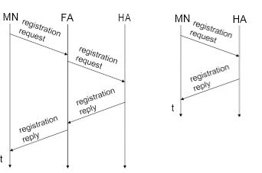

**Mobile IP registration request**

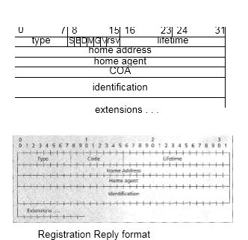

**Tunneling Architecture**

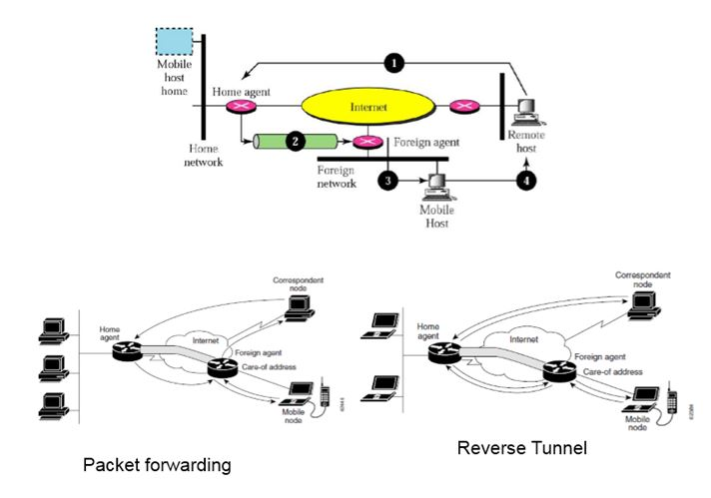

Mobile unit transmits packets using home IP address. Its packet movement are transparent relative to correspondent nodes

“The mobile node sends packets using its home IP address, effectively maintaining the appearance that it is always on its home network. Even while the mobile node is roaming on foreign networks, its movements are transparent to correspondent nodes”.

**“Methods to intercept a MN’s packets by HA”:**

a. “HA is a router with multiple interfaces. it advertises reachability to the MN’s home network”.   
b. “HA is not a router with multiple interfaces. It must use ARP to receive the MN’s packets. It should responds to ARP requests on behalf of the MN or can use gratuitous ARPs to inform the home network that it is receiving the MN’s IP data packets”.

Mobile Communication protocol

https://ilor.itrackglobal.com/ilor/objects/OSSContent:202/datastreams/ibmlogo/content

* **Nano Learning Object**

|  |  |
| --- | --- |
| **Nano Learning Object(NLO)** | **NLO Outcome** |
| Encapsulation process | Gain knowledge on the encapsulation process |

* **NLO Contents**
* Encapsulation process

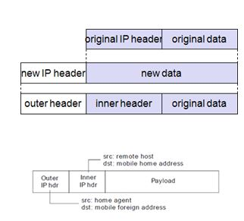

**“Mobile utilizes home address as source address in packets”**

* + “Replies come to Home agent”
  + Home agent must tunnel packet to Mobile / Foreign Agent
  + IP-in-IP tunneling (RFC 2003)
  + “IP proto field 4”
  + Minimal IP encapsulation (RFC 2004)
  + IP proto field 55
  + GRE – Generic Routing Encapsulation (RFC 1701)
  + IP proto field 7

**Types of Encapsulation**

“Three types of encapsulation protocols are in Mobile IP”:

“IP-in-IP encapsulation”: required to be supported. Full IP header added to the original IP packet. The new header contains HA address as source and Care of Address as destination”.

“Minimal encapsulation: optional. Requires less overhead but requires changes to the original header. Destination address is changed to Care of Address and Source IP address is maintained as is”.

“Generic Routing Encapsulation (GRE): optional. Allows packets of a different protocol suite to be encapsulated by another protocol suite”.

Type of tunneling/encapsulation supported is indicated in registration.

IP in IP encapsulation (mandatory in RFC 2003)

tunnel between HA and COA Minimal encapsulation (optional) avoids repetition of identical fields

e.g. TTL, IHL, version, TOS

only applicable for unfragmented packets, no space left for fragment identification

  Mobile Communication protocol

https://ilor.itrackglobal.com/ilor/objects/OSSContent:202/datastreams/ibmlogo/content

* **Nano Learning Object**

|  |  |
| --- | --- |
| **Nano Learning Object(NLO)** | **NLO Outcome** |
| Routing techniques | Gain an insight into the routing techniques |

* **NLO Contents**
* Routing techniques
  + **Triangle Routing:**
    - It is simplest form as all packets go to home network (HA) and then sent to MN via a tunnel.
    - involves two IP routes which needs to be set-up, one original route and the second the tunnel route.
    - Limitation: unnecessary network overhead results in latency.
  + Route optimization:   
    It allows the correspondent node to learn the present location of the MN through which tunnel   
    its packets directly.
  + mobility: correspondent node has to update/maintain its cache.
  + authentication: HA has to interact with the correspondent node to do authentication for every registration

**Mobile IP Problems: Triangular Routing**

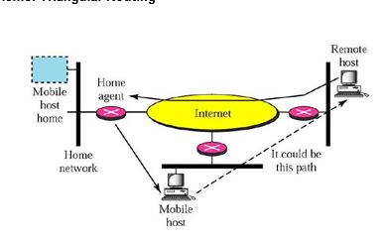

**“Triangle routing definition**

When a CN sends traffics to MN), the it follows the sequence:

1. Data Packets get the Home Agent information   
2. “Home agent encapsulates these packets (with source IP and destination IP ) and tunnels them to the Foreign Agent (FA)”.   
3. “The Foreign Agent does the opposite of encapsulation and forwards the packet to the mobile node”.

From figure, it is clear that the route taken by these packets is looks like triangle in nature. In special case, CN and MN are in the same net.

Though CN and MN are available in the same net, flow of data packets will be through Home agent which takes unnecessarily longer period.

1. 1 High latency because of more delay per data packet  
2. Low utilization of network resources  
3. bottle neck is HA.  
4. Excess of home agent server load.”

**Mobile IP Problems: Double Crossing**

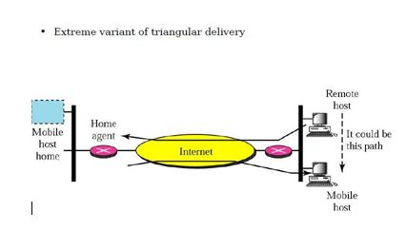

**Problems with Triangle Routing**

Triangle routing has the MN correspond directly with the CN using its home address as the SA Firewalls at the foreign network may not allow that

Multicasting: if a MN is to participate in a multicast group, it needs to use a reverse tunnel to maintain its association with the home network.

TTL: a MN might have a TTL that is suitable for communication when it is in its HM. This TTL may not be sufficient when moving around (longer routes possibly). When using a reverse tunnel, it only counts as a single hop. A MN does not want to change the TTL everytime it moves.

**Solution: reverse tunneling**

**Reverse tunneling (RFC 2344)**

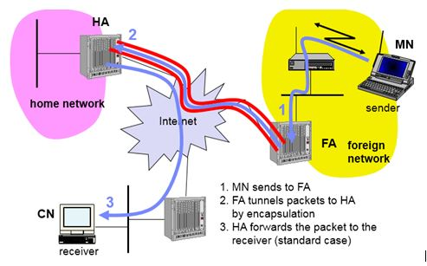

   Mobile Communication protocol

https://ilor.itrackglobal.com/ilor/objects/OSSContent:202/datastreams/ibmlogo/content

* **Nano Learning Object**

|  |  |
| --- | --- |
| **Nano Learning Object(NLO)** | **NLO Outcome** |
| Route optimization | Learn about the route optimization |

* **NLO Contents**
* Route optimization

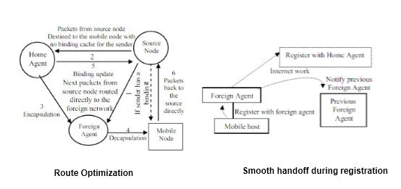

Route Optimization Protocol in figure was designed to solve the Triangular Routing Problem. When sending a data packet to a Mobile Node, the following are sequences must be followed.

1. If the sender has a binding cache consisting of COA of MN, it will deliver the data packets directly towards the Mobile Node.   
2. If the sender has no binding information the first packets should be destined at first to the Home Agent(HA).   
3. Here HA encapsulates the data packets and send them to the Foreign Agent (FA).   
4. Foreign Agent decapsulates the packets and send them to the Mobile Node.   
5. Binding information is transferred from the Home Agent to the source node for the further correspondences in the future, such that the next packets should be routed directly to the Foreign Network   
6. ”If Mobile unit transmits packets to the source node, the data packets will be transferred directly form the Mobile Node to the source node”

“This method supports a smooth handoff when the Mobile Node registers with a new Foreign Agent” .

**When foreign agent Changes**

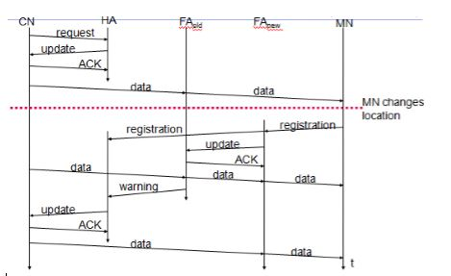

Route optimization using dynamic address allocation in Mobile IP

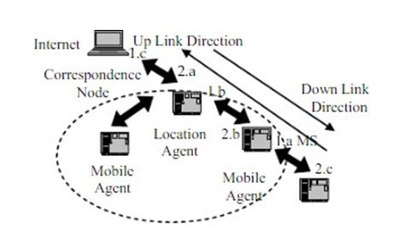

This technique proposes an extension to the Mobile IP architecture. In this scheme one Mobile Station (MS) is to handle two IP addresses between internet and intra-domain, one is called Current Address (CA) and another one is called Register Address (RA). Location Agent (LA)is a router responsible for translating both addresses between internet and intra-domain. Register Address is used for packets routing in internet; Current Address is used for packets in intra-domain. Mobile Agent (MA) is router on a “Mobile Station's current network “ which forwards packets to Mobile Station, it has a functionality similar to FA and HA

Considering a packets routing scheme between MS and CN, the packets downlink and uplink of the proposed architecture are described in figure 10 as following:1.

When a MS sends a packet to CN, the packet routed first to LA by using Current Address. When LA receives packet, it will use the Current Address of MS to check relative address of MS. LA uses the Register Address instead of Current Address and retransmits the packet to CN. This sequence is called packet Up Linksequence.2.

In case of packet Down Link, when a “CN sends a packet to MS”, the packet is routed to LA by using Register Address first. When LA receives the packet, it will use the Register Address of MS to check the relative Current Address of MS. LA uses the Current Address instead of Register Address and retransmits the packet to MS

Hard handoff scheme is proposed to be used with this technique. Also a “packet retransmission” scheme is used to avoid packet loss while hard handoff, in which every MA should have a buffer to store the downlink packets transmitted to MS. After MS handoff, old MA would retransmit packets which are stored in its buffer to new MA which delivers them to MS.

By evaluating the performance comparison between the Mobile IP scheme and the dynamic address allocation scheme, it has been found that the transmission time taken between the CN and MS takes a longer Downlink path in case of Mobile IP scheme than the dynamic allocation scheme in which the transmission time equal to the time taken between the CN and MA plus the time taken between MA and MS. Also the traffic would increase obviously in the Mobile IP scheme. Comparatively, Dynamic Allocation Scheme would not increase any extra traffic

**“Bi-directional route optimization over wireless LAN”**

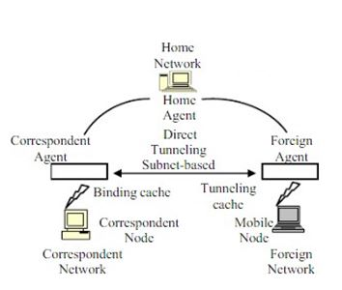

* + “bidirectional route optimization is used to overcome issues of Triangle Routing problem”.
  + “Correspondent Agent” maintains the “binding cache” and intercepts all data packets sent to and from the “Correspondent Nodes”.
  + “At the other end of the optimized route, FA maintains a tunneling cache for bidirectional route optimization”.
  + “An entry of the tunneling cache determines that a CN supports Route Optimization and direct tunneling, so that a Foreign Agent can directly tunnel a packet received from a MN to
  + the CN that matches a tunneling cache entry”.

  Mobile Communication protocol

https://ilor.itrackglobal.com/ilor/objects/OSSContent:202/datastreams/ibmlogo/content

* **Nano Learning Object**

|  |  |
| --- | --- |
| **Nano Learning Object(NLO)** | **NLO Outcome** |
| Management issues in mobile IP | Gain an inisht into the management Issues in Mobile IP |

* **NLO Contents**
* Management issues in mobile IP

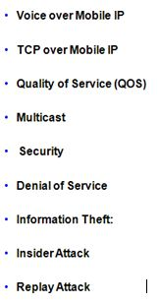

**“Quality of Service (QOS)”**

* + ”Integrated Services (IntServ), Differentiated Service (DiffServ), and Multiprotocol Label Switching (MPLS)”.

**Multicast**

* + IP multicast is an efficient way to send packets from one host to multiple hosts.

**Security**

Voice over Mobile IP

* + Due to the limitations of Mobile IP, handoff latency an route optimization , Mobile IP needs to be “optimized”.

**TCP over Mobile IP**

* + “Many versions of TCP protocol” have been released to improve overall performance. It reduces throughput etc,

**“Denial of Service”:**

* + ”Attacks Denial of Service can be caused when an attacker sends many data packets to a host (eg a Web server) “
  + “It can e caused when an intruder somehow interferes with packets flowing between two nodes in the network or when a malicious host creates a false registration request”

**Information Theft:**

* + ”an unauthorized person, inevitably, access to wireless and wired network”.
  + Link layer encryption

**“Insider Attack”:**

“This typically involves a discontented employee access to sensitive data and transmits it to a competitor”.

“Replay Attack”: “ A malicious host can collect a copy of a valid registration, store, and then play it later”

   Mobile Communication protocol

https://ilor.itrackglobal.com/ilor/objects/OSSContent:202/datastreams/ibmlogo/content

* **Nano Learning Object**

|  |  |
| --- | --- |
| **Nano Learning Object(NLO)** | **NLO Outcome** |
| Cellular and WLAN integration | Learn about the Cellular and WLAN Integration |

* **NLO Contents**
* Cellular and WLAN integration
  + Objective is to keep bit rate higher than 100 Mb/s
  + Need to exploit WLAN technology and integrate into mobile data network
  + Capable of ubiquitous data service and y high data throughputs in hotspot locations
  + A Tight Coupling Architecture
  + A Loosely Coupled Architecture

**Cellular and WLAN Integration Architecture**

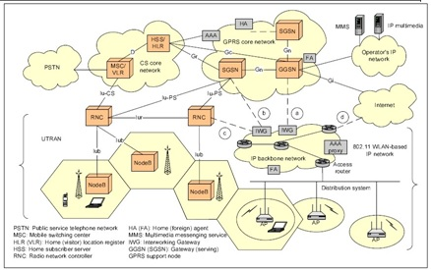

**Multiple Access Options**

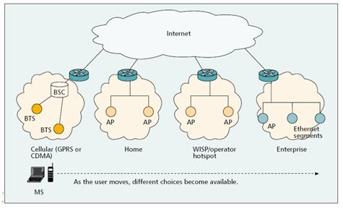

**WLAN Coupling Points in GPRS Network**

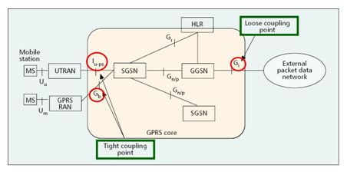

**UMTS Network Architecture**

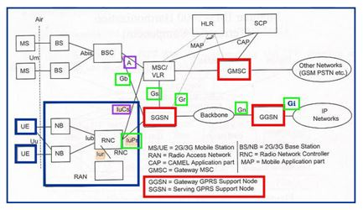

  Mobile Communication protocol

https://ilor.itrackglobal.com/ilor/objects/OSSContent:202/datastreams/ibmlogo/content

* **Nano Learning Object**

|  |  |
| --- | --- |
| **Nano Learning Object(NLO)** | **NLO Outcome** |
| Six interworking scenarios | Gain an insight into the Six Interworking Scenarios |

* **NLO Contents**
* Six interworking scenarios
  + Objective is to support Common customer care and billing
  + Radio Access control and charging as per 3GPP policy
  + Radio Access 3GPP and GRPS-based service
  + Providing Service continuity and improve QOS
  + Seamless services for the subscribers

Radio Access to 3GPP and circuit-switched services such as Voice

**WLAN-GPRS Tight Coupling**

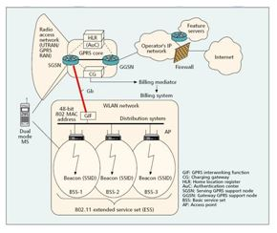

A Loose Coupling Architecture

* + “WLAN-GPRS Integration with Loose Coupling: System Configuration”

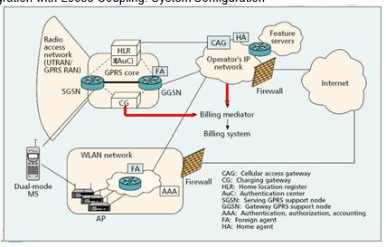

**Comparison Tight Coupling /Loose Coupling**

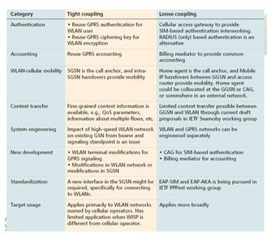

**Heterogeneous Networks in LTE**

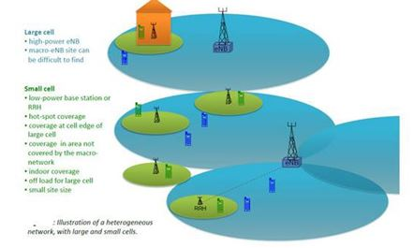

* + Effective planning required to support capacity requirements
  + Various methods such as carrier addition, BTS additions ,dual band, adding small cells are used to support increase in traffic
  + Adding more sectors per enode B or deploying more marcro enodeB are some alternative methods for LTE
  + microcells helps in supporting hot spots with higher user demand.

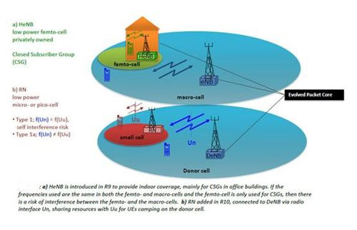

* + ”In heterogeneous networks the cells of different sizes are referred to as macro-, micro-, pico- and femto-cells; listed in order of decreasing base station power”.
  + ”The actual cell size depends not only on the eNB power but also on antenna height, type, antenna position, as well as the location such as rural or city” .
  + “low power eNB is used to provide “indoor coverage”,
  + ”The Relay Node is another type of low-power base station specified in LTE R10 specifications”.

**Integrate wireless LAN service**

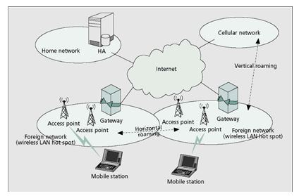

Mobile Communication protocol

https://ilor.itrackglobal.com/ilor/objects/OSSContent:202/datastreams/ibmlogo/content

* **Nano Learning Object**

|  |  |
| --- | --- |
| **Nano Learning Object(NLO)** | **NLO Outcome** |
| Handoff metrics | Learn about the Handoff Metrics |

* **NLO Contents**
* Handoff metrics

Horizontal HO – mainly use received signal strength (RSS) to decide the handoff… But Vertical HO? RSS? Offered bandwidth? Price? Power consumption? Speed? ….

**Vertical Handoff Process**

**Step 1: “System Discovery”**

The MT must know which wireless networks are reachable. Periodic beacons from AP.

* + “ Signal measurements”
  + “Database query”.
  + “Handoff metrics gathering. Bandwidth, cost, delay, SNR, power, etc. Periodic / Adaptive network scanning”
  + ”All interfaces always on”.

**Step 2: “Handoff Decision”**

The MT then evaluates the reachable wireless networks to make a decision. “ Fuzzy Logic / Neural Networks.

**“Multiple Attribute Decision Making.**

* + ”Decision based on utility / cost functions”.

**Step 3: “Handoff Execution”**

If the MT decides to perform a VHO, it executes the VHO procedure required to be associated with the “new wireless network”

**WLAN-Cellular Handover**

* + Handover is accomplished through MIP
  + Requires Following Components

o MIP Client  
o MIP Home Agent

* + How does it work?

o Mobile is assigned a Home Address.  
o When Mobile is away from home, it acquires a Care-of-address  
o Mobile IP Client registers Care-of-address with Home Agent   
o All IP packets destined to Home Address are intercepted by Home Agent.   
o Home Agent forwards IP packets to Care-of-Address  
o As Mobile Moves between WLAN and Cellular

* + Care-of-Address Changes but Home Address remains same
  + TCP/UDP Sessions based on Home Address are unaffected between handoffs

**The handover process :**

1. Initiation  
2. Decision  
3. Execution

* + “Handover initiation is accountable for triggering the handover according to specific measurement conditions such as radio deterioration or network congestion”.
  + “The decision for the most appropriate new Access Point is considered. At this phase several parameters such as signal strengths of neighboring access points, quality and distance related information is taken into consideration”.
  + ”Exchange for communication or re-establishment and data routing through the new connected path is made during execution”.

**WLAN-Cellular Handover (Mobile IP)**

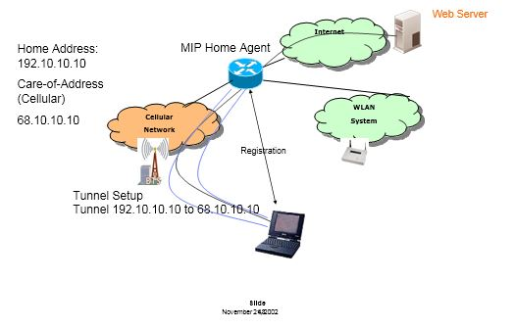

Support for Mobile IP in Cellular Systems 3GPP2 has incorporated MIP

PDSN behaves as FA, Handsets have MIP clients 3GPP does not require MIP

Some GGSN providers have MIP capability

**Is FA Care-of-Address Registration important?**

Session Mobility Issues

* + Support for Mobile IP in Cellular Systems NATs and Firewalls
  + Interaction between VPN and MIP Clients MIP Handover Performance

Handoff Delays

* + Handoff Delays are still “large” (~4 secs) Sources of delay
  + IP address assignment (DHCP) and authentication Detection of Loss of WLAN coverage
  + Cellular Data call-setup
  + Impact of Delay (> 4 sec) on Applications Some FTP clients will “hang”
  + Streaming Clients sometimes “freeze” Adjusting buffer size has “mixed” effect

**NATs and Firewalls**

* + VPN Clients intolerant of changes in Route Table
  + Any Change in route table usually resets the VPN
  + Force VPN Re-authentication
  + Assume VPN over MIP
  + MIP running on top of WLAN
  + Move out of WLAN coverage into Cellular Acquire IP address from Cellular.
  + MIP handover from WLAN to Cellular

Workarounds

1. Integrated MIP and VPN  
2. Make VPN more “tolerant” of changes

**WLAN-Cellular Handover (Mobile IP)**

